
Jolly Helmet
Make your Helmet Happy Again!
Clean it. Dry it.
Wear it happy.
Coin-operated helmet cleaning and drying stations
MEJES, JERAHMEEL ALZEL M.
CRUZ, DEAN RYAN P.
MENDOZA, RICAH S.
MARTOS, KRISTINA E.
DEVELOPERS AND DESIGNERS
USER MANUAL

Contents
Customer guide 2
Meet the machines 2
Before you start 3
Box 1 - Cleaner 5
Box 2 - Dryer 8
Box 3 - Cleaner + Dryer 9
Prices and time 11
Special screens and safety 12
Admin guide (Control Center) 14
Connecting 15
Home page 15
Box settings (rules, levels, phases) 16
Screen refresh and maintenance 19
Refill station (ACS) 21
Troubleshooting and care 23
Online page (Monitor, Alerts, Reports) 24
Technician guide (Hardware, online monitoring and maintenance) 30
How it is built 31
Component list 33
Pinouts 35
Circuit and wiring 39
Firmware and flashing 44
Online monitoring 46
Maintenance 53
Hardware troubleshooting 55
Reference (Safety, charts, settings and index) 56
Safety and emergencies 57
Box flowcharts 60
Troubleshooting decision trees 67
Settings reference 75
Circuit schematics 80
Policies 86
Glossary 88
Version and revisions 91
Index 93

Customer guide

Welcome to Jolly Helmet!
A self-service station that cleans and dries your motorcycle helmet while you wait.

Meet the machines
There are three Jolly Helmet stations. Each one has a touch screen, a coin slot and a door. Pick the one that fits what your helmet needs.

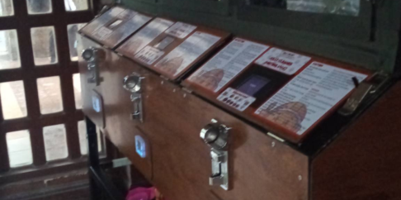 | 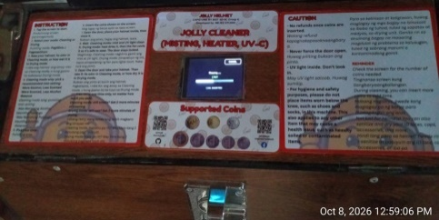 | 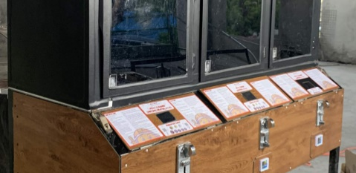

Station | What it does
Box 1  Cleaner | Removes odor. UV light plus a fine mist of alcohol, scented liquid, or both.
Box 2  Dryer | Dries a wet helmet with warm air, then cools it down before you take it out.
Box 3  Cleaner + Dryer | One station, two modes. Choose CLEANING or DRYING on the first screen.

Tip / Paalala: Pwede mong gamitin ang Box 1 at Box 2 nang magkasunod: linis muna, tapos tuyo.

Which machine is free?
Look for the QR sticker on the machines. Scan it with your phone camera. A page opens that shows Box 1, Box 2 and Box 3 as FREE, IN USE (with about how many minutes are left) or OUT OF ORDER. You do not need an app or a password. The button at the top changes the language between English and Filipino. When a machine is running your cycle you may also tap Add your name on its card and type a nickname (12 letters at most). Everybody who opens the page sees it, so use a nickname, not your full name. It disappears by itself when your cycle ends.
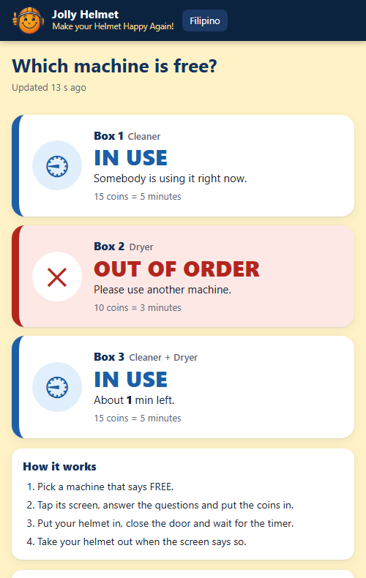
The customer status page: which machine is free (phone)

Tip / Paalala: I-scan ang QR sticker para makita kung aling makina ang libre. Pindutin ang "Filipino" sa itaas ng page.

Before you start
You need: your helmet and coins. The machine counts coins by value: a one-peso coin counts as 1.

How the touch screen works
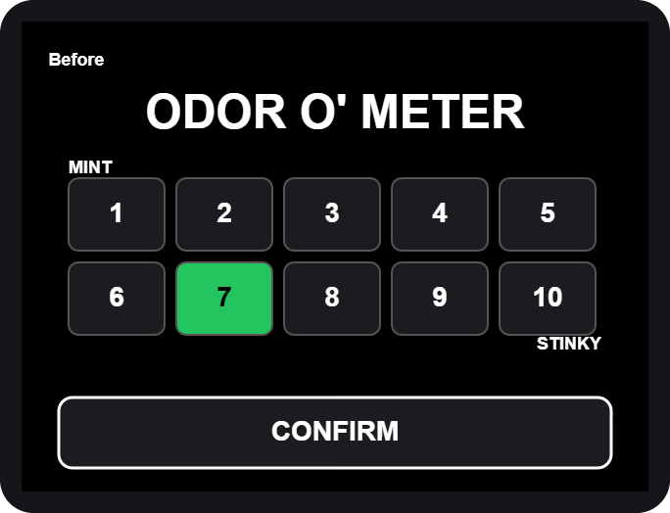  Rating grid: tap a box 1-10, then CONFIRM | 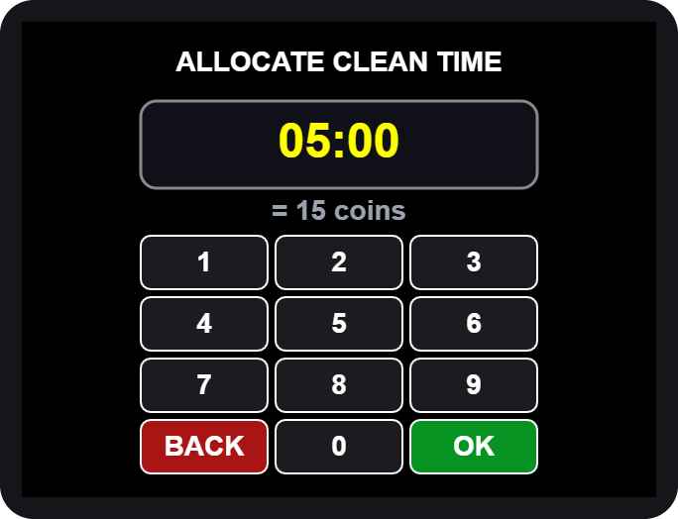  Number pad: type the minutes and seconds, then OK

- Big words (yellow) tell you what to do next: OPEN, PLACE, CLOSE, TAKE.
- Buttons are the dark boxes with white words. Tap them once.
- The screen blinks briefly now and then. This is normal, it refreshes itself.

Never put your hand in while the machine runs. If you open the door, the machine pauses by itself.

Box 1 - Cleaner
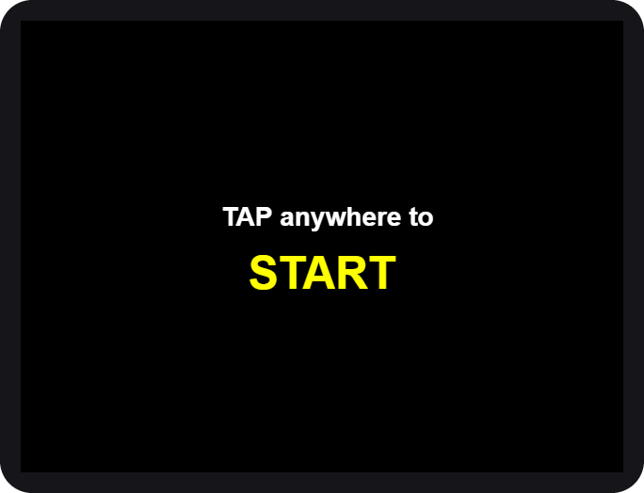  1. Tap anywhere to START | 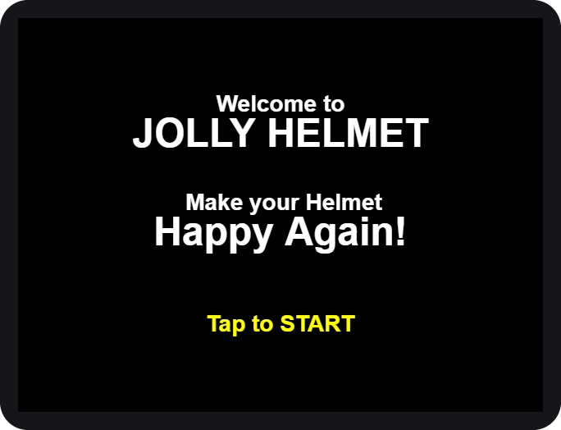  2. Welcome

- Wake the machine. Tap anywhere on the screen. For a moment it says "Please Wait" while it checks its alcohol and scented liquid.
- Tap to START on the welcome screen.

If the screen says OUT OF ORDER, the station needs refilling or service. Please tell the staff.

Rate it and choose the mist
3. ODOR O' METER | 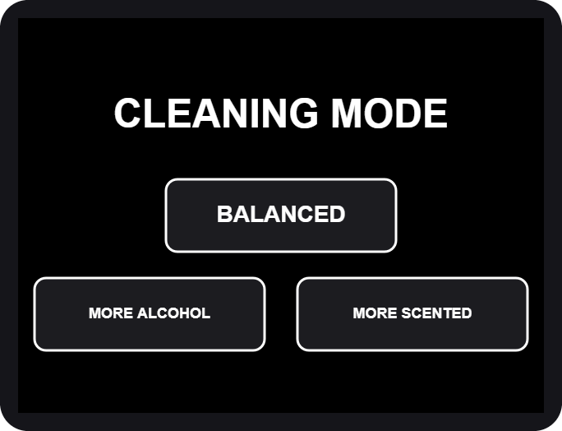  4. CLEANING MODE

- Rate the smell. Tap 1 (MINT, fresh) to 10 (STINKY), then CONFIRM. The worse the smell, the more time we suggest.
- Choose the mist. BALANCED uses both liquids, MORE ALCOHOL is stronger against germs, MORE SCENTED leaves a fresher scent.

Pick the time and pay
5. ALLOCATE CLEAN TIME | 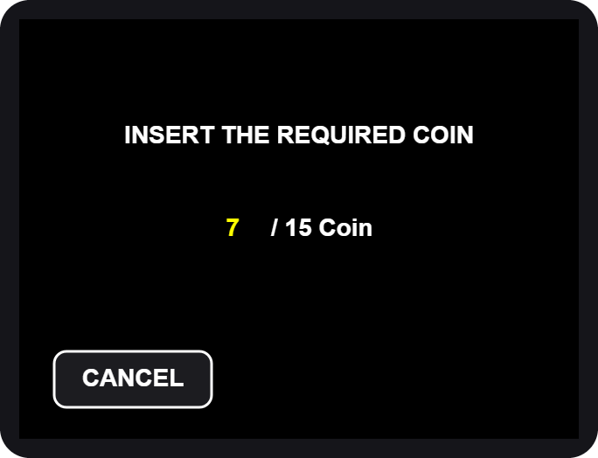  6. INSERT THE REQUIRED COIN

- Allocate time. The pad shows the time we suggest for your rating. Type a different time if you like, then tap OK. The shortest time and the longest time are shown if you go outside them.
- Insert the coins. The screen counts up: coins inserted / coins required. When it is enough, the machine moves on by itself.

Extra coins beyond the price give no extra time and are not refunded. Tap CANCEL before paying if you change your mind.

Load your helmet
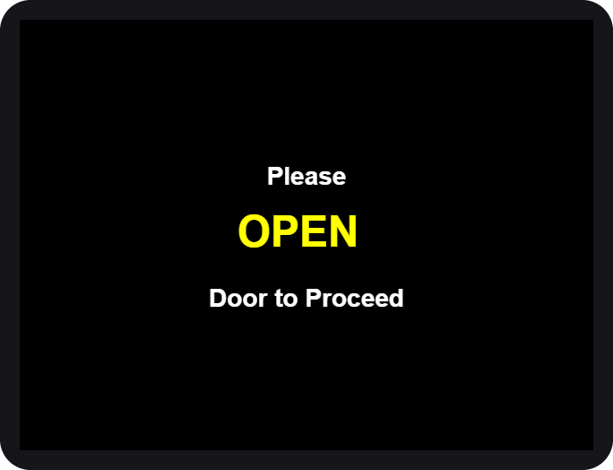  7. OPEN | 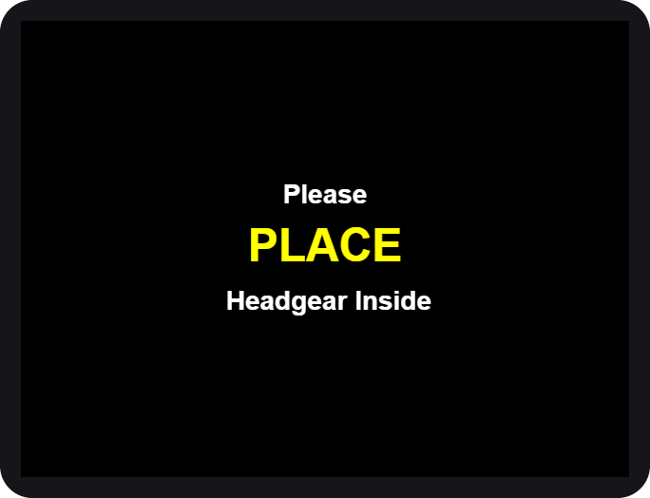  8. PLACE | 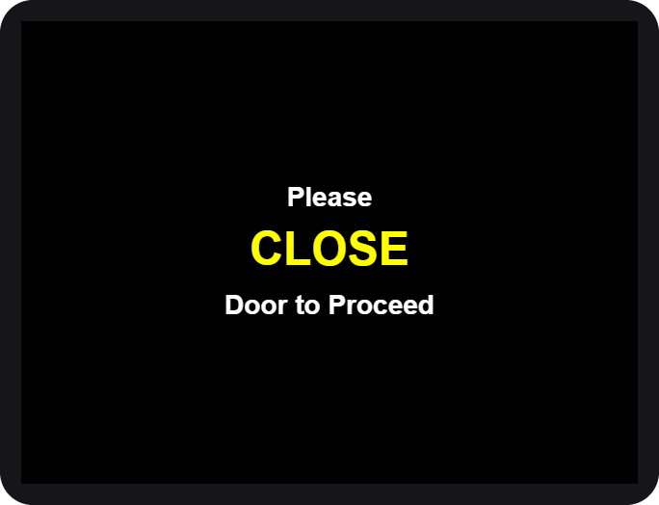  9. CLOSE

- OPEN the door when the screen asks.
- PLACE your helmet inside, opening facing the front, then step back.
- CLOSE the door. The machine checks that the door is shut and the helmet is inside, then starts.

If you see HELMET NO DETECTED, the machine did not see your helmet. Open the door and place it again.

While it cleans
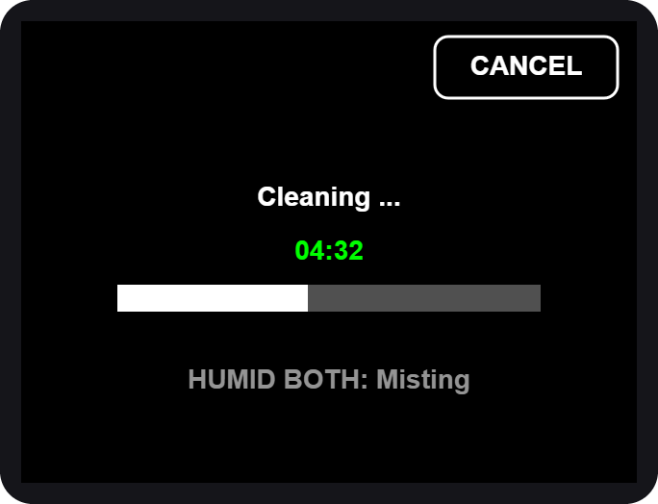  10. Cleaning... time left | 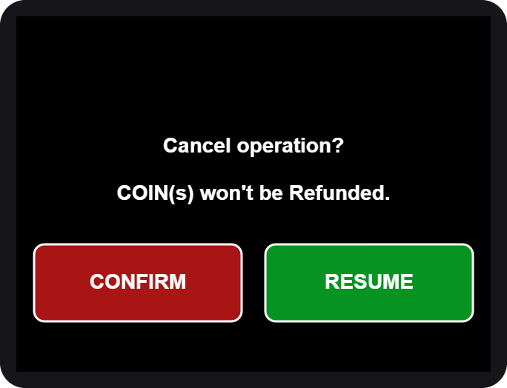  CANCEL asks first

- The big green number is the time left. The bar fills as it goes.
- The small grey line shows what is on: the mist, the UV light.
- To stop early tap CANCEL, then CONFIRM. Coins are not refunded. RESUME keeps cleaning.

If the door is opened during a run, everything pauses (SAFETY PAUSE). Close the door and it continues where it stopped.

All done
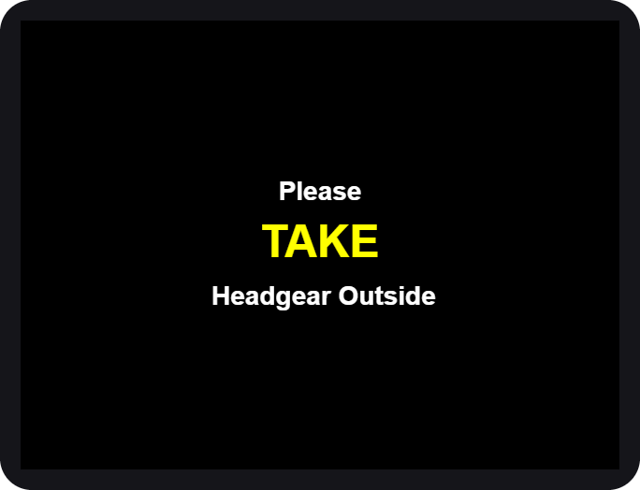  11. TAKE your helmet | 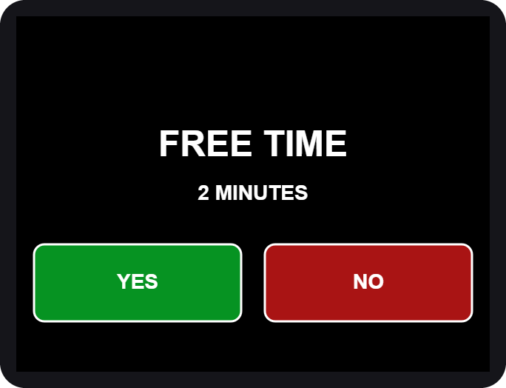  13. FREE TIME?

- OPEN the door and TAKE your helmet. Close the door again.
- Rate it again on the same 1-10 grid, then CONFIRM.
- Free retry. Not happy yet? The machine may offer a short FREE TIME (2 minutes). Tap YES to run once more, or NO. It is offered once per visit.
- The screen thanks you and returns to the start.

Box 2 - Dryer
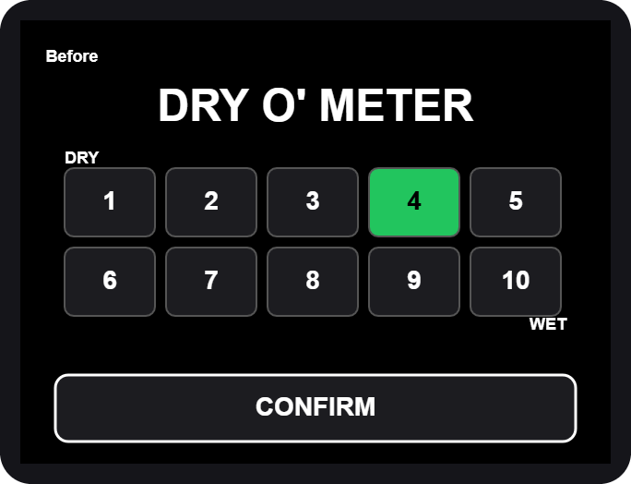  DRY O' METER | 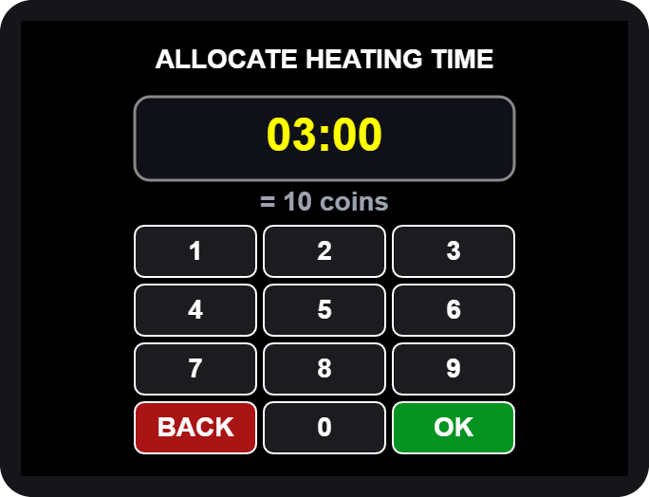  ALLOCATE HEATING TIME

- Tap anywhere, then Tap to START (same as Box 1).
- Rate how wet it is: 1 = DRY ... 10 = WET, then CONFIRM.
- Allocate heating time on the number pad, then OK.
- Insert the coins shown on the screen.
- OPEN, PLACE, CLOSE the door, same as Box 1.

Heating and cooling
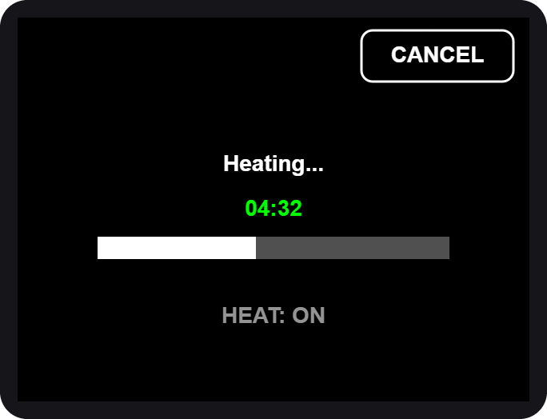  6. Heating... | 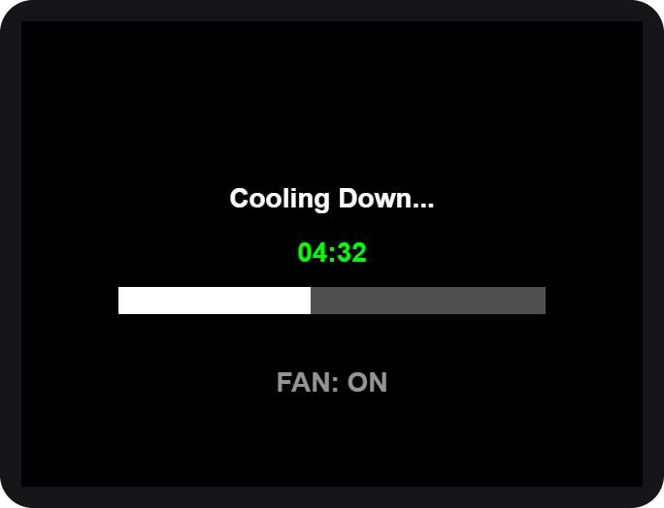  7. Cooling Down...

- Heating. Warm air dries the helmet and UV light freshens it. You can CANCEL, but coins are not refunded.
- Cooling down. A fan runs alone so the helmet is not hot to wear. The door stays locked until it ends.
- OPEN the door, TAKE your helmet, CLOSE the door.
- Rate it again, then use the free retry if you want one.

If you cancel while heating, the machine still cools the helmet down first, for your safety.

Box 3 - Cleaner + Dryer
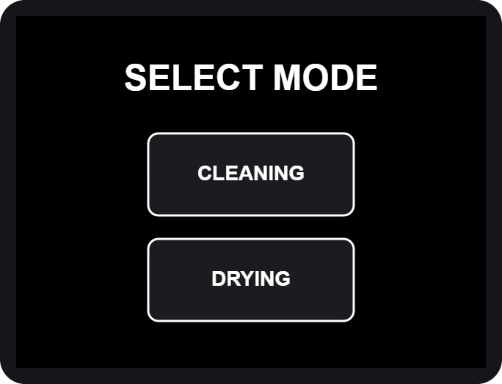  SELECT MODE | 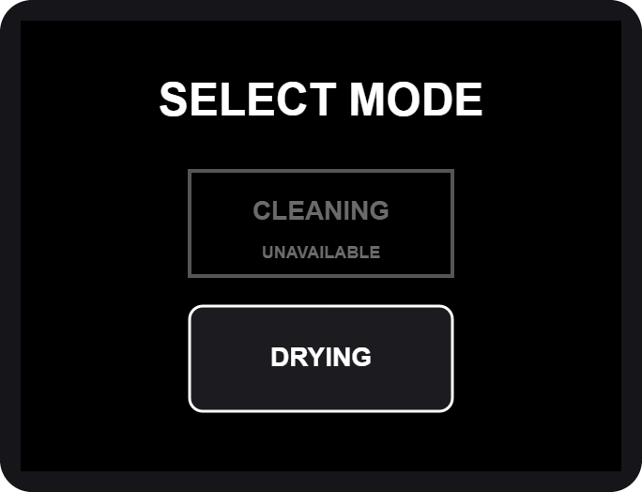  CLEANING unavailable

- Tap anywhere, then Tap to START.
- SELECT MODE. Tap CLEANING or DRYING.

If CLEANING is grey and says UNAVAILABLE, the cleaning liquids are being refilled or are low. DRYING still works.

CLEANING mode
Same steps as Box 1: rate the odor, choose the mist, pick the time, pay, load the helmet. At the end you rate two things: how dry it is, then how it smells. The heater runs only in the last minute, together with the UV light.

DRYING mode
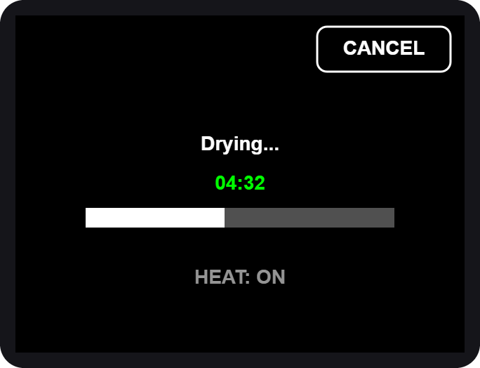  Drying... | 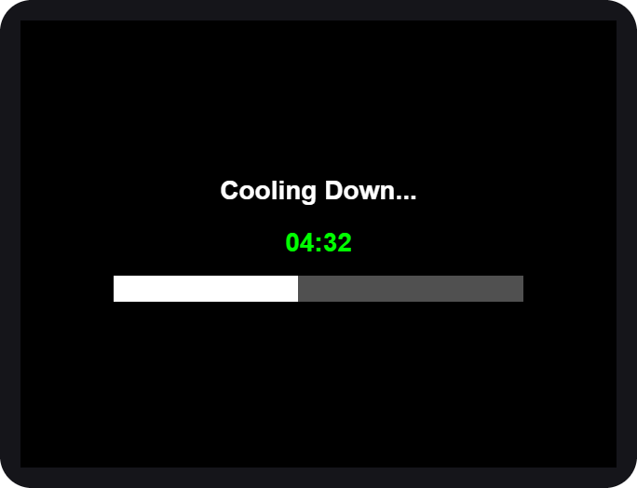  Cooling Down...

- Rate how wet the helmet is (DRY O' METER), then CONFIRM.
- Allocate drying time on the number pad.
- Pay, then OPEN, PLACE, CLOSE.
- Drying uses warm air and UV light. After it, the machine cools down for about a minute with nothing running.
- OPEN, TAKE, CLOSE, rate again and use the free retry if offered. A free retry after cleaning is another cleaning; after drying it is another drying.

Prices and time
Box 1 and Box 3 (cleaning): 15 coins = 5 minutes.

Rating | Suggested time | Coins
1 - 5 | 5 minutes | 15
6 - 7 | 10 minutes | 30
8 - 9 | 15 minutes | 45
10 | 20 minutes | 60

Longest session: 30 minutes (90 coins).
Box 2 (drying): 10 coins = 3 minutes.

Rating | Suggested time | Coins (about)
1 - 3 | 3 minutes | 10
4 - 6 | 5 minutes | 17
7 - 8 | 8 minutes | 27
9 - 10 | 10 minutes | 34

These are the starting prices. The admin can change them, so always check the INSERT THE REQUIRED COIN screen for the exact amount.

Special screens and safety

Special screens
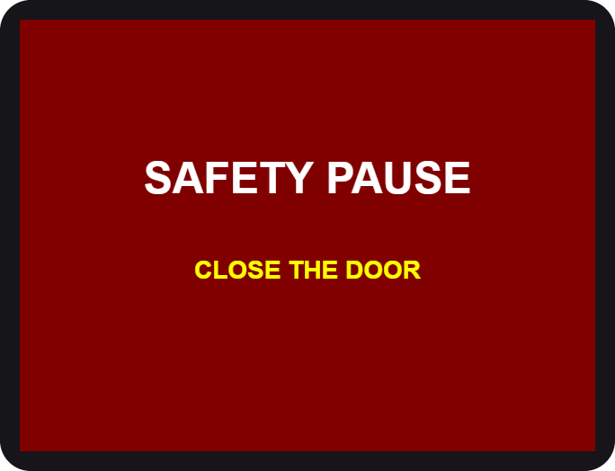  Door opened during a run | 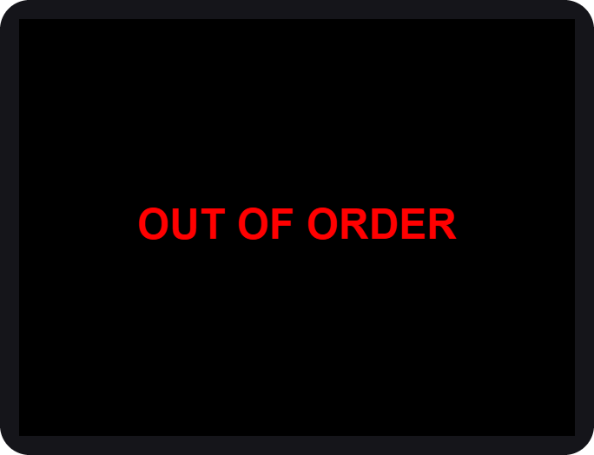  Station needs service

You see | What it means / what to do
SAFETY PAUSE | The door was opened. Close it and the run continues.
HELMET NO DETECTED | No helmet seen. Open the door and place it again.
OUT OF ORDER | The station cannot work now. Use another station and tell the staff.
CLEANING UNAVAILABLE | Cleaning liquids are low. Use DRYING or come back later.
MAINTENANCE | A technician is working on the station.

Safety first
- Helmets only. Do not put bags, gloves, liquids or anything else inside.
- Keep your hands out while the machine runs. Hot air and UV light are used.
- UV light is strong. Never look into the chamber while it is on. The door must be closed.
- Do not force the door. It is locked on purpose while the machine runs. To stop, use CANCEL on the screen. If the screen does not answer, use the safety slide (see "If the door will not open").
- Remove your helmet's accessories (camera, speaker, visor tint film) if they are not heat-safe.
- Children should use the machine with an adult.
- In an emergency, tap CANCEL, then CONFIRM. The machine stops and the door unlocks (on the dryers after a short cool-down).

If your helmet is stuck after a power cut or a fault, do not pull on the door. Slide the safety lock down (lower left of the enclosure door): the door unlocks at once. Then tell the staff.

If the door will not open
The door is locked on purpose while a machine runs. If the screen does not answer, the power is off, or the lock is broken, you can always open the door yourself with the safety slide.
- Look at the lower left corner of the enclosure door. The safety slide is there.
- Slide it down. The door unlocks at once, with or without power.
- Open the door and take your helmet out. Tell the staff afterwards.
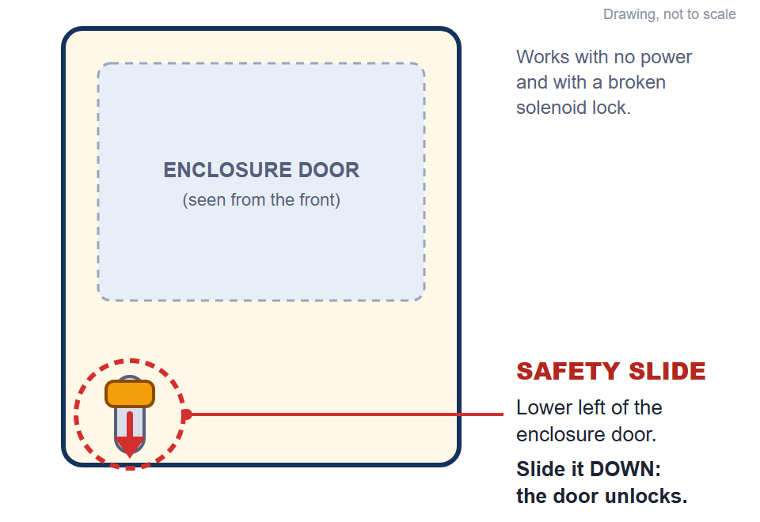
The safety slide: lower left of the enclosure door. Slide it down to unlock (drawing)

If the machine was running, opening the door stops it (SAFETY PAUSE) and switches the UV light and the heat off. The UV light is strong: do not look into the chamber until it is off. The helmet may be warm.

Questions

Question | Answer
The screen went white. | Wait a moment, it restarts itself. If it stays white, tell the staff.
I inserted a coin but nothing changed. | Insert the coin again slowly. Tell the staff if the count does not move.
Can I get a refund? | Coins are not refunded after the run has started or been cancelled.
The time is too long / too short. | On the number pad, type the time you want before tapping OK.
Why was I offered a free retry? | Because the helmet may need one more round. It is offered once per visit.
Which station should I use? | Smelly: Box 1 or Box 3 CLEANING. Wet: Box 2 or Box 3 DRYING.
The door will not open. | Wait until the run ends, or tap CANCEL. If the screen does not answer or the power is off, slide the safety lock down (lower left of the enclosure door).

Admin guide (Control Center)
The Control Center: settings, calibration and maintenance
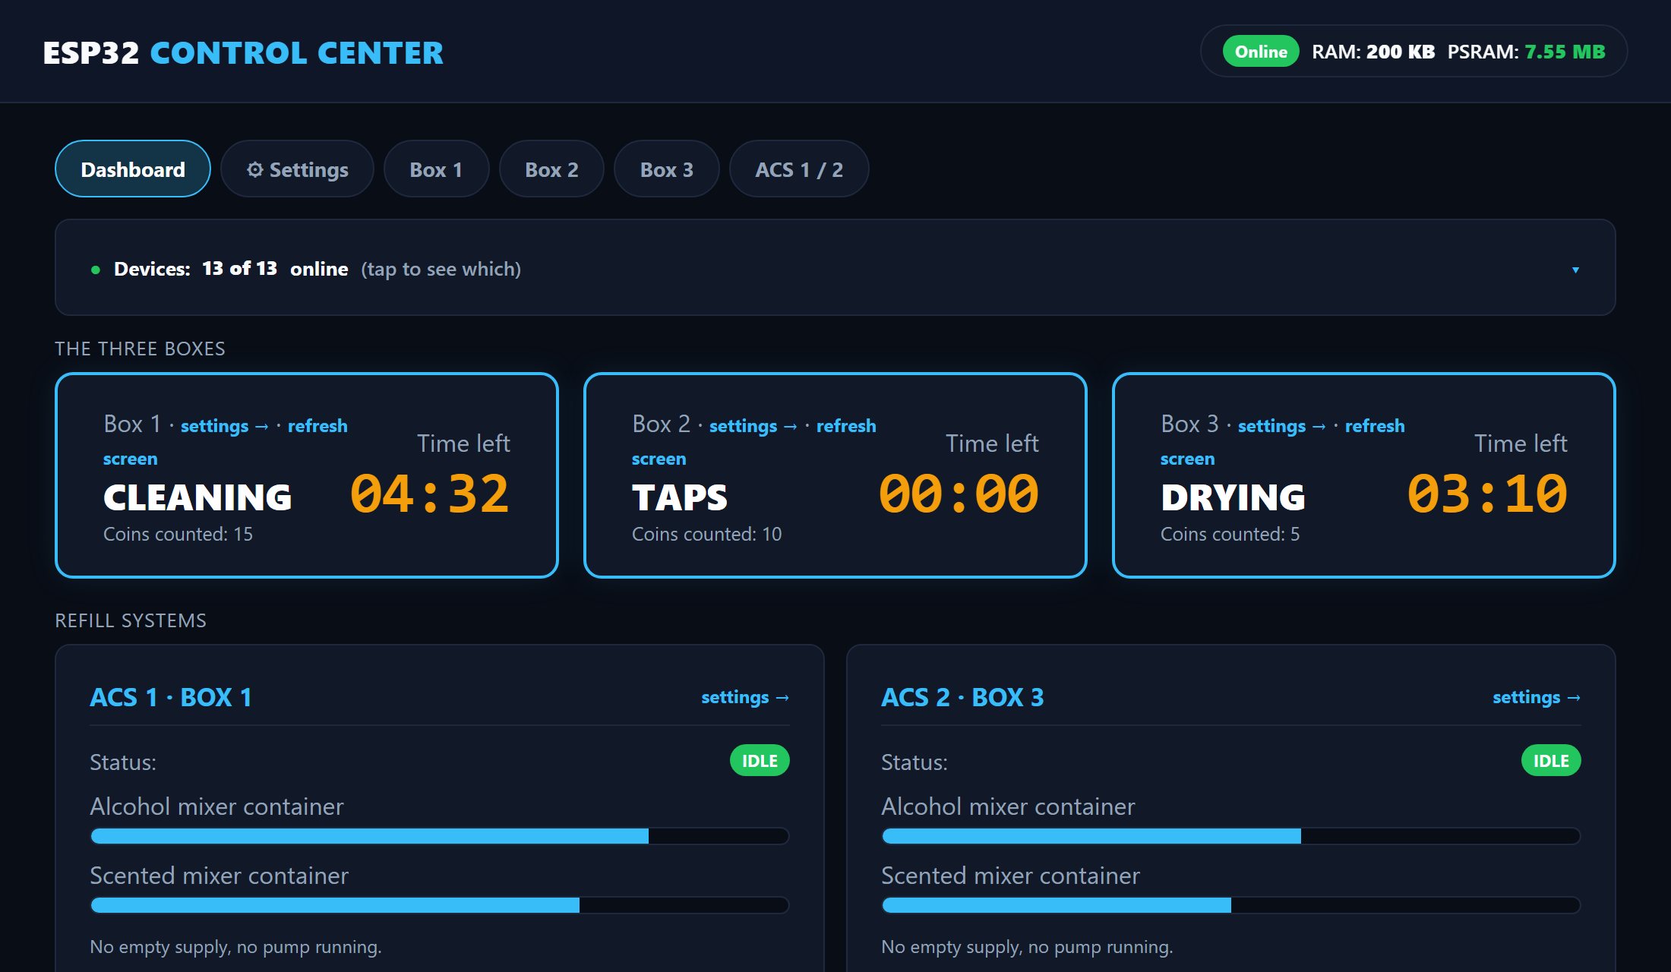
WEB PANEL FOR ADMINS AND TECHNICIANS

Connecting
The Control Center is a small web server (the LocalServer) inside the machine. You connect to it with a phone or laptop. It does not need internet.
- Switch on the machine and wait about 30 seconds.
- On your phone, join the Wi-Fi JollyHelmet-Local, password 12345678.
- Open a browser and go to http://192.168.4.1. On most phones the page opens by itself (a captive portal); if it does not, type the address.
- The Dashboard appears. The bar at the top (Dashboard, Settings, Box 1, Box 2, Box 3, ACS 1 / 2) takes you to every page; the same bar is at the top of every settings page.

The machines keep running and keep every setting even when the LocalServer is off or being replaced. It only shows, and sends your changes.

The Wi-Fi password is printed here for admins. Change it in the LocalServer program if this manual is shared outside the team.

Home page
- Dashboard (older pages and the flowcharts call it Home): the first tab of the Control Center. The bar at the top takes you to every other page.
- Alert banners (red): empty supplies, low mixers, a station out of order, and the two memory and log-storage notes (see Warnings and crash reports).
- Navigation bar: Dashboard, Settings, Box 1, Box 2, Box 3 and ACS 1 / 2 (the same bar is on every page).
- The three boxes: current step, coins counted, time left, plus settings and refresh screen links.
- Refill systems: ACS status, mixer levels, empty or running pumps.
- Statistics: users served, total revenue, average cycle time and coins, the Daily and Weekly usage chart, the day viewer and the Finished and cancelled tally.
- Devices line: how many boards are online. Tap it for the online or offline badge of every board.

Navigation bar and the Devices line
The same navigation bar sits at the top of every page: Dashboard, Settings, Box 1, Box 2, Box 3 and ACS 1 / 2. Tap a name to go there; the page you are on is highlighted. Below it the Devices line tells you how many boards answer (for example 13 of 13 online). Tap it to open the list with an ONLINE or OFFLINE badge for every board.
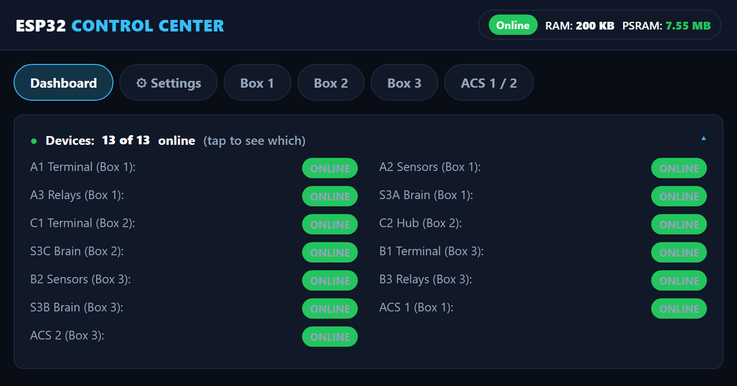
The navigation bar and the Devices list (tap the Devices line to open it)

Daily usage and the day viewer
The chart shows how many customers came each day (Daily, the last 7 days) or each week (Weekly). Orange is the part that was cancelled. A lighter shade is the previous data collected by the team after the upgrade (see the Settings tab below).
- Tap a bar of the Daily chart, or pick a date and tap Show the customers, to open that day customer by customer: time, box, coins, pesos, Finished or Cancelled, and minutes.
- The two tabs Machine and JSON only tell you where each row came from: Machine is what the machines recorded, JSON is what the team added from its own records. Both are real customers.
- Sessions without a date finished before a phone set the clock. They get their date as soon as the clock is set.
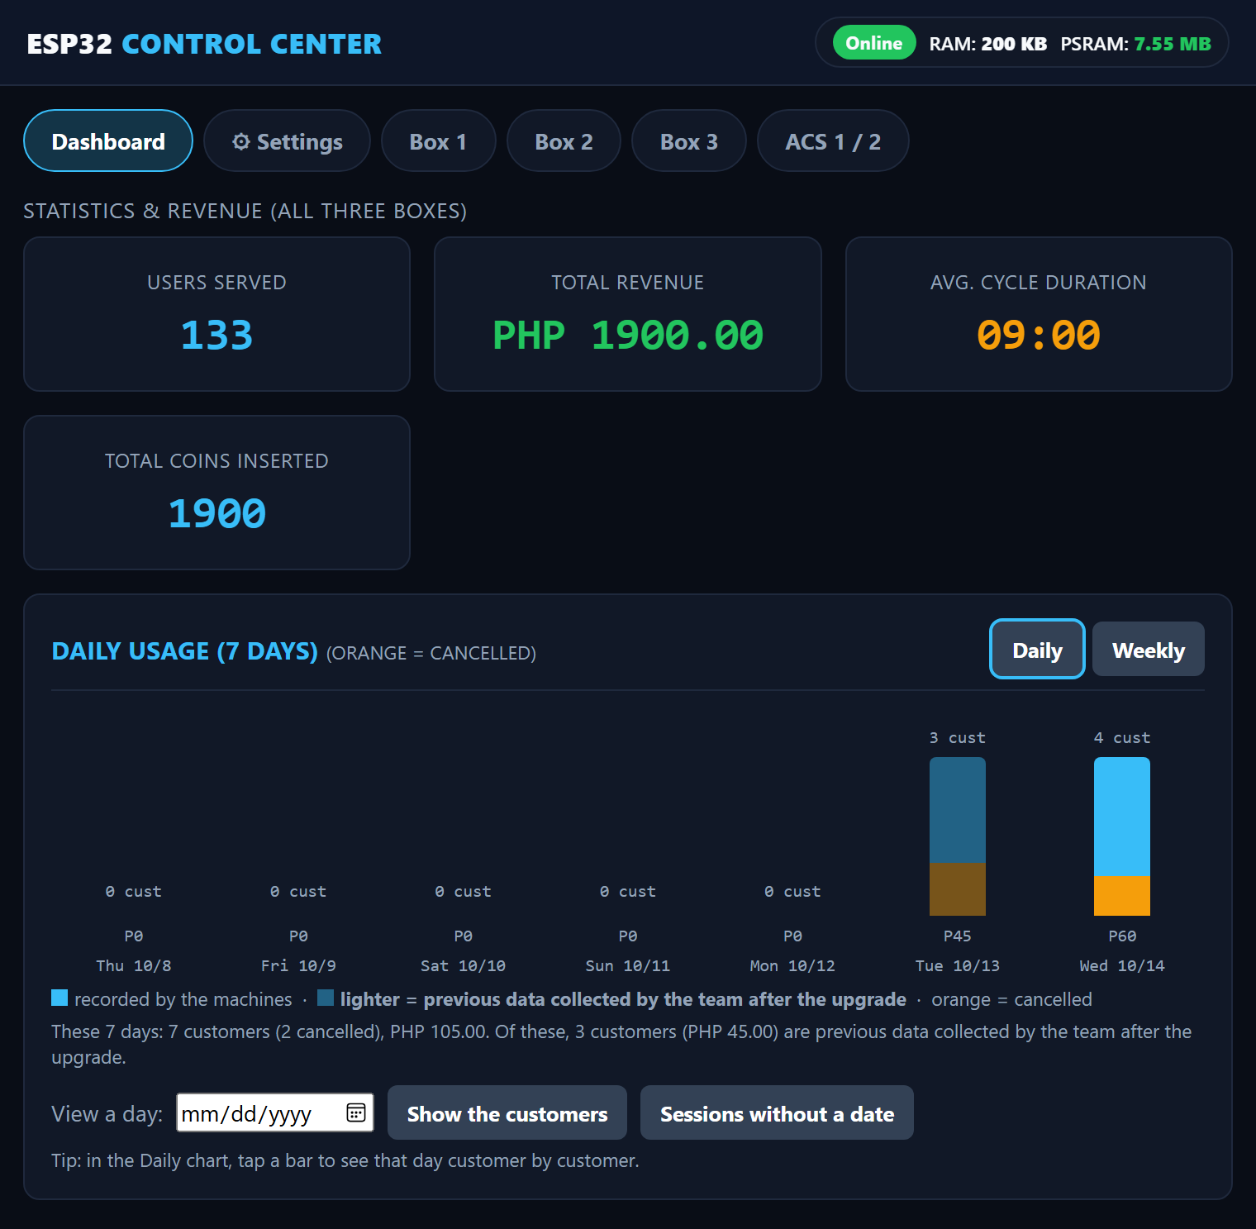
Statistics and the usage chart (lighter bars = previous data)

Finished and cancelled sessions
This card is the whole tally from the first day in one table: users served, coins, revenue and average time, for Finished and for Cancelled. Finished means the cycle ran to the end. Cancelled means the customer aborted in the middle; the coins that were paid still count as revenue. The line under the table says how much of the numbers came from the JSON file and how much the machines counted themselves, so nobody has to add two tables together.

A payment that is cancelled on the INSERT COIN screen is not counted as a session.

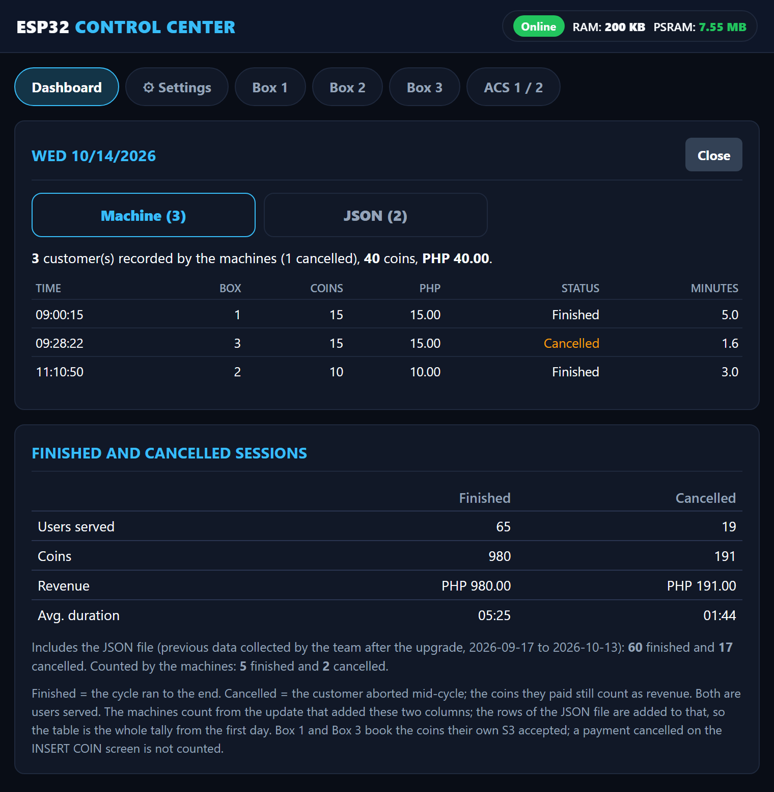
One day opened customer by customer (Machine tab), and the Finished and cancelled tally below it

Settings tab: clock, session log, backup and previous data
The Settings tab holds what you set once and rarely touch.
- Clock: the LocalServer has no clock of its own. A phone sets it when the Control Center is opened after a power-on, or you type the date and time. A power cut loses it.
- Session log: every session the machines report is saved with its date and time (never a name). The bar shows how much storage is used. Entries older than a year are dropped by themselves.
- Download log (CSV): this is the backup. Download it now and then and keep the file.
- Restore from backup CSV: if the log is ever lost (a power cut damaged the storage, or Reset Stats was tapped by mistake), choose the CSV here and tap the button. Only an unchanged download is accepted: the last line of the file is a check that is refused if anything was edited or the file was saved again in a spreadsheet. Sessions already on the board stay, nothing is added twice, and the totals are raised to at least the log's tally.
- Previous data (history.json): customers from before the log existed. The team builds the file with the ENTRY board (see below) or on a PC and uploads it here. The chart draws it lighter and the Finished and cancelled card adds it. It never changes the machine log, the totals or the CSV.
- Coin value (pesos per pulse) and Reset Stats: Reset Stats empties the counters and the machine log, so download the CSV first. The history file stays.
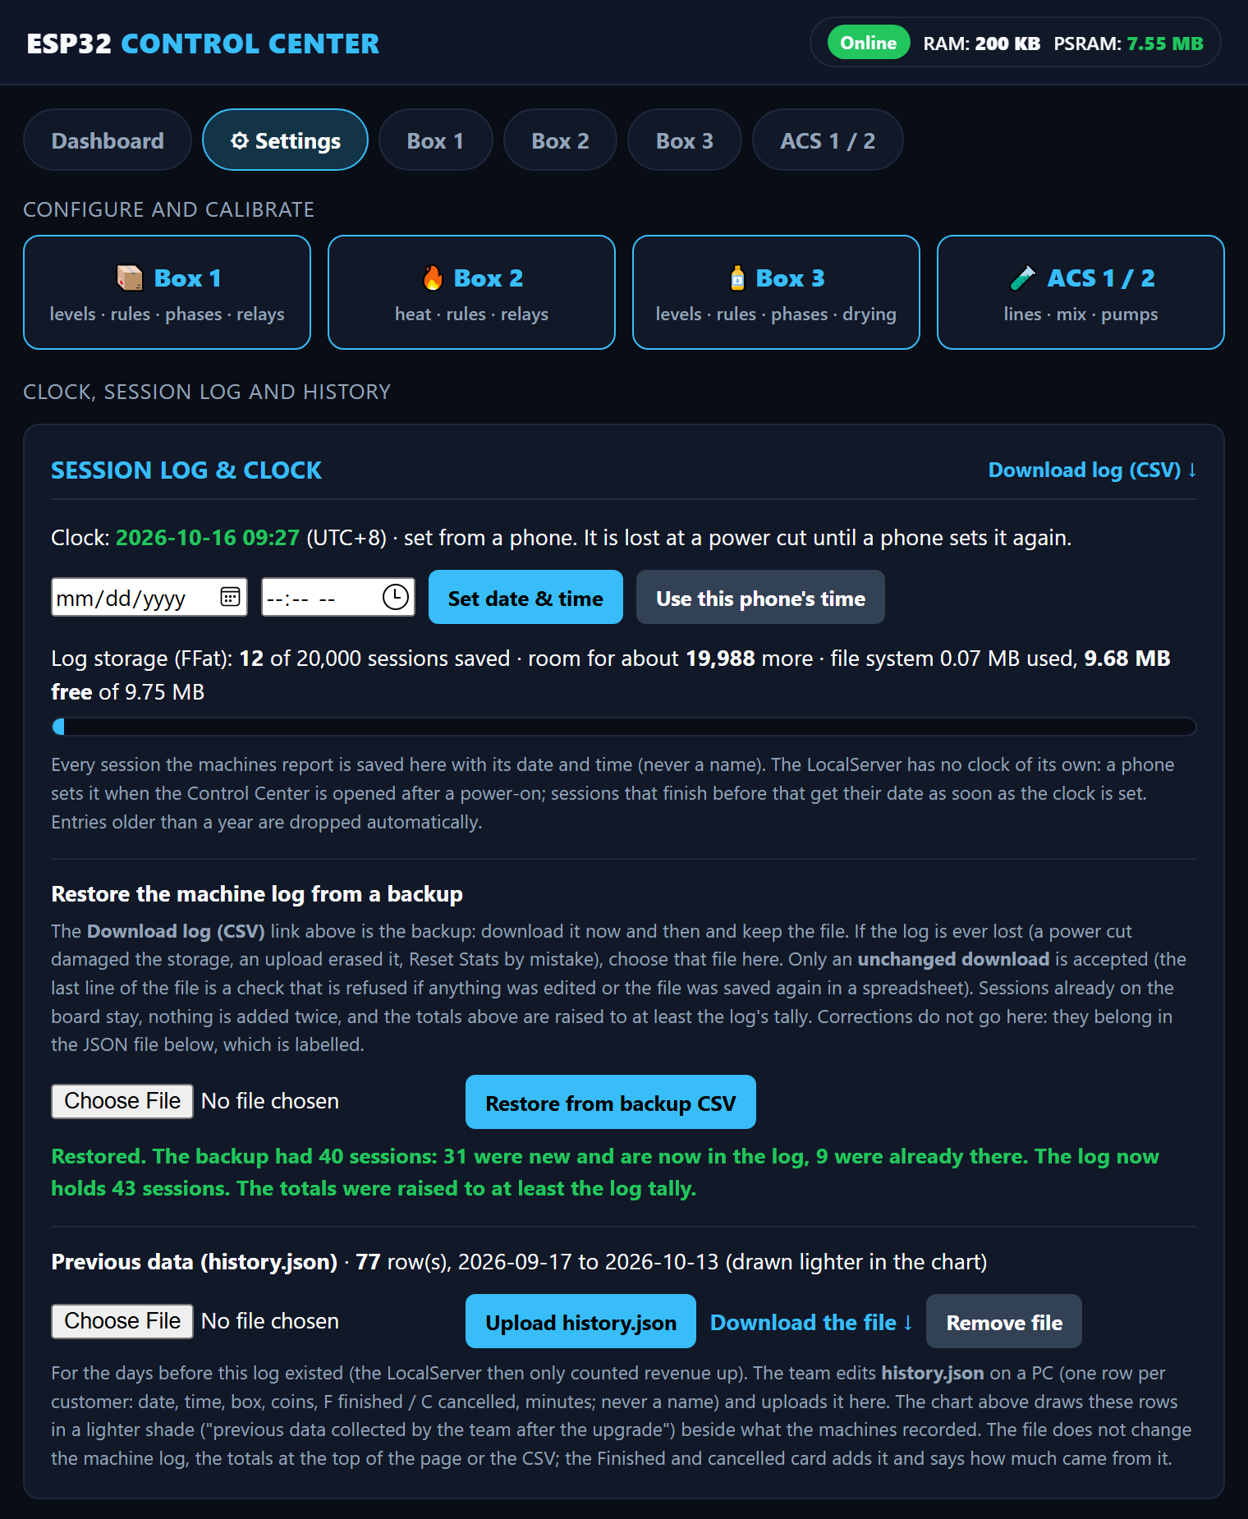
Settings: clock, session log, restore from a backup CSV and the previous data

The check line of the CSV stops mistakes and casual edits. It is not a lock. A correction to the data does not go into the machine log: it belongs in the JSON file, which is labelled as the team's own records.

Warnings and crash reports
Two red notes can appear on top of the Dashboard. The first says the board found damage in its memory. The second says the log storage was damaged and was re-created empty at the last start: open Settings, restore your last backup CSV, and send the history file again from the ENTRY board if you use it.
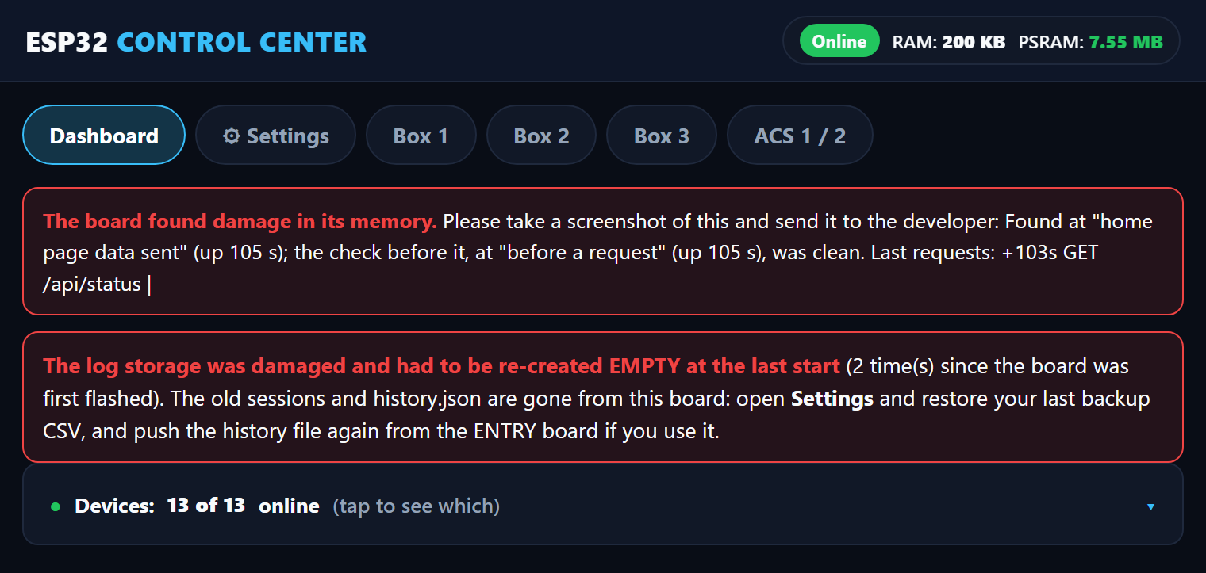
The two red notes on the Dashboard
If the unit ever restarts by itself you do not need a laptop. Open Settings and look at This board. The last restarts are kept in the board's own flash (a power cut does not erase them). Tap Crash reports kept on this board, take a screenshot and send it to the developer. Delete these reports clears the list.
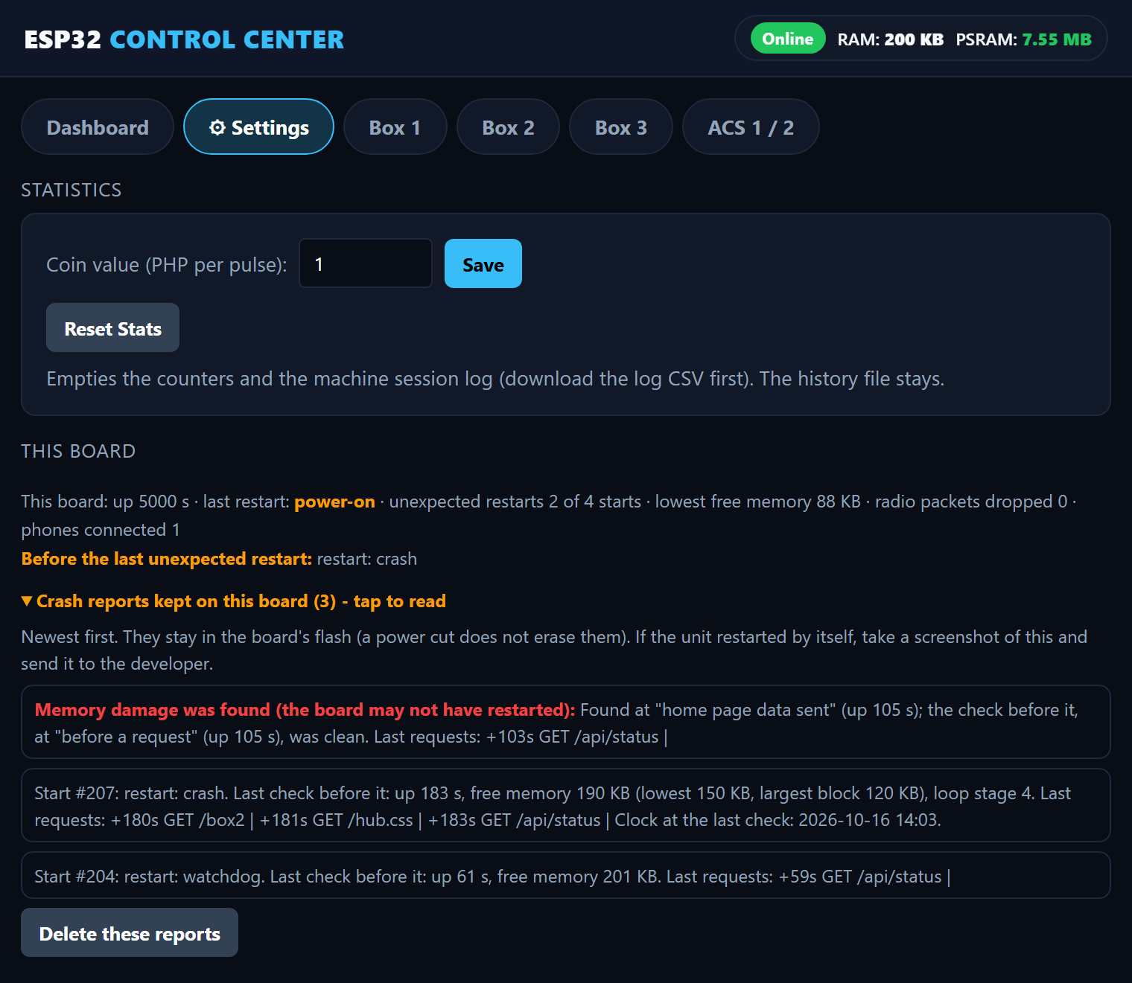
Settings, This board: the stored crash reports

ENTRY board (spare board for past customers)
The ENTRY board is a spare ESP32 with a simple form. With it the team types in the customers of the days before the LocalServer kept dates, from the team's own records (survey forms, photos, videos and so on), and sends them to the LocalServer as the previous-data file. It is not one of the 15 boards of the machines and nothing in a box needs it.
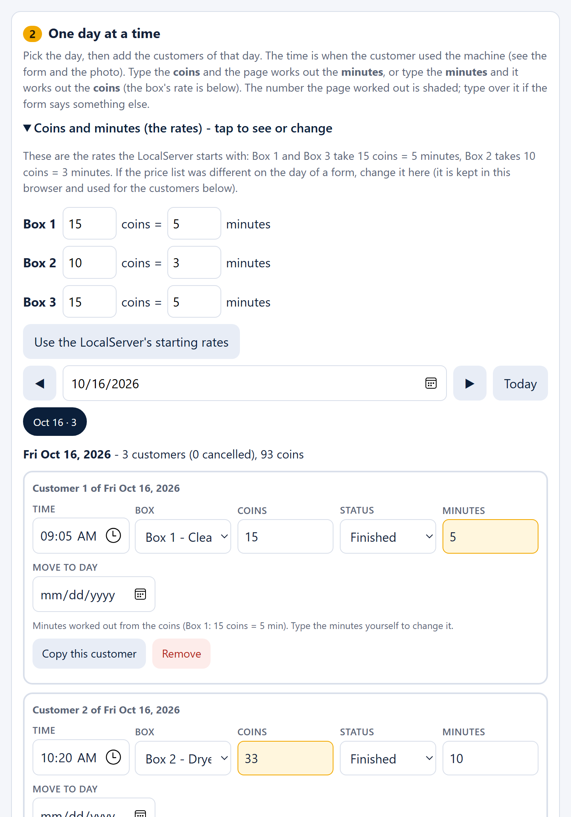
The ENTRY form: the rates box and customer cards (a shaded number was worked out by the page)
- Power the ENTRY board and the LocalServer.
- On a phone, join the Wi-Fi JollyHelmet-Entry (password 12345678). The form opens by itself. If it does not, open a browser and go to http://192.168.5.1.
- Pick a day, then tap Add a customer on this day. Each customer is one card: time, box, coins, Finished or Cancelled, minutes.
- Type the coins and the page works out the minutes, or type the minutes and it works out the coins. The rates start with the LocalServer's values (Box 1 and Box 3: 15 coins = 5 minutes; Box 2: 10 coins = 3 minutes). The number the page worked out is shaded: type over it if the form says something else.
- Copy this customer repeats a card and sets the new time to the first time plus its minutes.
- Tap Push to the LocalServer. The board joins JollyHelmet-Local by itself and sends the file. The LocalServer checks every row first and keeps its old file if anything is wrong.

A push replaces the previous data on the LocalServer with what is on the form. Tap What is on the LocalServer now first before you add more. Never type a name. If the LocalServer's Wi-Fi name or password is changed in its firmware, change LS_SSID and LS_PASS at the top of ESP32_ENTRY.ino too.

Box settings (rules, levels, phases)

Rules and prices
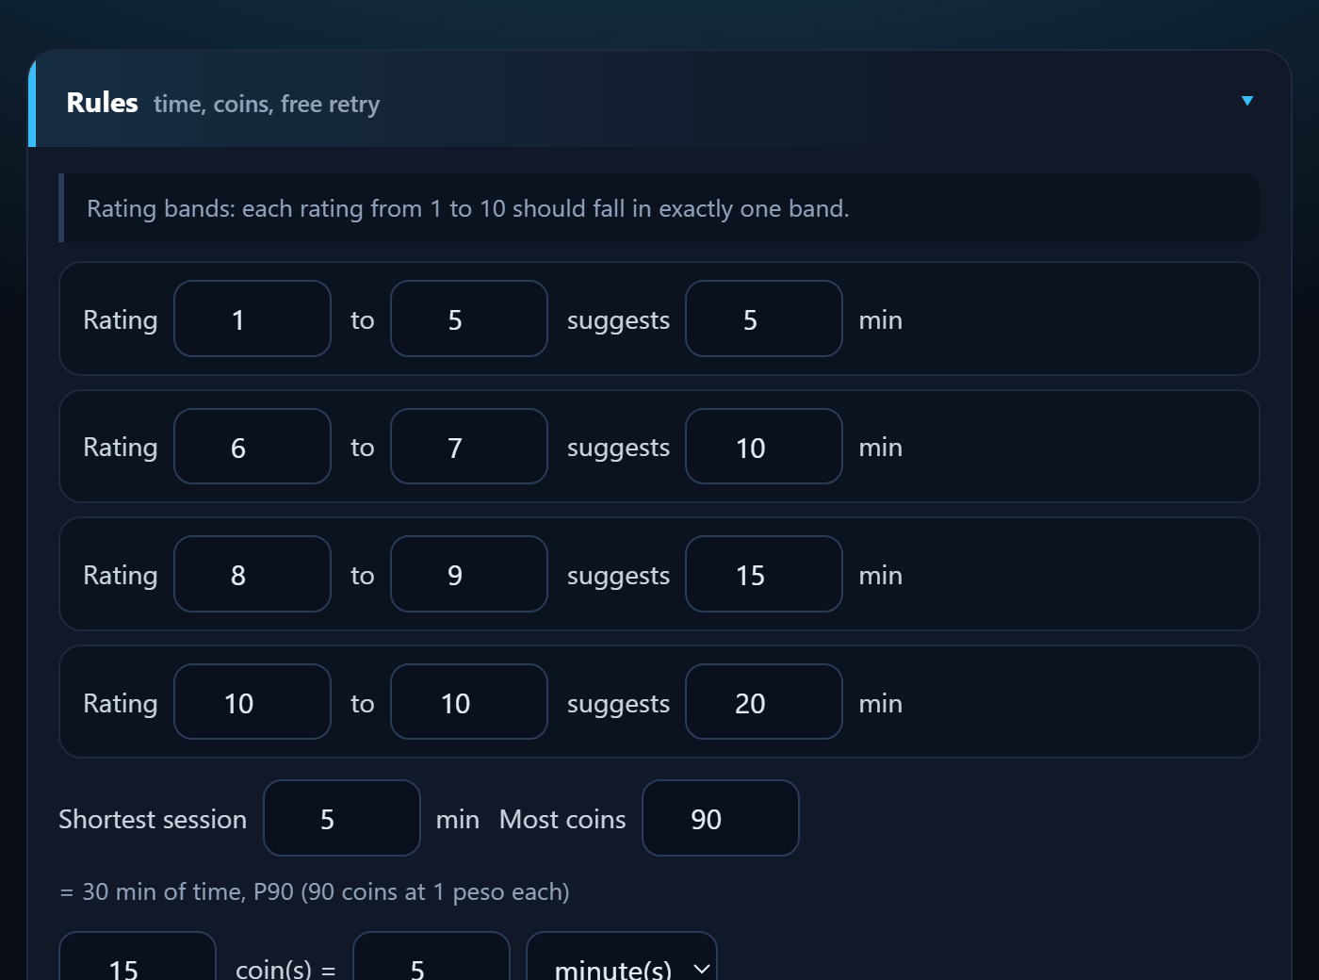
How to use it (Box 1, Box 2 and Box 3 have the same section):
- Open the box page, scroll to Rules.
- Set the rating bands (which ratings suggest how many minutes), the shortest session, the most coins and the coin rate (N coins = X minutes).
- Set the free retry (from which rating, for how many minutes).
- Tap Send RULES. A green tick means the box has saved them.

Containers and sensors
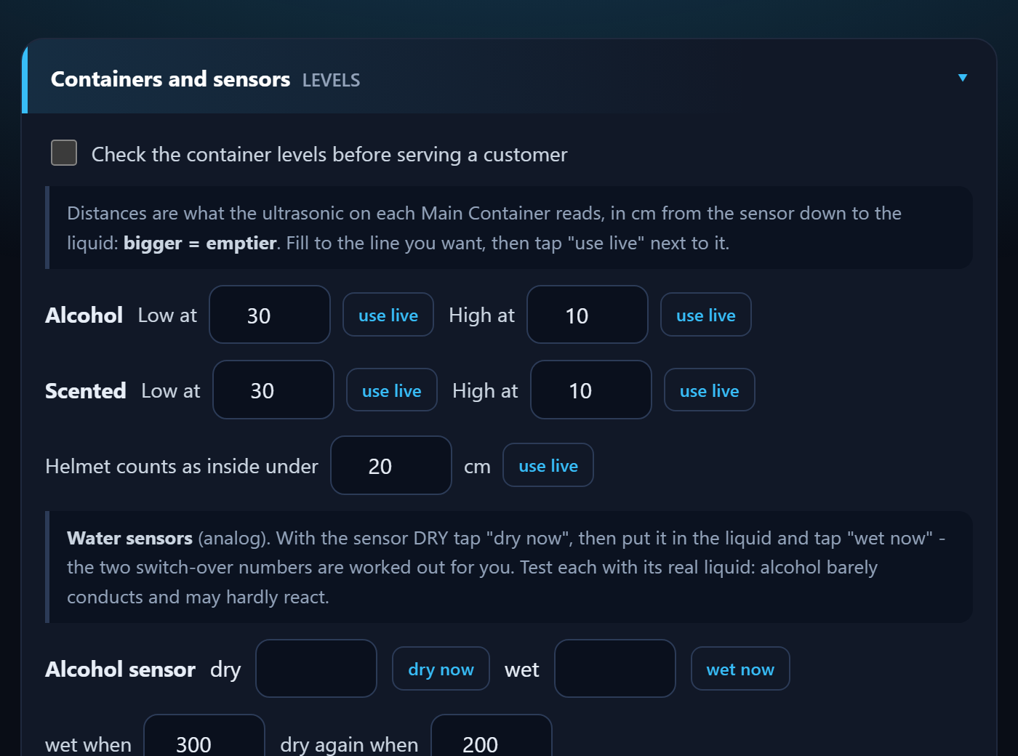
- Check the container levels: keep OFF until the numbers are measured.
- Low / High at: fill to the line, tap use live. Bigger number = emptier.
- Helmet inside under: put a helmet in, tap use live, raise it a little.
- Water sensors: dry now, then wet now in the real liquid (alcohol conducts poorly).
- Refill tries: tick send the request to the ACS only when the ACS works. Then tap Send LEVELS.

Cleaning phases
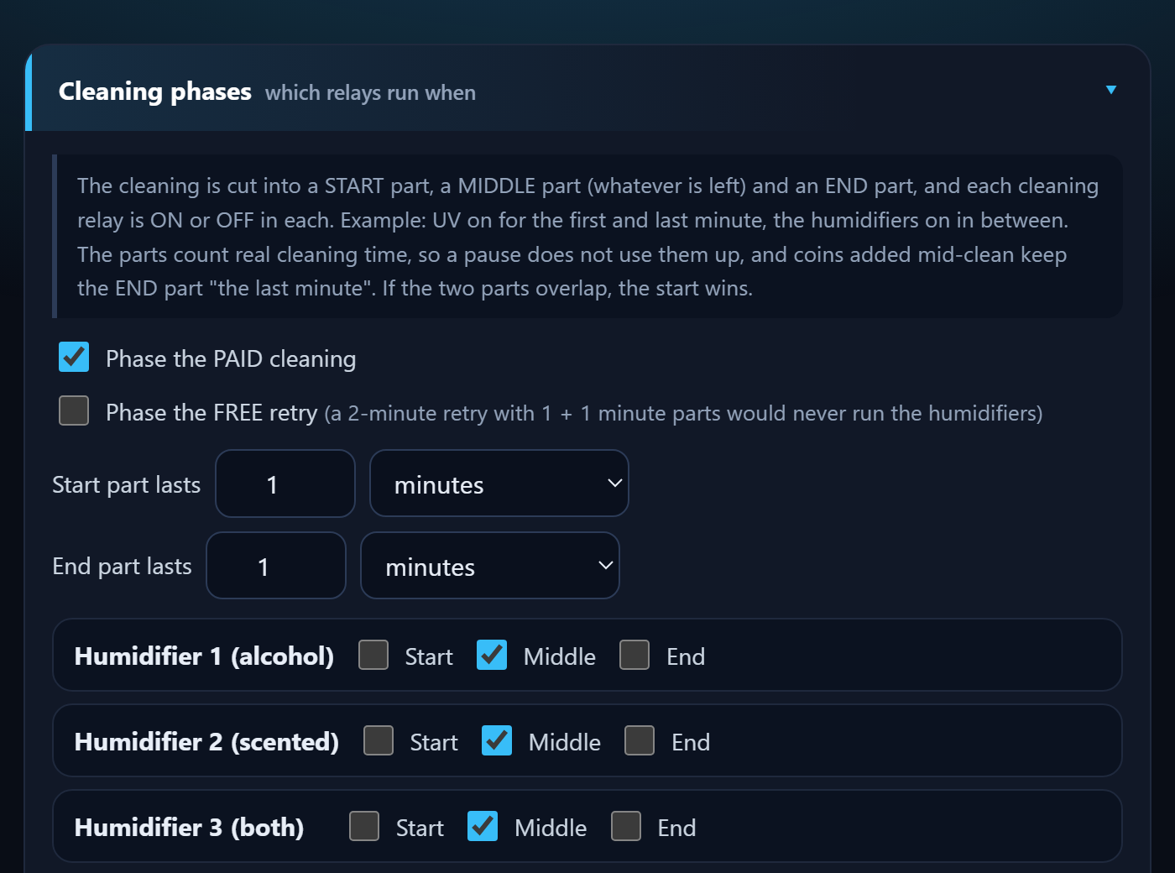
A cleaning is cut into a START part, a MIDDLE part and an END part. Tick when each relay is on.
- Example: UV on in Start and End, mist in the Middle.
- Always on = tick Start, Middle and End.
- Box 3: keep the HEATER in the End part only, never with a humidifier. The page warns you if they overlap.
- Paid cleaning and the free retry have their own tables.
Tap Send PHASES.

Heating and drying
- Box 2 - Heating: set the helmet distance (put a helmet in, use live) and the cool-down seconds (default 60, 5 to 900). Tap Send HEAT.
- Box 3 - Drying: set the cool-down seconds, then Send DRYING. The drying time itself comes from the customer's choice and the Rules.

Good to know
- Every setting is saved inside the box's own board, so it survives a power cut or a LocalServer replacement.
- If a number is outside its allowed range, the box refuses it. The green tick will not appear.
- Use Reload beside a Send button to bring back what the box really has.

Change one thing at a time and test it with a short session before leaving it.

Screen refresh and maintenance

Screen (touch display)
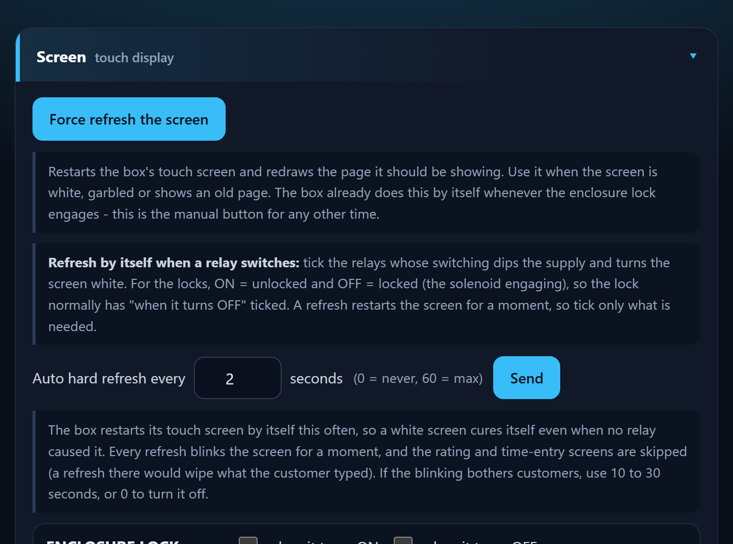
A heavy load switching on can make the touch screen go white. Three tools cure it:
- Force refresh the screen: restarts it now.
- Auto hard refresh every N seconds: restarts it by itself (0 = never, 60 = max). Rating and number-pad screens are skipped.
- Refresh when a relay switches: tick the relays (ON and/or OFF) that should trigger it. The lock is normally ticked OFF.

OPEN A / OPEN B beep
While a box waits at OPEN A or OPEN B for the door to be opened, it beeps again and again (beep, wait, beep, wait) until the door opens. You set the length of the beep and of the wait on each box page, in the section OPEN A / OPEN B beep.
- Beep for 20 to 1000 ms, then wait 0 to 10000 ms. A wait of 0 gives one beep only.
- Tap Send. The box keeps the values in its own memory. The default is a beep of 100 ms and a wait of 500 ms.
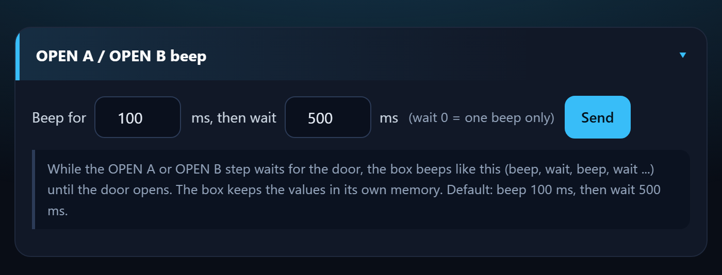
The OPEN A / OPEN B beep section of a box page

Maintenance mode
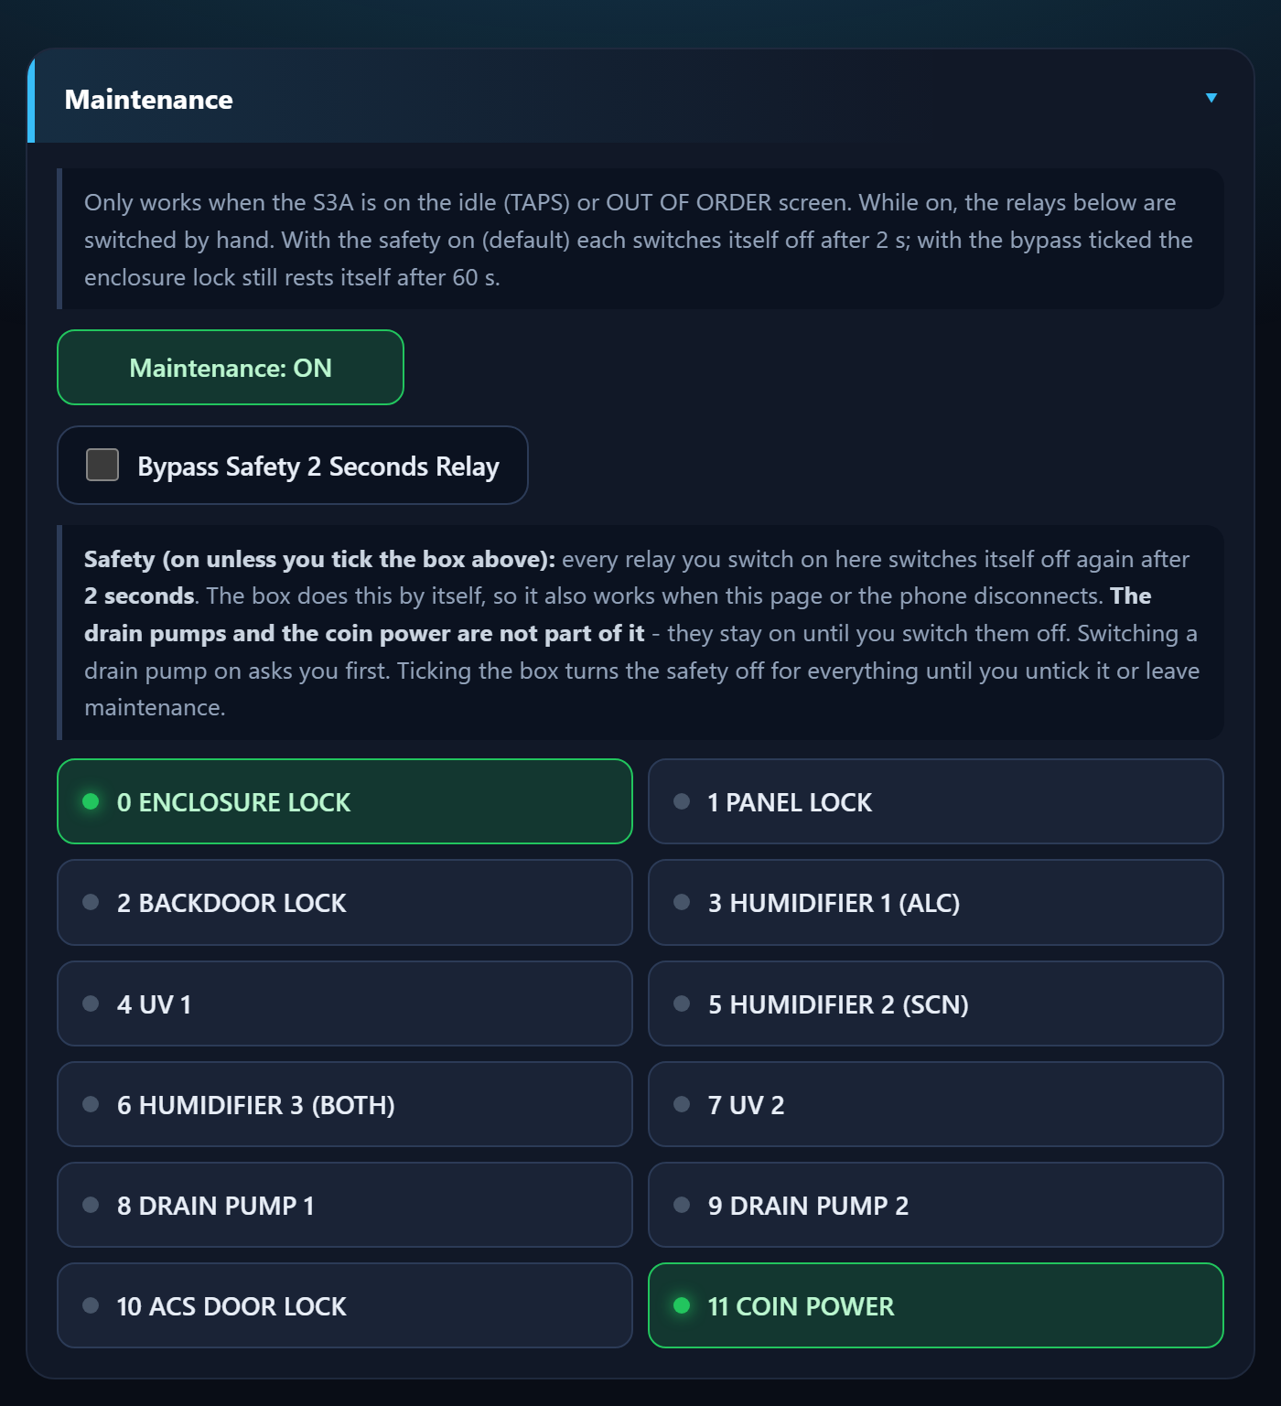
- Make sure the station is on its start screen (TAPS) or OUT OF ORDER.
- Tap Maintenance. The machine shows MAINTENANCE.
- Tap a relay button to switch it on by hand. Green = on. With the safety on it switches itself off again after 2 seconds (see below); tap it again to repeat.
- Tap Maintenance again. Everything switches off.

With the safety on, a relay you switch on by hand goes off by itself after 2 seconds. With the bypass ticked the heater turns itself off after 5 minutes and the lock after 60 seconds. Keep the door shut and clear when testing the heater.

The 2-second safety and the drain pump warning
So that a forgotten tap cannot leave a lamp, a humidifier, the heater or a lock running, every relay you switch on in Maintenance switches itself off again after 2 seconds. The box does this by itself, so it also works if the phone or the page disconnects.
- Bypass Safety 2 Seconds Relay: tick it when a relay must stay on, for example to watch a humidifier make mist. The safety is then off for every relay until you untick the box or leave Maintenance. The heater still turns itself off after 5 minutes (Box 2 and Box 3) and the enclosure lock rests after 60 seconds.
- Drain pumps and coin power are not part of the 2-second safety (Box 1 and Box 3). They stay on until you switch them off.
- Drain pump warning: tapping a drain pump first shows a WARNING window ("You are now toggling Drain Pump 1 ON"). Tap Yes, turn it ON only when the drain tube is connected and the container can take the liquid. No, cancel (or Esc, or a tap outside the window) does nothing, and No is the default.
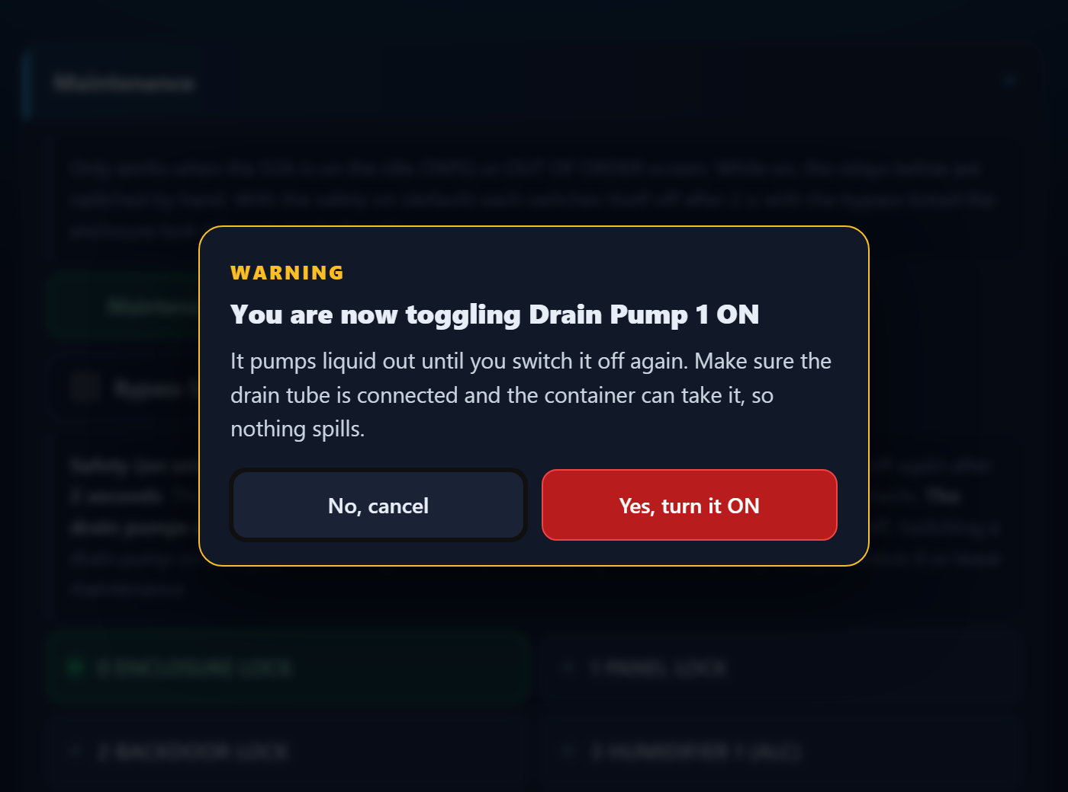
The drain pump warning in Maintenance (No is the default answer)

Check the drain tube and the container before you tap Yes. A drain pump that is left on keeps pumping until you switch it off.

Refill station (ACS)
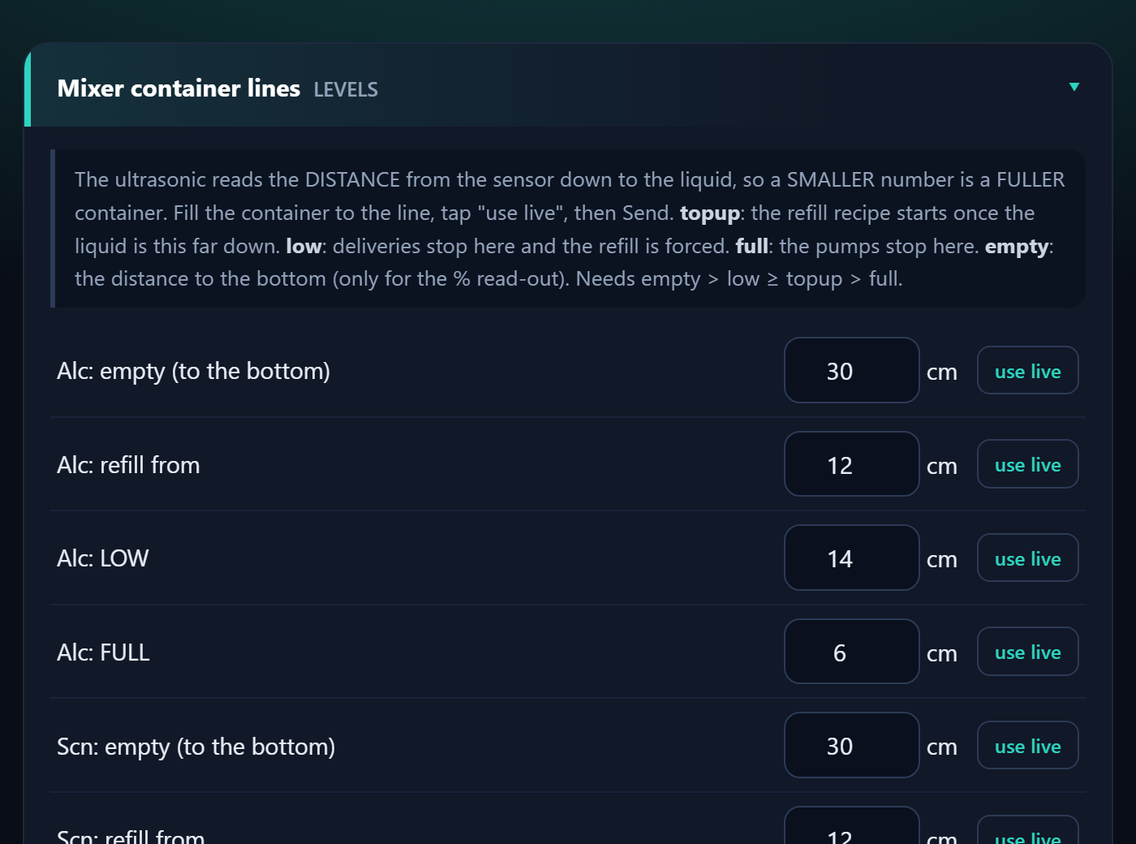
ACS 1 refills Box 1, ACS 2 refills Box 3. Each has three supply tanks (water, alcohol, scented), two mixer containers, and six pumps. Choose the ACS at the top of the page.
- When a mixer drops to its refill from line, the ACS adds water first, then the alcohol (or scented liquid) up to FULL.
- When a box asks, the matching mixer pump sends one short shot to the box.

Setting up the ACS
- Mixer container lines: fill each mixer to the line and tap use live for refill from, LOW, FULL and empty. Smaller number = fuller. Tap Send LEVELS.
- Mix: the water share of each top-up (30% water = 70/30 alcohol). Tap Send MIX.
- Timing / water-level sensors: use dry now / wet now for each sensor and Work out the thresholds. Tap Send TIMING.
- Check the pumps one at a time in Maintenance before the first automatic run.

Use plain water in all three supply tanks for the first test.

Reading the ACS

You see | It means
IDLE | Nothing to do. Mixers are above the refill line.
ALC WATER IN  ALC ALCOHOL IN | Filling the alcohol mixer: water, then alcohol.
SCT WATER IN  SCT SCENTED IN | Filling the scented mixer.
DELIVER ... | Sending one shot to the box.
WATER / ALCOHOL / SCENTED EMPTY | That supply tank is empty (or its pump is dead). The pump stopped and it retries in 5 minutes.
Half-made mix | A recipe was interrupted. The mixer is not delivered until it is finished.

Try it and fix it
- Ask: alcohol / scented pretends to be the box and makes one delivery shot. Stop cancels it.
- Retry now forgets an EMPTY verdict after you refilled a tank.
- Mixers are fine as they are clears the half-made flag when the mixers really hold good mix.
- Maintenance: run each of the six pumps by hand, one at a time. Each pump stops itself after 60 seconds.

Refilling a supply tank
- The three supply tanks have no sensors: look at them during your daily check.
- Refill the tank that is low or reported EMPTY.
- Tap Retry now.

Never run a pump dry. If liquid does not move when a pump runs, check the tube and the relay wiring first.

Troubleshooting and care

Troubleshooting

Problem | What to do
Screen white or garbled | Box page, Force refresh the screen. If it returns, tick the relay that causes it or lower the auto-refresh time.
A board shows OFFLINE | Check its power and wiring, then watch its badge in the Devices list on the Dashboard.
Station shows OUT OF ORDER | One board is silent (sensor or relay board). See the offline badges.
CLEANING is UNAVAILABLE | Containers are low. Check the ACS; refill, then Retry now.
Coins not counted | Use the coin check on the box page: pulses should rise by the coin's value.
Touch is off or upside down | The terminal needs its touch calibration or rotation checked.
Settings, This board, says last restart BROWNOUT | Power dipped. Use a stronger supply and a short cable.
Door will not open, helmet stuck | Slide the safety lock down (lower left of the enclosure door): it unlocks the door at once, with or without power. Then find the cause: box page, Maintenance, ENCLOSURE LOCK (Fix it: The door will not open).
A red note says the board found damage in its memory, or the unit restarted by itself | Settings, This board, Crash reports kept on this board. Take a screenshot and send it to the developer. The reports stay after a power cut.
A red note says the log storage was damaged and re-created empty | Settings, Restore from backup CSV with your last downloaded log. Send the history file again from the ENTRY board if you use it.
A relay in Maintenance switches itself off | That is the 2-second safety. Tick Bypass Safety 2 Seconds Relay to keep it on, and untick it when you are done.
A phone cannot find the Control Center | Join the Wi-Fi JollyHelmet-Local (the old name ESP32_LOCAL is no longer used). Then open http://192.168.4.1.

Care and spare parts

Daily check
- Dashboard: the Devices line says every board is online, no red banner.
- Look at the three ACS supply tanks (they have no sensors).
- Check the revenue and the number of users.

When a board breaks
- Keep one spare ESP32 per role, flashed and labelled (A1, S3B, ACS 2...).
- Swap it in and wire it exactly like the old one.
- Watch its badge turn ONLINE in the Devices list on the Dashboard, then re-enter that box's settings if they were lost.
- After rewiring, test each relay or pump by hand in Maintenance first.

S3A, S3B, S3C and the LocalServer are ESP32-S3 boards (16 MB, OPI PSRAM). The relay boards A3 and B3 must be plain ESP32 boards.

Online page (Monitor, Alerts, Reports)
The online page shows your machines on a phone or a PC, wherever you are. It only watches: nothing on it can start, stop or change a machine. Open it with the address your technician gave you. The first time it asks for the Blynk token: paste it once, it stays in that browser.

The tabs

Tab | What it is for
Monitor | The live state of every box and refill station, the level dials, the revenue and the customers served.
Alerts | What needs attention now, a log of what happened, and the sound of each alert.
Reports | Revenue and customers per day, the busiest hours and days, what each box earns. CSV files and a printable report.
Checklist | The daily, weekly and monthly checks. Tap them as you do them.
Fix it | Yes / no questions that lead you to the fix. The same guides as the decision trees in the Reference chapter.
Manual | This manual. The customer chapters are open to everybody. The admin, technician and reference chapters open with the team password.
QR button | The QR code and a printable sign for the customer page. Stick the sign on every machine.

Level dials
Every container has a dial. 0 is the refill line: a box stops cleaning there. The dial is green when the container is fine, amber from the early warning line (30 %) and red under 15 %. So you can refill before a box shows OUT OF ORDER. Under each dial the page says whether the level is falling and about how long it will last.
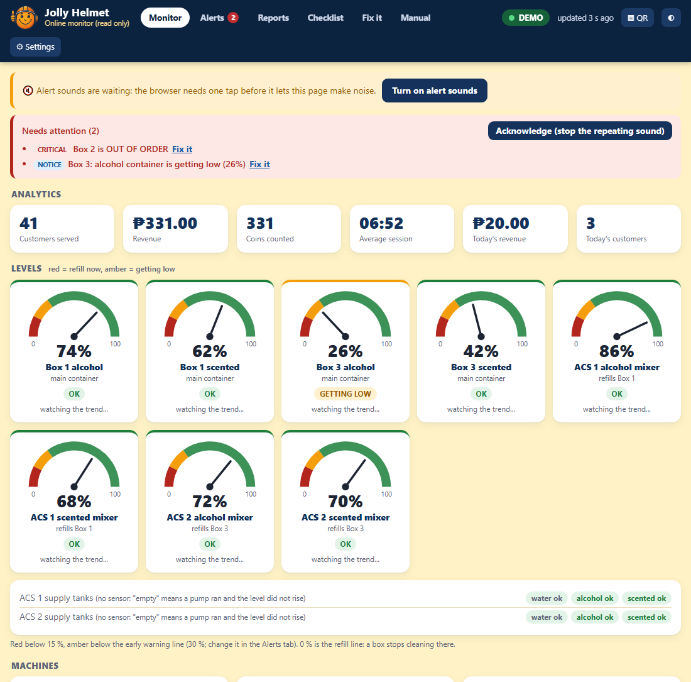
The Monitor tab: alerts at the top, the level dials, then the machines (demo data)

Alerts and sounds
When something needs attention the page shows a banner, puts a number on the tab and the tab icon, and plays a sound. Every kind of alert has its own sound, so you can tell them apart without looking.

Alert | Level | Sound | What to do
A box is OUT OF ORDER | Critical | Siren. Repeats. | Fix it: A box shows OUT OF ORDER. Usually a container needs a refill or a board is offline.
An ACS supply tank is empty | Critical | Alarm. Repeats. | Fill that tank, then use Retry now on the ACS page.
No board is heard at all | Critical | Alarm. Repeats. | Check the power and the radio at the site. Fix it: A board shows OFFLINE.
A door was opened during a run | Warning | Three rising beeps, twice | The run continues when the door is shut. Find out why it was opened.
A container is low (under 15 %) | Warning | Three beeps | Refill it now.
An ACS mixer is low, cleaning is switched off, a board is offline | Warning | Two tones (ding-dong) | Look at the ACS tanks and the Dashboard. Use Fix it.
The data is old, or Blynk cannot be read | Warning | Falling tones | Check the internet at the site and the Online Server. Fix it: The web page says OLD DATA.
A container is getting low | Notice | Soft blip | Plan a refill.
A maintenance check is overdue | Notice | Soft blip | Open the Checklist tab.
An alert cleared | Info | Chime | Nothing: it is back to normal.

- A browser keeps a page silent until you have tapped it once. Tap Turn on alert sounds, then keep the page open (a background tab is fine).
- Press Acknowledge to stop a repeating alarm. A new alert still sounds.
- In the Alerts tab you can change the sound of every alert, switch one off, set the volume, change how often a critical alert repeats and move the early warning line.
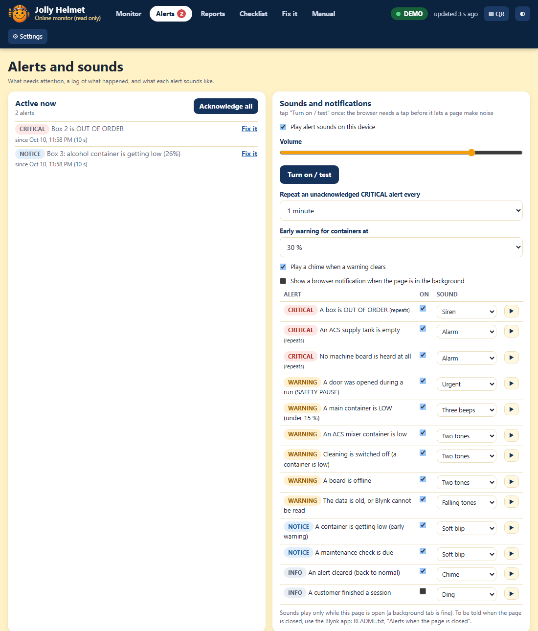
The Alerts tab: active alerts, the sound settings and the log (demo data)

A page that is closed, or a phone that is locked, cannot play a sound. For alerts on a closed page use the Blynk app (Technician guide, Online monitoring, Alerts when the page is closed).

Reports
- Revenue and customers per day for the last 14 days, with the 7-day average, and this week against the week before.
- Busiest hours and busiest days: when the customers come.
- What each box earns: sessions, revenue and the share of each box.
- Daily CSV, Last sessions CSV and Boxes and hours CSV open in Excel. Print / save as PDF makes a clean report page.
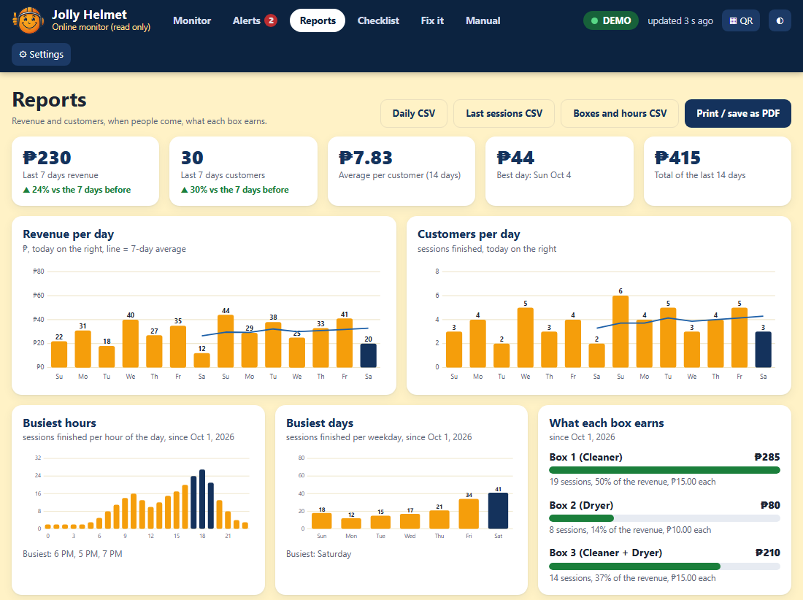
The Reports tab (demo data)

Checklist and Fix it
The Checklist follows the maintenance schedule of the Technician guide. Tap a machine under a check when you have done it there. The page shows when each check was last done and what is due. It is saved in the browser you use: use Save a backup to move it to another phone.
Fix it asks one yes / no question at a time and ends with what to do. If an alert is on, the matching guide is suggested at the top.
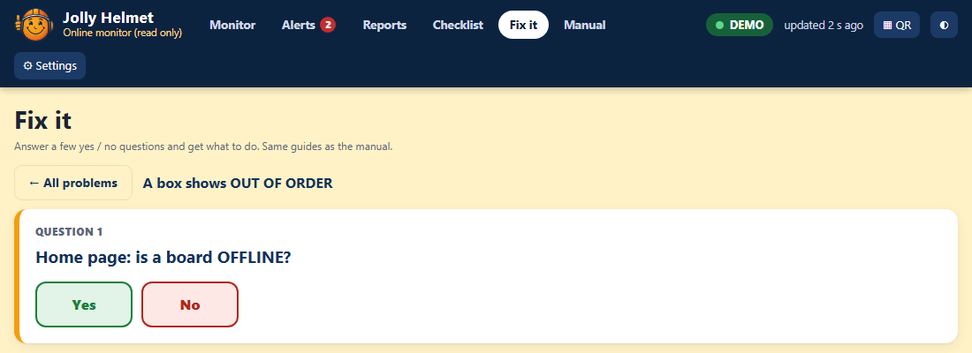
Fix it: one question at a time

Technician guide (Hardware, online monitoring and maintenance)
Components, pinouts, wiring, firmware, online monitoring and maintenance

How it is built
Each machine is a small team of ESP32 boards that talk by radio (ESP-NOW, channel 1). The only wires between the boards are power wires.
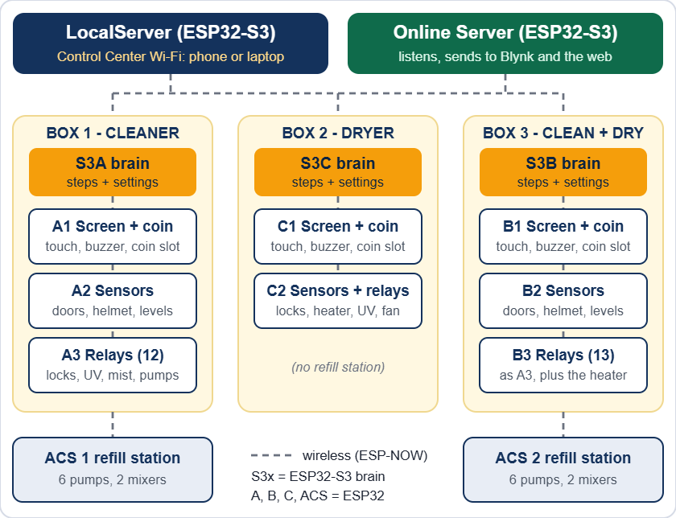
The whole installation: three boxes, two refill stations, the LocalServer and the Online Server

The 15 boards

Board | Where | What it does (sketch folder)
S3A | Box 1 | Brain. Runs every step and keeps the settings. (ESP32_S3A)
A1 | Box 1 | Touch screen, coin slot, buzzer. (ESP32_A1)
A2 | Box 1 | Sensors: 4 doors, helmet, 2 containers, 2 water sensors. (ESP32_A2)
A3 | Box 1 | 12 relays: 4 locks, 3 humidifiers, 2 UV, 2 drain pumps, coin power. (ESP32_A3)
S3C | Box 2 | Brain. (ESP32_S3C)
C1 | Box 2 | Touch screen, coin slot, buzzer. (ESP32_C1)
C2 | Box 2 | 3 door sensors, helmet sensor and 6 relays: 3 locks, heater, UV, fan. (ESP32_C2)
S3B | Box 3 | Brain. (ESP32_S3B)
B1 | Box 3 | Touch screen, coin slot, buzzer. (ESP32_B1)
B2 | Box 3 | Sensors, same as A2. (ESP32_B2)
B3 | Box 3 | 13 relays: same as A3 plus the heater. (ESP32_B3)
ACS 1 | Box 1 refill | 6 pumps, 2 mixer containers (ultrasonic and water sensor each). (ESP32_ACS1)
ACS 2 | Box 3 refill | Same as ACS 1. (ESP32_ACS2)
LocalServer | Control Center | Wi-Fi JollyHelmet-Local, settings pages, revenue. Also broadcasts its revenue totals for the Online Server. (ESP32_LOCALSRV)
Online Server | Online | Listens to the machines and sends a snapshot to Blynk for the web page. Never controls anything. (ESP32_ONLINESRV)

Brains and terminals
- Brains (S3A, S3B, S3C, LocalServer, Online Server) are ESP32-S3 boards with 16 MB flash and 8 MB PSRAM. Nothing is wired to them except power.
- Terminals (the A, B, C and ACS boards) are plain ESP32 (WROOM) boards on screw-terminal expansion boards. They hold every sensor, relay and display wire. A3 and B3 must not be WROVER (PSRAM) boards, because GPIO 16 and 17 are relays.
- Settings are saved inside the brains (S3A, S3B, S3C) and the ACS boards. The LocalServer only saves the revenue numbers. The Online Server saves its own Wi-Fi, Blynk token and the daily revenue history.
- If a terminal hears nothing from its brain for 15 seconds, it switches its relays off (heater, UV, mist, pumps, coin power). If a helmet is stuck behind a closed door, it also lets the enclosure lock go.
- The enclosure door also has a mechanical safety slide (lower left) that unlocks it by hand, with no power and no firmware.

Component list
Quantities are for the whole installation: Box 1, Box 2, Box 3, ACS 1 and ACS 2.

Boards and display

Item | Qty | Used in
ESP32 DevKit (ESP32-WROOM-32) with screw-terminal expansion board | 10 | A1 A2 A3 B1 B2 B3 C1 C2 ACS 1 ACS 2
ESP32-S3 DevKit N16R8 (16 MB flash, 8 MB OPI PSRAM) | 5 | S3A S3B S3C LocalServer Online Server
2.8 in SPI TFT with resistive touch (ST7789, 240 x 320) | 3 | A1, B1, C1
Allan multi-coin acceptor, 12 V | 3 | One per box
Active buzzer | 3 | A1, B1, C1
Resistor 10 kΩ | 3 | Coin signal lines

Sensors

Item | Qty | Used in
MC-38 magnetic door sensor (reed) | 11 | Box 1: 4, Box 2: 3, Box 3: 4
Ultrasonic distance sensor HC-SR04 (5 V) | 11 | Helmet: 3 (one per box). Main containers: 4. ACS mixers: 4.
Analog water-level sensor | 8 | Box 1: 2, Box 3: 2, ACS 1: 2, ACS 2: 2

Relay boards

Item | Qty | Used in
16-channel relay board, active-LOW | 2 | A3 (12 used), B3 (13 used)
6-channel relay module | 1 | C2 (all 6 used)
8-channel relay module with JD-VCC | 2 | ACS 1, ACS 2 (6 used each)

Loads

Item | Qty | Used in
12 V solenoid door lock | 11 | Box 1: 4 (enclosure, panel, back, ACS side). Box 2: 3. Box 3: 4.
Humidifier (mist maker), 5 V | 6 | Box 1: 3, Box 3: 3 (alcohol, scented, both)
Drain pump, 5 V | 4 | Box 1: 2, Box 3: 2
Refill pump, 5 V | 12 | ACS 1: 6, ACS 2: 6
UV-C germicidal disinfection lamp, 220 V | 5 | Box 1: 2, Box 2: 1, Box 3: 2
Heater (hair dryer), 220 V | 2 | Box 2, Box 3
Fan, 5 V | 1 | Box 2 cool-down

Power and protection

Item | Qty | Used in
12 V power supply | 5 | Locks, coin slots and the DC-DC modules
DC-DC power module, 12 V in, 3.3 V and 5 V out (multi output) | 5 | All ESP32 boards, screens, relay boards, sensors, mist makers, pumps
Diode 1N4007 | 11 or more | One across every lock solenoid
Fuses, 220 V inlet or outlets, earth | - | Mains side: UV-C lamps and heaters

Not electrical: 2 main containers (alcohol, scented) in Box 1 and in Box 3. In each ACS: 3 supply tanks (water, alcohol, scented) and 2 mixer containers. Tubing and fittings.

What is in each unit

Item | Box 1 | Box 2 | Box 3 | ACS 1 | ACS 2
ESP32 terminal boards | 3 | 2 | 3 | 1 | 1
ESP32-S3 brain | 1 | 1 | 1 | - | -
Touch screen, coin slot, buzzer | 1 | 1 | 1 | - | -
Door sensors | 4 | 3 | 4 | - | -
Ultrasonic sensors | 3 | 1 | 3 | 2 | 2
Water-level sensors | 2 | - | 2 | 2 | 2
Door locks | 4 | 3 | 4 | - | -
Humidifiers | 3 | - | 3 | - | -
Drain pumps | 2 | - | 2 | - | -
Refill pumps | - | - | - | 6 | 6
UV-C lamps (220 V) | 2 | 1 | 2 | - | -
Heater | - | 1 | 1 | - | -
Fan | - | 1 | - | - | -

Pinouts
GPIO numbers are the ESP32 pin names (D4 = GPIO4). Every relay input is active-LOW: the pin goes LOW to switch the relay ON. These tables match the flashed firmware and the pin sheet RevisedJollyHelmet_Checked.xlsx.

Relay input numbers (IN1, IN2...) come from the Cirkit drawing. The GPIO is what the firmware drives. If a relay sits on a different input, trust the GPIO and fix the label.

S3A, S3B, S3C and LocalServer - nothing to wire
These four boards have no external wiring: power (5 V) and the USB cable for flashing only. GPIO 35, 36 and 37 are used inside the module by the OPI PSRAM: never connect anything to them.

A1, B1, C1 - screen, coin slot, buzzer
Identical wiring on A1, B1 and C1, with one difference: the coin signal of C1 is on GPIO 32 (A1 and B1 use GPIO 23).

GPIO | Signal | Wired to
15 | TFT CS | Display CS
4 | TFT RESET | Display RST
2 | TFT DC | Display DC (RS)
13 | MOSI (shared) | Display SDI (SDA) and touch T_DIN
14 | SCK (shared) | Display SCK (SCL) and touch T_CLK
27 | Touch CS | Touch T_CS
12 | Touch MISO | Touch T_DO
23 (C1: 32) | Coin signal | Allan COIN, through a 10 kΩ resistor
21 | Buzzer | Active buzzer +
5V | Display power | Display VCC and LED (BLK)
GND | Ground | Display, coin acceptor, buzzer -

- Not connected: display SDO (MISO), touch T_IRQ, coin COUNTER.
- Coin acceptor 12 V: from the COIN POWER relay on A3 and B3 (Box 1, Box 3). Straight from the 12 V supply in Box 2.
- Free pins on A1 and B1: 5, 16, 17, 18, 19, 22, 25, 26, 32, 33. Free pins on C1: 5, 16, 17, 18, 19, 22, 23, 25, 26, 33.

A2, B2 - sensors (Box 1, Box 3)

GPIO | Signal | Wired to
26 | Helmet ultrasonic TRIG | Sensor TRIG
25 | Helmet ultrasonic ECHO | Sensor ECHO
32 | Alcohol container TRIG | Sensor TRIG
33 | Alcohol container ECHO | Sensor ECHO
23 | Scented container TRIG | Sensor TRIG
22 | Scented container ECHO | Sensor ECHO
27 | Enclosure door | MC-38 sensor S
14 | Panel door | MC-38 sensor S
19 | Back door | MC-38 sensor S
18 | ACS side door | MC-38 sensor S
34 | Alcohol water sensor | SIG (analog, input only)
35 | Scented water sensor | SIG (analog, input only)

- Ultrasonic VCC 5 V. Water sensors 3.3 V. Door sensors: the other wire goes to GND, the ESP32 supplies the pull-up (closed = LOW).
- Free pins: 2, 4, 12, 13, 15, 16, 21.

A3 - Box 1 relays (16-channel board)

GPIO | Input | Load | Supply
4 | IN1 | Enclosure door lock | 12 V
16 | IN2 | Panel door lock | 12 V
17 | IN3 | Back door lock | 12 V
23 | IN4 | ACS side-door lock | 12 V
18 | IN5 | Humidifier 1 (alcohol) | 5 V
19 | IN6 | Humidifier 2 (scented) | 5 V
25 | IN7 | Humidifier 3 (both) | 5 V
22 | IN9 | Coin power (the coin slot's 12 V) | 12 V
27 | IN10 | UV-C lamp 1 | 220 V
21 | IN11 | UV-C lamp 2 | 220 V
33 | IN12 | Drain pump 1 (alcohol container) | 5 V
32 | IN13 | Drain pump 2 (scented container) | 5 V

- Supply column: what each load runs on. The UV-C lamps are 220 V: the relay contact switches the live wire (see Switching 220 V loads). Locks and the coin slot are 12 V, humidifiers and drain pumps 5 V.
- IN8 and IN14 to IN16 are not used. GPIO 2, 12 and 15 are left idle (boot pins).

B3 - Box 3 relays (16-channel board)
Pin for pin the same as A3, plus one more relay:

GPIO | Input | Load | Supply
26 | IN14 | Heater (hair dryer) | 220 V via the relay contacts

C2 - Box 2 sensors and relays

GPIO | Signal | Wired to
26 | Helmet ultrasonic TRIG | Sensor TRIG
25 | Helmet ultrasonic ECHO | Sensor ECHO
27 | Enclosure door | MC-38 sensor S
14 | Panel door | MC-38 sensor S
19 | Back door | MC-38 sensor S

Relays (6-channel module):

GPIO | Input | Load | Supply
4 | IN1 | Enclosure door lock | 12 V
16 | IN2 | Panel door lock | 12 V
17 | IN3 | Back door lock | 12 V
18 | IN4 | Heater (hair dryer) | 220 V
23 | IN5 | Fan | 5 V
5 | IN6 | UV-C lamp | 220 V

- GPIO5 gives a short pulse when the board powers up, so the UV relay may click once. Recommended: when you next reflash C2, move the UV relay to a boot-safe pin (13, 21, 22, 32 or 33) so a 220 V UV-C lamp can never flash at power-up.

ACS 1 and ACS 2 - refill stations
Identical wiring on both. Relays (8-channel module with JD-VCC, 6 used):

GPIO | Input | Pump | Supply
18 | IN1 | Alcohol pump (tank to alcohol mixer) | 5 V
19 | IN2 | Scented pump (tank to scented mixer) | 5 V
21 | IN3 | Water pump for the alcohol mixer | 5 V
23 | IN4 | Water pump for the scented mixer | 5 V
22 | IN5 | Mixer alcohol pump (mixer to the box) | 5 V
25 | IN6 | Mixer scented pump (mixer to the box) | 5 V

Sensors:

GPIO | Signal | Wired to
4 | Alcohol mixer ultrasonic TRIG | Sensor TRIG
14 | Alcohol mixer ultrasonic ECHO | Sensor ECHO
26 | Scented mixer ultrasonic TRIG | Sensor TRIG
33 | Scented mixer ultrasonic ECHO | Sensor ECHO
34 | Alcohol mixer water sensor | SIG (analog)
35 | Scented mixer water sensor | SIG (analog)

- The three supply tanks (water, alcohol, scented) have no sensors. The ACS detects an empty tank when the mixer level does not rise.
- The pumps are 5 V. Check each pump by hand in Maintenance before the first automatic run (the relay inputs were mixed up once).

Circuit and wiring

Circuit summary
- Every box and refill station is a group of ESP32 boards. They share only power and the radio channel.
- Every lock, lamp, pump and heater is switched by a relay contact. Every sensor is read directly by a terminal board.
- Voltages: 12 V (door locks, coin slots), 5 V (ESP32 boards, screens, relay boards, HC-SR04 ultrasonic sensors, humidifiers, pumps), 3.3 V (water-level sensors, from the ESP32 3V3 pin or the DC-DC module), 220 V (the UV-C lamps and the heaters).

Power and grounding
- Measure every output of the DC-DC module (5 V and 3.3 V) with a meter before you connect boards. Never put 12 V on an ESP32 pin or on the 5 V rail.
- Join all grounds: 12 V -, 5 V - and every ESP32 GND. Never join a 12 V + to a 5 V +.
- A relay module has a JD-VCC jumper. Jumper on: the coils run from the module's VCC (one 5 V supply, shared ground). Jumper off: feed JD-VCC and its GND from a separate 5 V supply.
- Locks, pumps and heaters starting can pull the 5 V down. Symptoms: white screen, LocalServer restarts, odd resets. Cures: short thick 5 V wires, a 470 to 1000 µF capacitor next to the TFT and the ESP32, a separate 5 V for the relay coils. The firmware also switches relays on 25 ms apart.
- Put a fuse on every supply. Keep the 220 V wiring in its own enclosure, away from the boards.
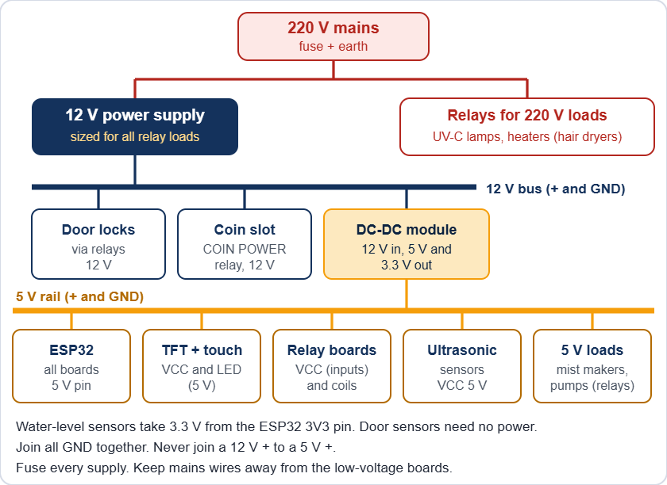
Power for one box (the exact rails are listed in the component tables)

Relay outputs
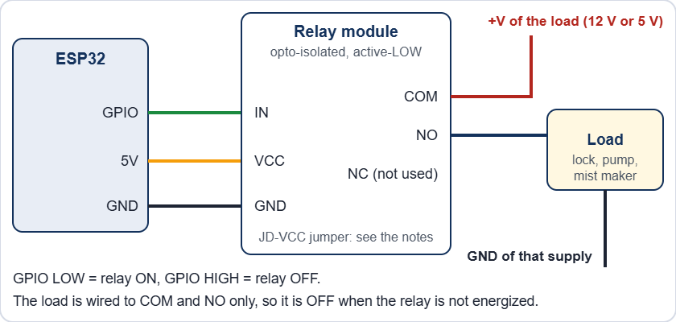
One relay channel
- Wire the load to COM and NO. Then it stays off when the relay or the board has no power. Leave unused channels unwired.
- Relay pins avoid GPIO 0, 1, 2, 3, 5, 12, 14, 15 because they pulse at boot. Safe output pins: 4, 13, 16 to 19, 21 to 23, 25 to 27, 32, 33.
- GPIO 34, 35, 36 and 39 are input only.

Switching 220 V loads (UV-C lamps and heaters)
- The UV-C germicidal lamps and the heaters (hair dryers) run on 220 V. The relay contact switches only the live wire. The neutral goes straight from the supply to the load. The relay board's low-voltage side (IN pins, VCC) stays on the ESP32 side.
- Use relay contacts rated for the load. Most relay boards are 10 A at 250 V AC. A hair dryer can draw 8 A or more (read its label). A UV-C lamp draws much less, but its ballast or driver can pull a high current at switch-on.
- Fuse the 220 V feed of each box. Connect the earth wire to every metal part. Use insulated terminal blocks, strain relief on every cable, and keep 220 V wires away from the low-voltage boards and the screen.
- Recommended: a door switch in series with the live wire of each UV-C lamp, so the lamp cannot be lit with a door open even if the firmware or a relay fails.

Never open a box with the 220 V connected. Unplug it first.

Door locks
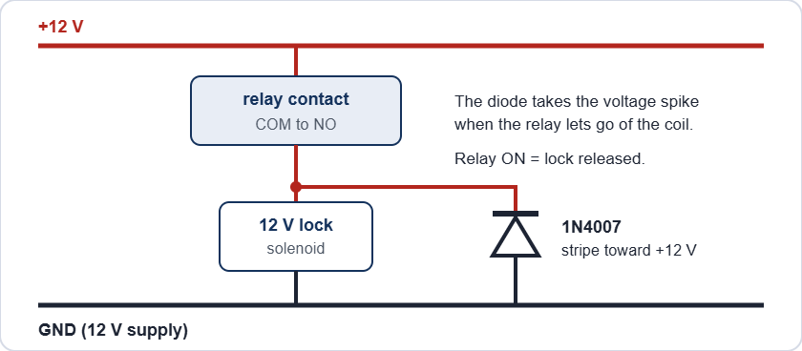
A door lock with its flyback diode
The locks are power-to-unlock: the relay is ON only while the door may open (the OPEN steps, Maintenance, or the trapped-helmet release). With no power a solenoid keeps its door locked, but the enclosure door also has a mechanical safety slide that opens it by hand (next block). The 1N4007 takes the voltage spike when the relay lets go of the coil. Without it the spike can reset the board and burn the relay contacts.

After a power cut the solenoid locks stay shut, but the enclosure door can be opened at once with the safety slide (lower left of the door, slide it down). When power is back, release a lock from the Control Center: Box page, Maintenance, ENCLOSURE LOCK. It switches itself off after 60 seconds.

Safety slide on the enclosure door
The enclosure door has a mechanical safety slide at its lower left. Sliding it down unlocks the door by hand. It works with no power, with a broken solenoid and without any help from the boards. It is the way out for a trapped helmet.
- The slide is part of the door. It is not wired and the firmware does not read it. When the door opens, the door sensor reports it: during a run the box shows SAFETY PAUSE and the UV-C, the mist and the heater are switched off within about 2 seconds.
- A door switch in series with each UV-C lamp (recommended, see Switching 220 V loads) cuts the lamp at once when the door opens, even before the firmware reacts.
- After the slide has been used, put it back in its normal position, close the door and check that the lock holds it. The Maintenance page of the Control Center switches the lock for a test.
- Test the slide every month (see the schedule in Maintenance): with the power off, sliding it down must unlock the door by hand. Never block, tape or remove the slide.

Coin slot and buzzer
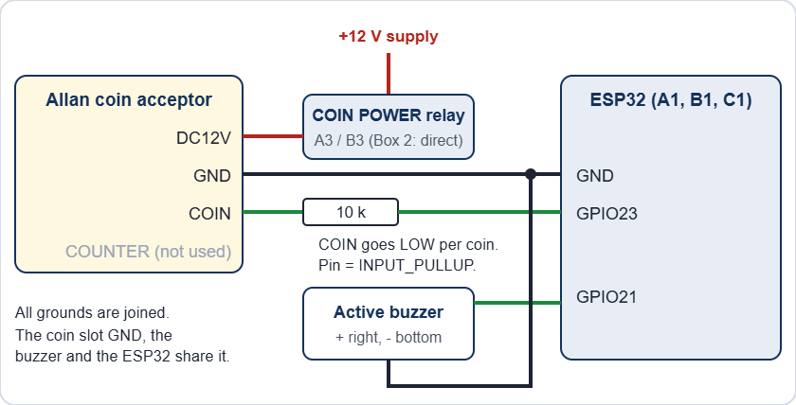
Coin acceptor and buzzer on A1, B1 and C1
- The Allan COIN output pulls to ground once per coin pulse. The pin is INPUT_PULLUP and the firmware counts falling edges, so the pin never sees more than 3.3 V. Check it once with a meter on every new unit.
- FAST, MED, SLOW and SET are switches on the acceptor itself, not wires. COUNTER is not used.
- The buzzer is the active type: GPIO21 HIGH = sound. If it sounds weak, or the board resets when it sounds, drive it through a transistor.

Sensors

Sensor | Wire | Goes to
Ultrasonic HC-SR04 | VCC | 5 V
 | TRIG | GPIO (output)
 | ECHO | GPIO (input), through a divider (the HC-SR04 gives 5 V)
 | GND | GND
Water-level | SIG | GPIO34 or GPIO35 (analog, input only)
 | VCC | 3.3 V
 | GND | GND
MC-38 door | S | GPIO (INPUT_PULLUP). Magnet near = closed = LOW
 | GND | GND

The HC-SR04 sends 5 V on ECHO and the ESP32 pins are not 5 V tolerant. Put a divider on every ECHO: ECHO to 1 kΩ to the GPIO, and 2 kΩ from that GPIO to GND. (A 3.3 V module such as the HC-SR04P needs none.) The pin sheet shows no divider, so check that every sensor has one.

Screen and touch
The display and the touch controller share the SPI lines MOSI (13) and SCK (14). Each has its own chip select (15 and 27). TFT_eSPI drives the display as an ST7789, 240 x 320. B1 is mounted upside down, so it runs setRotation(3).

Mains and UV safety

Mains can kill. The UV-C lamps and the heaters are on 220 V. Unplug the machine and wait before you open a box. Keep all 220 V wiring fused, earthed, in a closed enclosure with strain relief, away from the low-voltage boards.

UV-C light injures eyes and skin, even for a moment. Never look at a lit lamp and never test it with the door open. The firmware switches UV and mist off the moment a door opens, but firmware is not a safety device. Recommended: a door switch in series with the lamp's live wire, so the lamp cannot be on with a door open, and a warning label on every box.

Firmware and flashing

Arduino IDE settings

Board type | Settings
Terminals (A, B, C, ACS) | Board: ESP32 Dev Module. esp32 core 3.3.7. Upload speed 921600. Other options default.
Brains (S3A, S3B, S3C), LocalServer and Online Server | Board: ESP32S3 Dev Module. USB CDC On Boot: Enabled. CPU 240 MHz. Flash mode QIO 80 MHz. Flash size 16 MB. Partition: 16M Flash (3MB APP/9.9MB FATFS). PSRAM: OPI PSRAM. Upload speed 921600.

Libraries
- TFT_eSPI 2.5.43: only A1, B1, C1 (edit its User_Setup.h, see below).
- ArduinoJson 7.4.3, Async TCP 3.5.0, ESP Async WebServer 3.12.0: only the LocalServer and the Online Server.
- Everything else (WiFi, ESP-NOW, Preferences) comes with the ESP32 core.

TFT_eSPI User_Setup.h

Setting | Value
Driver | ST7789_DRIVER (the only one not commented out)
TFT_WIDTH, TFT_HEIGHT | 240, 320
TFT_MISO, TFT_MOSI, TFT_SCLK | 12, 13, 14
TFT_CS, TFT_DC, TFT_RST | 15, 2, 4
TOUCH_CS | 27
SPI_FREQUENCY, SPI_TOUCH_FREQUENCY | 20000000, 1000000

Flash a new or replacement board
- Find the board in the table The 15 boards and open its sketch folder in the Arduino IDE.
- The folder must hold the same Shared_Common.h as ESP32_S3A (the master copy). Different copies make boards ignore each other's messages.
- Choose the settings above, plug in the USB cable and upload.
- Open the Serial Monitor at 115200 baud to read the board's log.
- Watch the board's badge turn ONLINE in the Devices list on the Control Center Dashboard.
- For a brain (S3) or an ACS board, enter its settings again on its Control Center page. A new board starts with the default values.

Never run a bench or settings sketch (ESP32_S3A_CONFIG_BENCH, ESP32_S3C_CONFIG_BENCH, ESP32_ACS_CONFIG_BENCH, ESP32_A1_WIDGET_TEST) at the same time as the LocalServer or the real brain. They send the same messages and fight over them.

Test sketches

Sketch | Use
ESP32_A3_BENCH_TEST | Tests A3 alone: it pretends to be S3A and A2.
ESP32_B3_RELAY_TEST | Wi-Fi page (BOX 3 B3 TEST, password 12345678) to switch each B3 relay by hand.
ESP32_BUZZER_ULTRASOUND_TEST | Wi-Fi page to test a buzzer and read an ultrasonic sensor.
ESP32_C1_CALIBRATE | Touch calibration: touch the 4 targets, copy the printed calData line into the terminal sketch.

Safety built into the firmware
- Every relay pin is set OFF before it becomes an output, so relays do not pulse at power-up.
- Relays that turn on are staggered 25 ms apart, so loads do not start in the same instant.
- A door that opens during a run switches UV and mist off at once (SAFETY PAUSE).
- A terminal that loses its brain for 15 seconds switches its relays off.
- Hand-set relays in Maintenance switch themselves off after 2 seconds (the box does it by itself; the drain pumps and the coin power are exempt, and the tick box Bypass Safety 2 Seconds Relay turns it off). With the bypass the heater still goes off after 5 minutes and the enclosure lock after 60 seconds; ACS pumps after 60 seconds.
- The coin slot only has power while a payment is possible (Box 1 and Box 3).

The LocalServer must be flashed with the version that broadcasts its revenue totals every 10 seconds, or the Online Server shows no analytics. No other board needs a reflash for the Online Server.

Online monitoring
The Online Server is one more ESP32-S3 board. It listens to the machines (it never controls them), sends a snapshot to Blynk every minute, and a web page shows that snapshot from any phone or PC. Nothing on the web page can start, stop or change a machine.
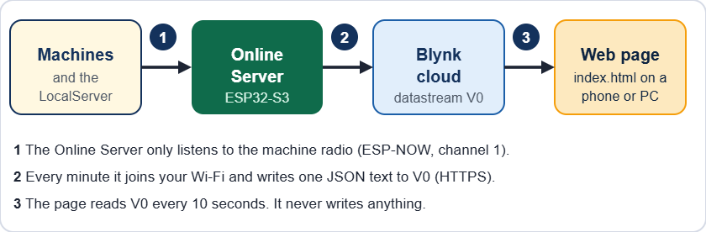
From the machines to the web page

What you need
- The Online Server (ESP32_ONLINESRV), powered with 5 V, near the machines so it hears every board by radio.
- The LocalServer switched on and flashed with the new version. It sends the revenue totals. Without it the analytics stay empty (the live data still works).
- A 2.4 GHz Wi-Fi network with internet: the school Wi-Fi or a phone hotspot, on any channel.
- A Blynk account and the Blynk Console (blynk.cloud).
- The folder ONLINE_WEB (the web page): put it on any web host, or just open index.html from a PC.

Step 1 - Set up Blynk (once)
- Sign in to the Blynk Console. Open Developer Zone, then My Templates, then New Template.
- Name: Jolly Helmet Online Server. Hardware: ESP32. Connection type: Wi-Fi. Click Done.
- Open the Datastreams tab. Click New Datastream, then Virtual Pin. Fill in V0 as in the table below and click Create.
- Optional: make V1 to V4 the same way (single numbers for Blynk's own dashboard and phone app). Default value 0.
- Optional: open the Events tab, click New Event, code alert (exactly), type Warning or Critical, and switch on a notification (push or e-mail).
- Click Save at the top right of the template. Without Save the device does not see the new datastreams.
- Open Devices, click New Device, choose From template, pick your template, name it Online Server and click Create.
- Open the device, tab Device info, and copy the Auth Token. Keep it private.

Name | Pin | Type | Min | Max | Needed?
live | V0 | String | - | - | Yes. The web page reads only this one.
revenue | V1 | Double | 0 | 100000000 | Optional (2 decimals)
customers | V2 | Integer | 0 | 10000000 | Optional
alerts | V3 | Integer | 0 | 30 | Optional
running | V4 | Integer | 0 | 3 | Optional

Step 2 - Set up the Online Server
- Flash ESP32_ONLINESRV (same settings as the LocalServer, see Firmware and flashing) and power it.
- On a phone, join the Wi-Fi JollyHelmet-Online (password 12345678). The setup page opens by itself. If it does not, open http://192.168.4.1.
- Tap Search for networks and tap your Wi-Fi, or type its name. Type its password.
- Paste the Blynk Auth Token.
- Choose how often to send. 1 minute is a good start. Tick "single numbers V1 to V4" and "Blynk event" only if you made them in Blynk. Under More settings: the time zone (8 for the Philippines) and, if you want the quota bar on the web page, the number of Blynk messages your plan gives per month.
- Tap Save and connect. The board tests the Wi-Fi and Blynk at once. The setup page may stop answering for a few seconds: this is normal, the board moves to your router's channel. It reconnects by itself and shows the result.
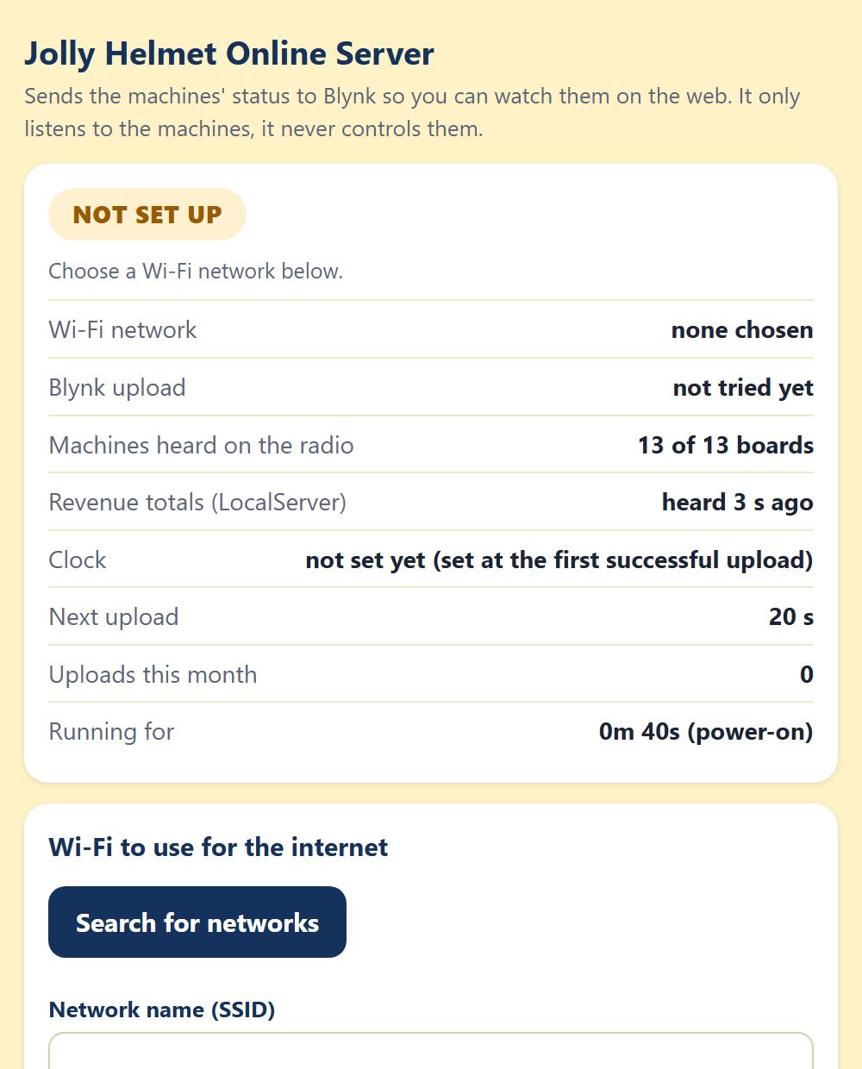 | 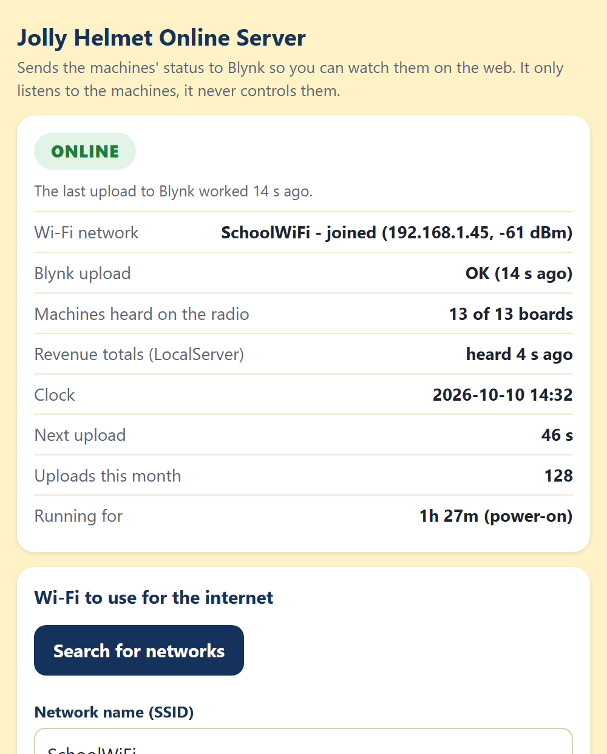 | 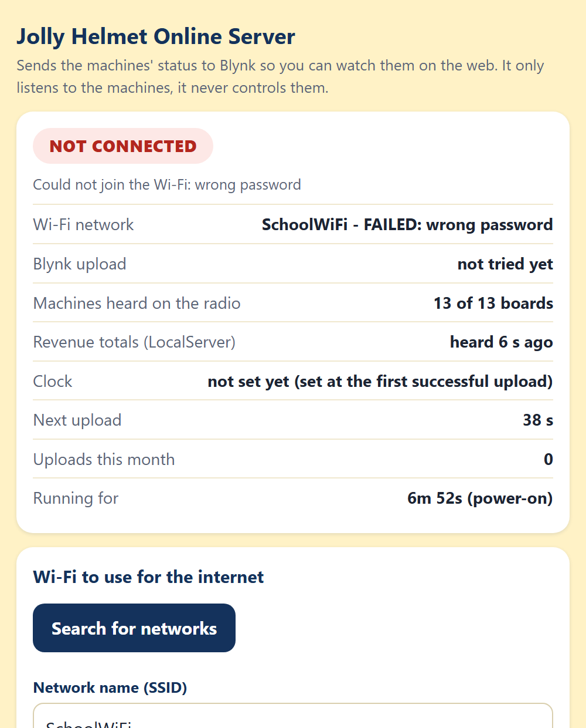
The setup page: not set up yet, online, not connected (wrong password)

On the setup page | Meaning
ONLINE (green) | The last upload to Blynk worked. It shows how many seconds ago.
NOT SET UP (amber) | No Wi-Fi or no token is saved yet.
TESTING (blue) | The board is joining the Wi-Fi and talking to Blynk.
NOT CONNECTED (red) | The Wi-Fi or Blynk failed. The reason is written under the badge.
Machines heard | Must be 13 of 13 when every board is on.
Revenue totals | "heard 4 s ago" means the LocalServer is on. "not heard yet": switch it on or reflash it.
Clock | Set at the first successful upload. The day charts and the secure connection need it.

While you use the setup page the board waits 90 seconds before its next upload, so the page does not drop while you type. A phone left connected to its Wi-Fi is disconnected for a moment at every upload.

Step 3 - Open the web page
- Put the folder ONLINE_WEB on a web host (GitHub Pages, Netlify, Cloudflare Pages, the school server) or open index.html on a PC.
- The first time, the page asks for the Blynk Auth Token. Paste it and click Connect. It is kept in that browser only. On a phone you can also open the page once as index.html#token=THE_TOKEN.
- To try the page without hardware, add ?demo to the address (or ?demo=alerts to see the warnings).
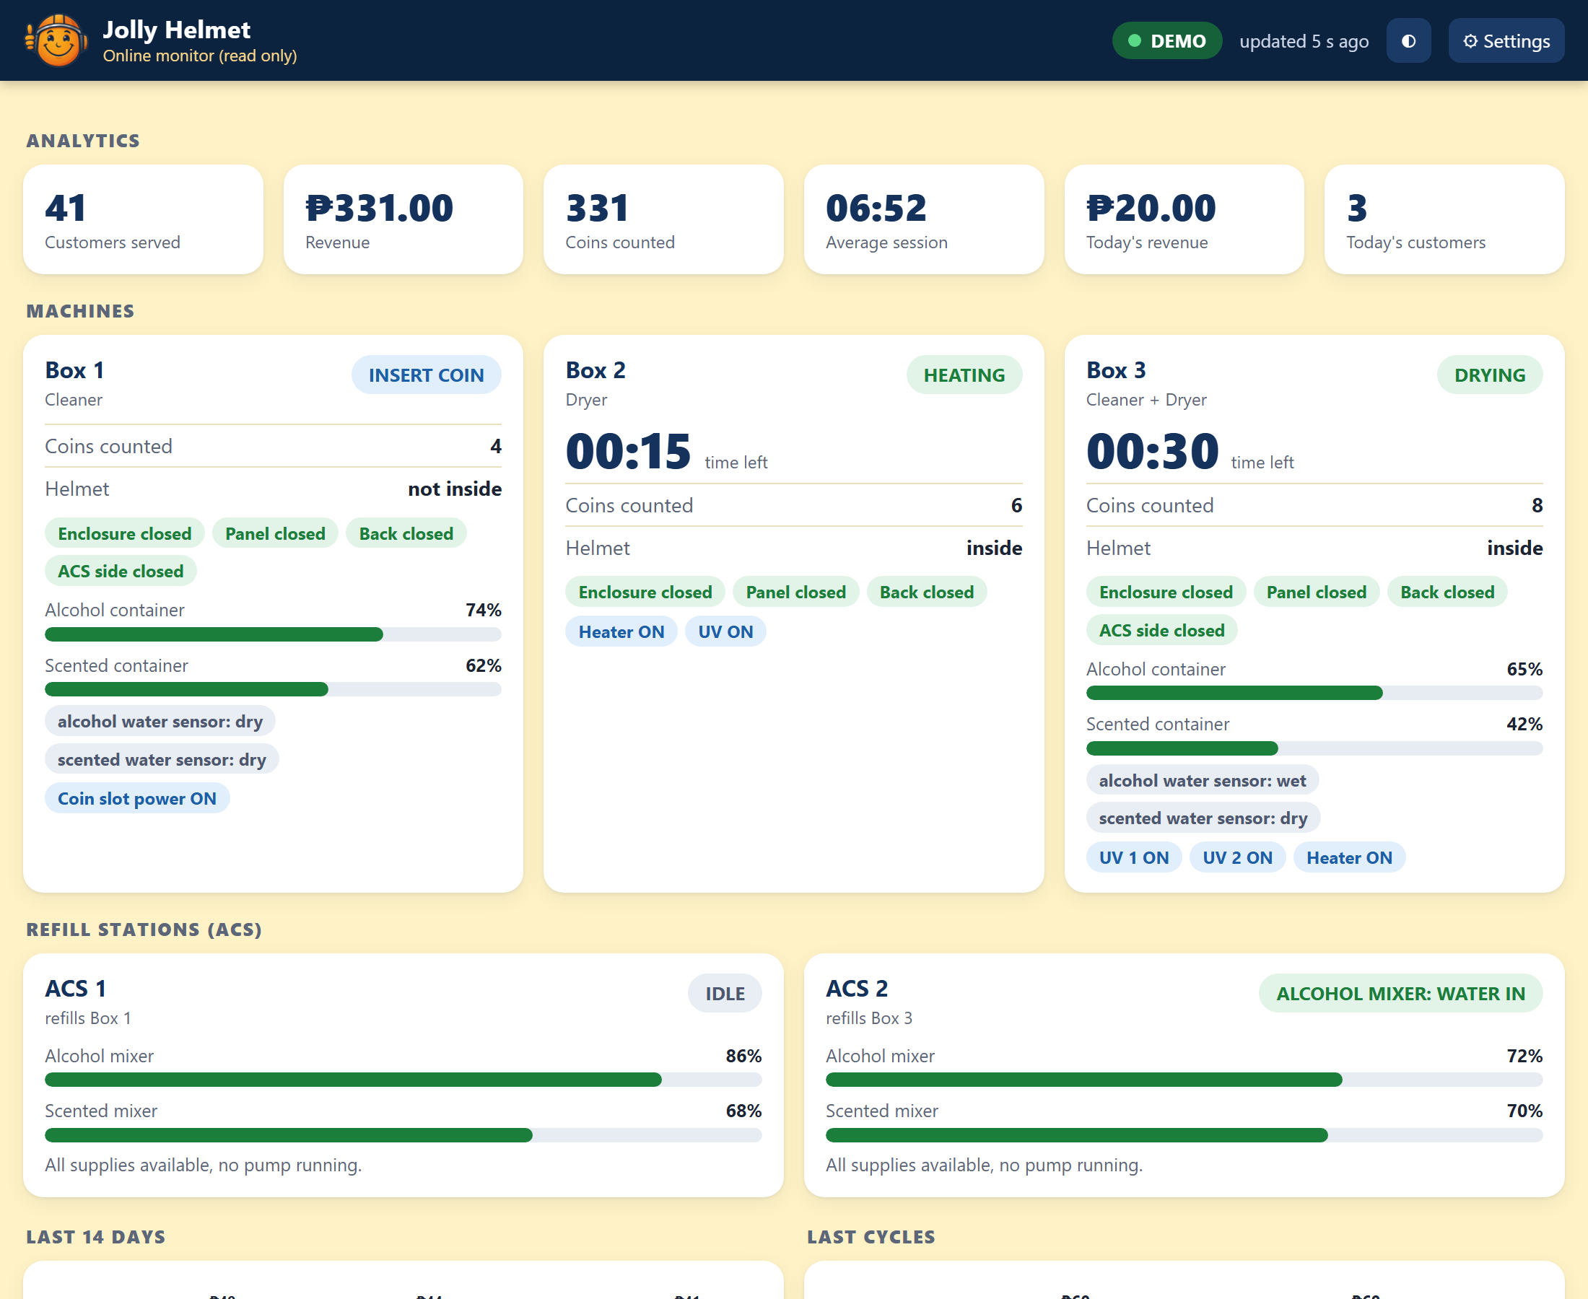 | 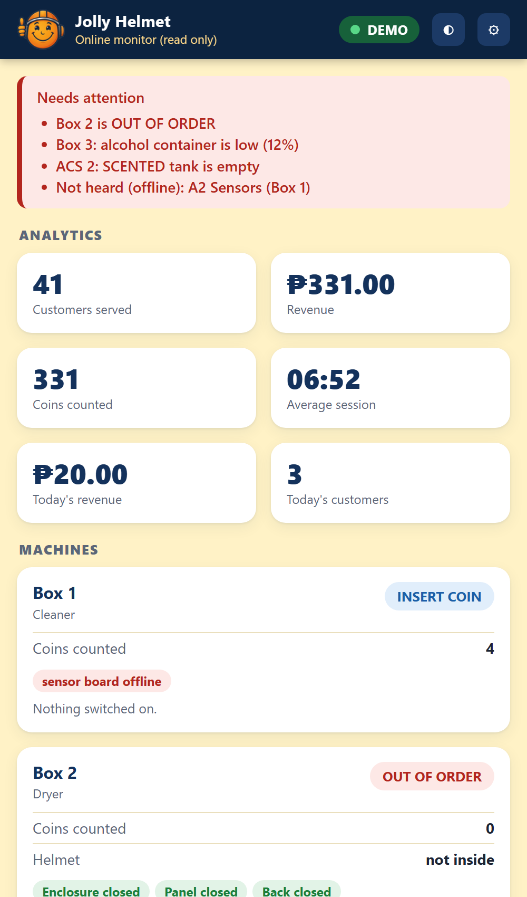
The web page on a PC and, on the right, on a phone with warnings (demo data)

Reading the web page

Part | What it shows
Badge (top right) | LIVE green: fresh data. DELAYED amber: a little late. OLD DATA red: nothing new for a long time. BAD TOKEN or NO LINK: the page cannot read Blynk. Next to it: "updated 5 s ago".
Needs attention (red box) | A box out of order, a container below 15 %, an empty ACS tank, a low mixer, a board that is not heard.
Analytics | Customers served, revenue, coins, average session, today's revenue and customers.
Machines | The step (green = running, blue = a customer is using it, amber = needs attention, red = out of order), time left, coins, helmet, doors, container levels with a small graph, water sensors and the relays that are ON.
Refill stations | Step, mixer levels, EMPTY tanks, pumps running, warnings.
Last 14 days, Last cycles | Revenue per day (today on the right) and the last 10 sessions (revenue and length).
Boards and Online Server | Online or offline for the 13 boards, the Online Server's uptime, restart reason, Wi-Fi signal, free memory and uploads this month.
Buttons | The half-moon switches light and dark. Settings: token, Blynk server and refresh time (5 seconds to 1 minute).

If a box shows "sensor board offline", the page does not hear that board, so it hides that box's doors, helmet and levels instead of showing wrong numbers.

Good to know
- The page only reads. A Blynk token can also write values, so do not publish it: leave it out of the page files and type it in the page.
- Blynk counts messages. One upload a minute is about 43,200 a month, plus one for V1 to V4 and one per alert event. Check your plan's limit.
- The Blynk Console may show the device as offline. This is normal: the board uses Blynk's web API, not a permanent connection. The page decides "alive" from the numbers inside the data.
- The board hears the machines on radio channel 1 and leaves it for about 5 to 10 seconds at every upload, so do not send faster than every 30 seconds.
- Only 2.4 GHz Wi-Fi works (the ESP32 cannot join 5 GHz).

Online troubleshooting

Message | Meaning | What to do
Requested datastream doesn't exist in the product | The template has no V0. | Create V0 (String) in the template and Save it.
Invalid token, BAD TOKEN | The token is wrong or belongs to another device. | Copy it again from Device info.
read Timeout, no answer | Blynk did not answer. The board tries once more with a shorter message. | Check that the Wi-Fi really has internet. Try your regional Blynk server in More settings. The status says if only the SHORT version went through.
network not found, wrong password | The Wi-Fi cannot be joined. | Check the name and password. It must be 2.4 GHz.
the clock could not be set | The Wi-Fi blocks the time servers (NTP). | Allow internet access. Last resort: tick "Skip the TLS certificate check".
Machines heard stays low after an upload | The radio did not return to channel 1. | Switch the Online Server off and on, and tell the builder.
Revenue totals not heard | The LocalServer is off or has the old version. | Switch it on, or reflash it.
V1-V4 failed, event failed | The optional datastreams or the alert event are missing in the template. | Create them, or untick them in the setup page.
The page says OLD DATA | The uploads stopped. | Open the board's setup page and read its status.

Customer status page (a second Blynk device)
The customer page (status.html) shows Box 1, Box 2 and Box 3 as FREE, IN USE or OUT OF ORDER. It is public, so it must not use your private token (a Blynk token can also write). It reads a second Blynk device that holds nothing but those three boxes.
- In the Blynk Console open Devices, New Device, From template, and pick the same template as before. Name it Jolly Helmet Public status.
- Open it, tab Device info, and copy its Auth Token. This token may be public. Never use the private token here.
- Open the Online Server setup page (Wi-Fi JollyHelmet-Online). Paste the token into Public status device token and tap Save and connect. The row Public status device on top then says OK.
- In the folder ONLINE_WEB open js/config.js and write the token in publicToken. (If you leave it empty, the QR code carries the token in the address.) Edit the prices and the "Something wrong?" line in the same file.
- Put the folder on the web host. Open the online page and tap the QR button. Paste the public token if it asks. Tap Print the sign and stick it on every machine.
- Test it: scan the QR code with a phone. The boxes must show FREE or IN USE. status.html?demo shows made-up data.

The public device holds | Meaning
b | For Box 1, Box 2 and Box 3: the step number, the seconds left and whether the brain is heard. Nothing else.
seq, ts, iv | A counter, the time and the upload interval. The page shows NO INFORMATION when the data is older than about 4 minutes.

If somebody misuses the public token, the worst they can do is write a wrong status into that one device (the next upload overwrites it within a minute) and use up some Blynk messages. They cannot reach the private device, the revenue or the machines. The page costs one more Blynk message per upload.

Online Server firmware of 2026-10-10
Flash ESP32_ONLINESRV again (same settings, see Firmware and flashing). The new version:
- counts every finished session per box, per hour of the day and per weekday, from the brains' own counters, and keeps the counts inside the board (this feeds Busiest hours, Busiest days and What each box earns in the Reports tab);
- writes the public status device when its token is set;
- shows two new rows on its setup page: Public status device and Sessions counted, and has a button Reset the per-box and busiest-hours statistics under More settings.
Until it is flashed, the three charts above say "Needs the Online Server firmware of 2026-10-10". Everything else works with the old firmware.

Optional customer names (Blynk V5)
A customer can type a nickname (12 characters at most) on the card of the machine that is running his or her cycle. Everybody who opens the customer page sees it ("Maria's helmet"), the customer's own phone says the helmet is done at the end, and the name clears by itself when the cycle ends. It is optional: no name, nothing shown.
- One extra datastream, once: in the Blynk Console, open the template of the public device, Datastreams, New, Virtual Pin V5, name names, data type String. Without it the page works as before and a customer who tries to add a name is told that names are not switched on yet.
- A name can be added only after the coins are in, so a payment that is cancelled never leaves a name behind. The phone that typed it can edit or remove it; other phones can only see it.
- The name is shown only while the box is looking after a helmet (OPEN A to ABORT) and only for that cycle. Flash the Online Server firmware of 2026-10-14 or later so it adds each box's session counter to the public value.
- Whatever sits in V5 is treated as untrusted text: the page strips < and > and control characters and shows it only as plain text. The page tells the customer to use a nickname, because the name is public to everybody who opens the page.
- Cost: a few Blynk messages for each customer who adds a name, nothing for the others. In js/config.js, names: false hides the feature and namesPin chooses the datastream.

Alerts when the page is closed (Blynk app)
A closed page cannot make a sound. The Blynk app can.
- On the Online Server setup page tick Send a Blynk event with code alert, then Save and connect.
- In the Blynk Console open the template, tab Events, and make sure the event with the code alert exists (see Step 1). Choose the type Warning or Critical and switch on its push notification. Click Save.
- Install the Blynk app on the phone, sign in with the same account and allow notifications. Every new alert (box out of order, tank empty, container low, board offline) now arrives as a notification, even with the page closed.

The Manual tab and the team password
The customer chapters of this manual are public. The rest (admin, technician, reference) prints the Wi-Fi passwords, so the web page keeps it encrypted: the file on the web host is unreadable without the team password, and the page decrypts it in the browser after the password is typed. The team password is not the Blynk token.
After you change this Word file: press Ctrl+A, then F9 in Word (updates the contents and the index) and save. Right-click MANUAL\build_web_manual.ps1 and choose Run with PowerShell. It asks for the team password (use the same one, or a new one and tell the team). It makes a fresh PDF next to the Word file and rewrites the folder ONLINE_WEB\manual. Upload that folder again. Word must be installed on that PC.

Online page problems

Symptom | Cause | What to do
No sound when an alert comes | The browser needs one tap. Or the page is closed, or sound is switched off. | Tap Turn on alert sounds. Keep the page open. Check Alerts, Sounds (the volume and the On boxes).
The customer page says NO INFORMATION | The public token is missing or wrong, the Online Server is not reflashed, or its data is old. | Check publicToken in js/config.js (or the QR address). The setup page row Public status device must say OK.
Busiest hours, days and box earnings are empty | The Online Server has the old firmware, or nothing was counted yet. | Flash the firmware of 2026-10-10 and wait for sessions.
A dial says "watching the trend" | It needs about 10 minutes of readings with the page open. | Wait. The trend is kept in the browser.
The Checklist is empty on another phone | Ticks are saved per browser. | Use Save a backup and Restore a backup.
The Manual tab shows only the customer guide | The team chapters are locked. | Tap Unlock and type the team password.
"That is not the team password" | Wrong password, or the web files were made with another one. | Run build_web_manual.ps1 again and upload the folder.

Maintenance

Before you open a box: finish or cancel any run, switch the machine off at the mains and unplug it. Wait for the heater to cool.

Schedule

When | What to do
Every day | Dashboard: the Devices line says every board is online and there is no red banner. The online web page says LIVE. Look at the 3 supply tanks in each ACS and the 2 main containers. Wipe the touch screens. Collect the coins and note the revenue.
Every week | Wipe the helmet chamber and the door seals. Open each door during a run: SAFETY PAUSE must show. Listen for each lock clicking. Look for leaks at pump tubes and mixers. Test each UV-C lamp in Maintenance with the door closed (the relay must click; never look at a lit lamp). Check the humidifiers make mist.
Every month | Switch every relay by hand in Maintenance and listen for the click. Clean the ultrasonic sensor faces and the water-level probes. Compare each distance with a ruler (use live). Test the coin slot with every coin. Check screw terminals and plugs are tight and nothing is hot or discoloured. Clean the humidifier discs and the heater and fan air intakes. Test the safety slide of each enclosure door: with the power off, sliding it down must unlock the door by hand.
Every 3 months | Capture the water sensors again, dry and wet, with the real liquids. Check the touch accuracy. With the power off, check the mains wiring, earth and fuses. Take a screenshot of every Control Center settings page and keep it.
Once a year or when worn | Replace the UV-C lamps at the end of their rated hours (their output fades before they stop glowing). Replace pump tubing and slow pumps. Replace any lock that sticks or gets hot. Replace humidifier discs.

Calibrate

What | How (Control Center)
Helmet distance | Box page: put a helmet in, tap use live, then Send. Do the same on Box 2 (HEAT).
Container lines | LEVELS: fill to each line, tap use live. Bigger number = emptier.
Water sensors | LEVELS: dry now, then wet now in the real liquid (alcohol conducts poorly).
ACS mixer lines and sensors | ACS page: LEVELS and TIMING, use live and Work out the thresholds.
Coin slot | Check the coin pulses on the box page: they must rise by the coin's value. Speed (FAST, MED, SLOW) is set on the acceptor.
Touch screen | Flash ESP32_C1_CALIBRATE on the terminal, touch the 4 targets, copy the calData line into the terminal sketch and flash it again. B1 (Box 3) may still need this.

Test every output by hand
- Put the box on its start screen (TAPS) or OUT OF ORDER.
- Control Center, box page, Maintenance. Tap each relay and check that the right thing happens.
- Do the ACS pumps one at a time and compare each with its label before you trust the automatic run.
- Tap Maintenance again. Everything switches off.

Replace a broken board
- Power off. Photograph the wiring, or print the pin table of that board.
- Move the wires one at a time to the same GPIO on the new board.
- Flash the right sketch (see Firmware and flashing). A3 and B3 must be plain ESP32 boards.
- Power on and wait for the ONLINE badge, then test each output by hand.
- Brain (S3) or ACS replaced: enter its settings again. LocalServer replaced: the revenue numbers start from zero. Online Server replaced: join its Wi-Fi again and enter the Wi-Fi and the Blynk token; the 14-day history starts again.

Spare parts to keep
- One spare ESP32 per role, flashed and labelled: A1, A2, A3, C1, C2, B1, B2, B3, ACS, plus one ESP32-S3.
- One spare relay board of each size, 2 MC-38 sensors, 2 ultrasonic sensors, 2 water-level sensors.
- One door lock solenoid, one 12 V supply, 2 DC-DC converters, fuses.
- Spare pumps and tubing, one UV-C lamp, one humidifier, a 10 pack of 1N4007 and 10 kΩ, a few 470 to 1000 µF capacitors.

Hardware troubleshooting

Symptom | Likely cause | What to do
Screen goes white when a lock or pump switches | The 5 V dips | Force refresh or Auto hard refresh (Control Center). Add a 470 to 1000 µF capacitor at the TFT supply. Shorter, thicker 5 V wires.
A relay clicks once at power-up | A pin that pulses at boot (GPIO5 on C2) | Harmless. Move it to a boot-safe pin if it bothers you.
A relay stays ON with no command | A boot-active pin, or a wire on the wrong input | Use a boot-safe pin (GPIO13 was moved to 33 on A3 and B3). Check the wiring.
LocalServer restarts when a phone connects | Supply dip (Settings, This board, says BROWNOUT) | Own 5 V supply, short cable, a 470 to 1000 µF capacitor.
A board shows OFFLINE | No power, the wrong sketch, or a bench sketch running | Measure 5 V at the board. Flash the right folder. Switch off every bench sketch. All boards use ESP-NOW channel 1.
Door always open or always closed | Magnet too far, or a wrong wire | Check the gap (a few mm) and the wire from S to the GPIO. Closed must read LOW.
Ultrasonic reads 0 or jumps | No echo, dirty face, TRIG and ECHO swapped, loose wire | Clean the face, check both wires, read the board's log.
Water sensor always wet or always dry | Dirty probes, or a bad dry/wet capture | Clean the probes. Capture dry and wet again in the real liquid.
Coins not counted | Coin slot has no power, loose COIN wire, wrong speed setting | The slot is powered only in the pay steps. Measure its 12 V at DC12V then. Check the 10 kΩ and the COIN wire.
A pump runs but the wrong liquid moves | Relay wired to the wrong pump | Run each pump by hand in Maintenance and fix the wiring.
A lock does not release | No 12 V at the solenoid, or the door presses on the latch | Measure the solenoid while its relay is ON. Push the door in a little. The safety slide still opens the enclosure door.
A lock is hot | It was powered too long | Check for a stuck relay. The firmware limits how long a lock stays energized.
A UV-C lamp does not light | No click: relay or wire. Click but no light: fuse, door switch, lamp or its ballast | Test it in Maintenance. Then, with the power OFF and unplugged, check the fuse, the door switch and the lamp.
Helmet stuck after a power cut | Locks are power-to-unlock (the enclosure door also has a safety slide) | Slide the safety lock down (lower left of the enclosure door) at once. When power is back, test the solenoid with Maintenance, ENCLOSURE LOCK.

Reference (Safety, charts, settings and index)
Safety, flowcharts, decision trees, settings, schematics, policies, glossary, versions and index

Safety and emergencies
The customer side of every machine is safe to use. The dangers are behind the panels: 220 V mains, UV-C light, a hot heater and flammable alcohol. Read this page before you open anything.

In an emergency
- Stop the run. Touch CANCEL, then CONFIRM. The UV-C, the mist and the heater switch off. Box 2 and Box 3 then cool down for a while (Box 2 runs the fan, Box 3 lets everything rest). The coins are not refunded.
- If a door is forced open during a run, the machine shows SAFETY PAUSE and switches the UV-C, the mist and the heater off at once. It carries on when the door is shut again with the helmet inside.
- Fire, smoke, burning smell, sparks or a person in danger: switch the machine off at the wall socket or the main breaker, step back, and call for help. Do not use water on anything electrical.
- A helmet is stuck, or the power is off: slide the safety lock down (lower left of the enclosure door). The door unlocks at once. More in the next block.

The solenoid locks are power-to-unlock: with the power off, or with a broken solenoid, they stay locked. The enclosure door has a mechanical safety slide at its lower left. Slide it down and the door unlocks, with or without power. Anybody can use it. Never block or remove it.

A helmet is stuck inside
- Fastest way: slide the safety lock down. It is at the lower left of the enclosure door. The door unlocks at once, even with no power or a broken solenoid. If the machine was running it pauses (SAFETY PAUSE) and the UV-C, the mist and the heater switch off. The helmet may be warm.
- Check that the machine has power. After a power cut, wait until the Devices line on the Control Center Dashboard shows the boards online again.
- Control Center, the box page, Maintenance, tap ENCLOSURE LOCK. The door unlocks for up to 60 seconds, then rests for 5 seconds. Tap Maintenance again when you are done.
- If the brain of the box stops answering for 15 seconds while a helmet is behind a closed door, the terminal board lets the enclosure lock go by itself.
- Still locked? Follow the decision tree The door will not open in this reference.

Dangers inside the machine

Danger | Where | Rule
220 V mains | UV-C lamps, heaters, power inlet, fuses | Only a qualified electrician works on the mains side. Unplug first and wait before touching anything. The relays switch the live wire, so a clicking relay does not mean the wire is dead.
UV-C light | Box 1: 2 lamps, Box 2: 1, Box 3: 2 | UV-C harms eyes and skin. Never look at a lit lamp. Test a lamp only with the door closed. A door switch that cuts the lamp when the door opens is recommended.
Hot heater and air | Box 2 and Box 3 | Let it cool (the machine runs a cool down). Never cover the air intakes. The heater switched on by hand in Maintenance turns itself off after 5 minutes.
Alcohol | Containers in Box 1 and Box 3, ACS tanks | Flammable. Keep it away from the heater, sparks and flames. Keep the lids closed and wipe spills at once. Keep a fire extinguisher near the machines.
Water and electricity | Pumps, mixers, humidifiers, drain | Fix leaks straight away. Keep tubes and containers away from the boards and relay modules.
Door lock coils | 11 solenoid locks, 12 V | A coil held on for a long time overheats (once it caused a fire-risk incident). The machine never holds one on for more than 60 seconds in a row.

Safety features built into the firmware

Feature | What it does
Door during a run | Door opened mid-run: SAFETY PAUSE, UV-C, mist and heater off. The run resumes when the door is closed and the helmet is still inside.
Door shut, no helmet | While paused, if the door is shut with nothing inside, the lock is released so the door can be opened again.
Lock duty cap | A lock is never on for more than 60 seconds in a row, then it rests for 5 seconds.
Brain-loss watchdog | If a terminal hears nothing from its brain for 15 seconds, it switches the heater, UV-C, mist, pumps and coin power off.
Hand-set limits | In Maintenance the heater stops after 5 minutes, locks after 60 seconds and the ACS pumps after 60 seconds.
Cool down | After heating, Box 2 runs the fan only and Box 3 lets everything rest, for 60 seconds by default. Also after a cancel.
Empty containers | With level checks on, a box with too little alcohol or scented liquid shows OUT OF ORDER (Box 3 keeps DRYING) and asks the ACS to refill.
Safety slide | A mechanical slide at the lower left of the enclosure door unlocks it by hand, with no power and no firmware. Opening the door then starts SAFETY PAUSE if a run was on.

First aid
- Electric shock: switch the power off first, then help. Do not touch the person while they are still in contact with a live part.
- UV-C in the eyes or on the skin: move away from the light, and see a doctor if the eyes hurt or the skin is red.
- Alcohol or scented liquid in the eyes: rinse with clean water for 15 minutes and get medical advice.
- Burn from the heater: cool it under cool running water and cover it with a clean cloth.

Who to call

Role | Name | Phone
Owner or supervisor | Sir Jolly Ropal | [Number]
Technician (MEJEZ STUDIO) | Jerahmeel Alzel M Mejes | 0975 791 5832
Electrician | Jerahmeel Alzel M Mejes | [0975 791 5832
Fire department | [Local number] | [Number]
Nearest clinic or hospital | [Name] | [Number]

Box flowcharts
One chart per stage of a run, with the same screen names the customer sees. A black rounded box is where a chart starts or ends. White boxes are screens or steps. A box with a thick border is where the machine is running. A box with a double border is a fault. A diamond is a decision. A thin rounded box says where the chart goes on. A dashed box is a note.

Box | Charts
Box 1 Cleaner | 1. From TAPS to INSERT COIN. 2. Open A, cleaning, open B, rating, free retry, finish.
Box 2 Dryer | 3. From TAPS to INSERT COIN and door A. 4. Heating, cool down, open B, rating, free retry, finish.
Box 3 Cleaner + Dryer | 5. From TAPS to INSERT COIN, with SELECT MODE. 6. Cleaning or drying, cool down, open B, rating, free retry, finish.

Box 1, chart 1: paying
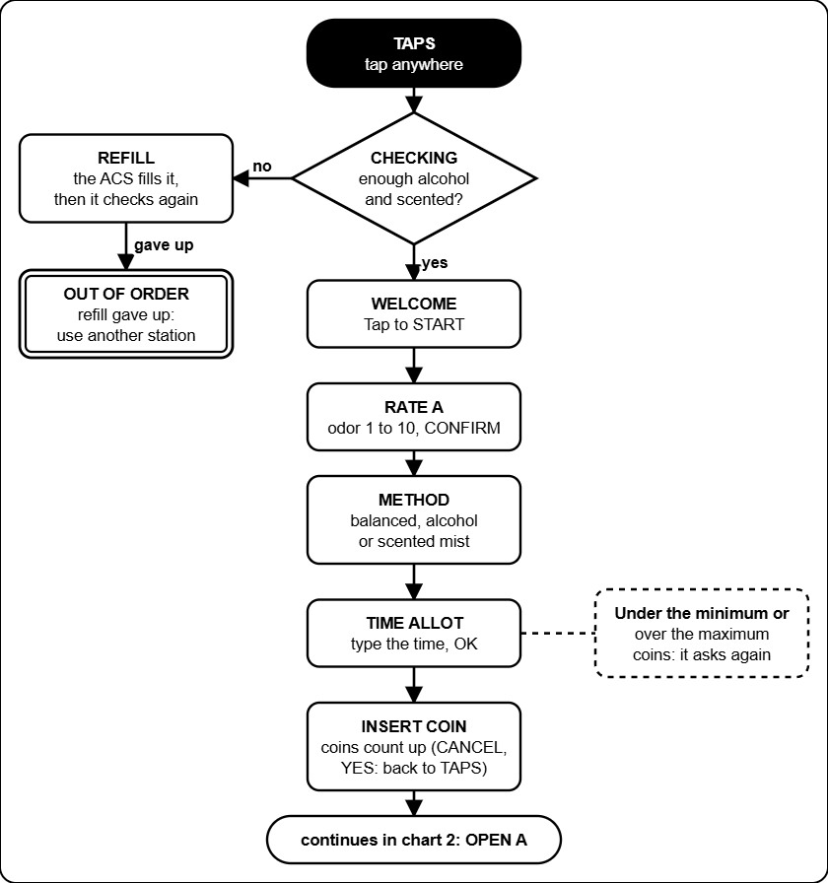
Box 1: from TAPS to INSERT COIN. Containers are checked first; the ACS refills them if they are low.

Box 1, chart 2: the run
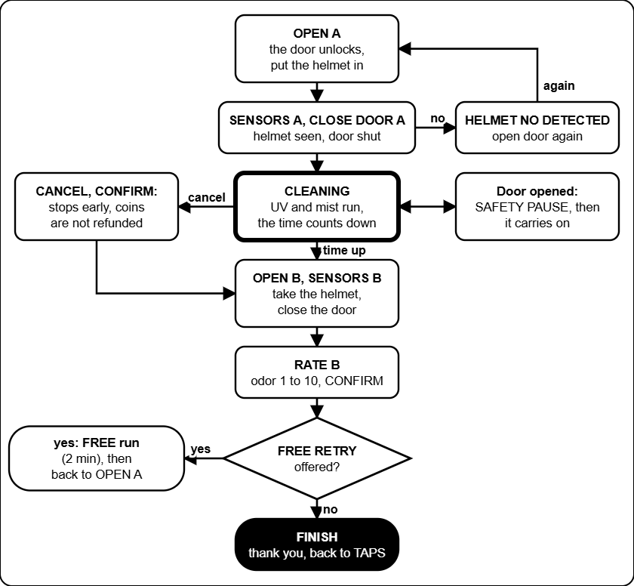
Box 1: cleaning, taking the helmet out, the second rating and the free retry.

Box 2, chart 3: paying
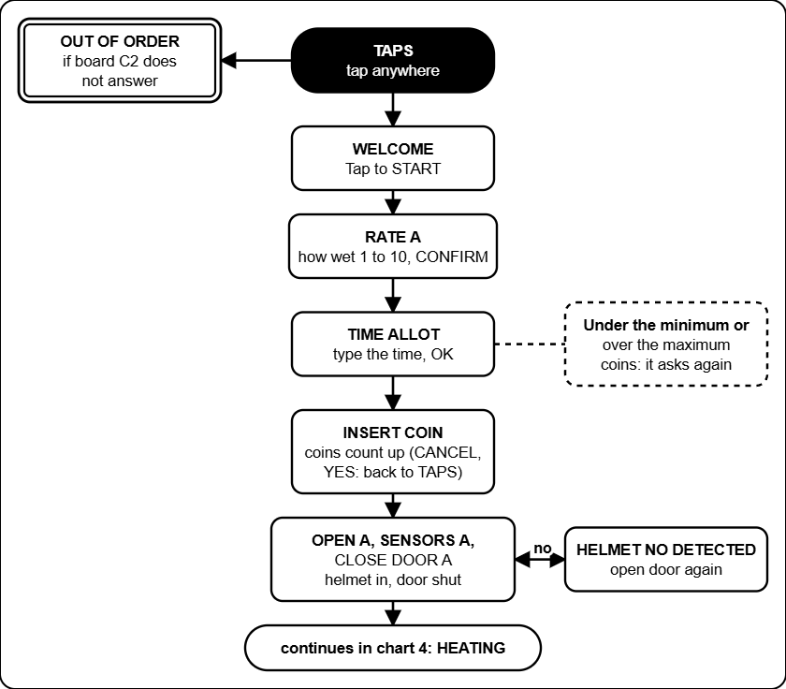
Box 2: from TAPS to the door. The box has no containers to check; it is out of order only if its terminal board stops answering.

Box 2, chart 4: the run
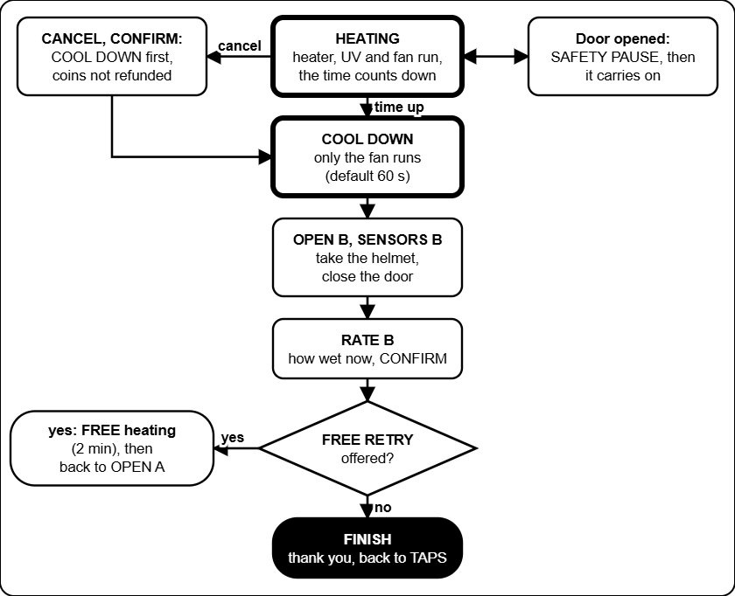
Box 2: heating, cool down with the fan, taking the helmet out and the free retry.

Box 3, chart 5: paying
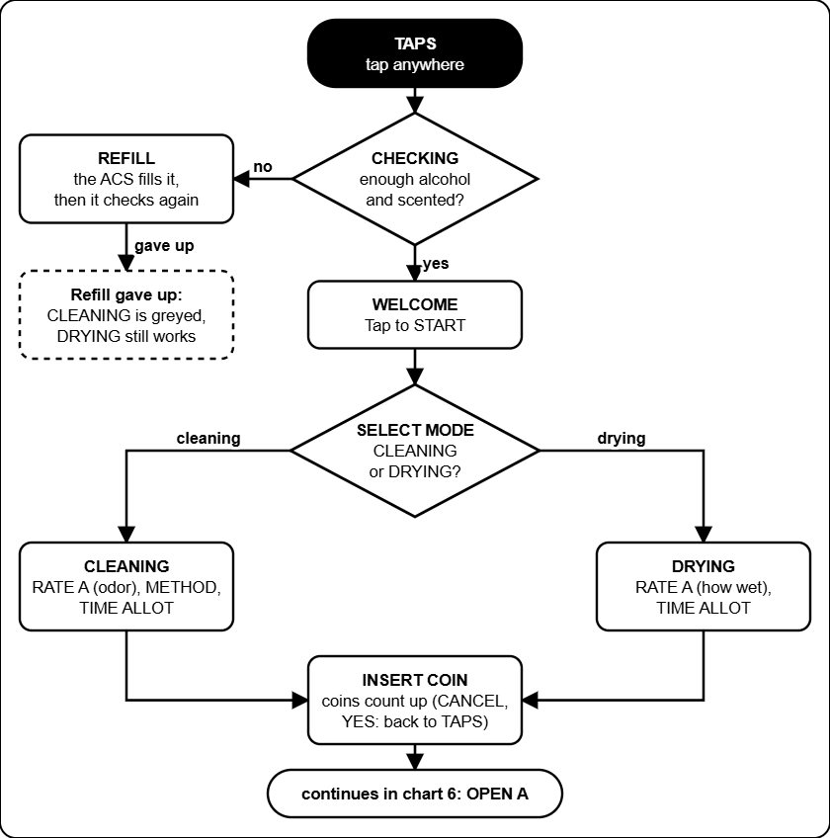
Box 3: the customer chooses CLEANING or DRYING. If the refill gives up, CLEANING is greyed out and DRYING still works.

Box 3, chart 6: the run
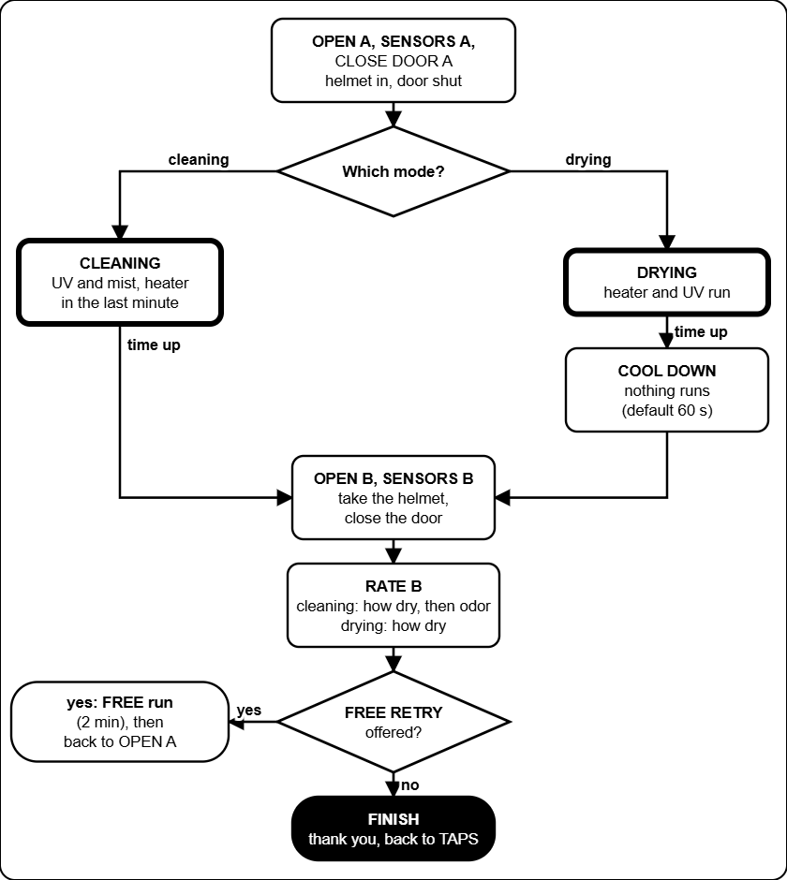
Box 3: cleaning (UV-C and mist, heater in the last minute) or drying (heater and UV-C), then cool down, the second rating and the free retry.

Troubleshooting decision trees
Start at the black box at the top. Answer each question (the diamonds) with yes or no and follow the arrow. Boxes with a thick border tell you what to do. These trees cover the problems that happen most; the tables in the Admin and Technician guides have the rest.

Symptom | Tree
The screen says OUT OF ORDER | 1. A box shows OUT OF ORDER
A board is OFFLINE in the Devices list | 2. A board shows OFFLINE
A coin goes in and nothing counts | 3. Coin inserted, the count does not move
A helmet is trapped, a door will not open | 4. The door will not open
The refill station does not fill | 5. A mixer is LOW or a tank is EMPTY
The web page shows old data or no link | 6. The web page says OLD DATA or NO LINK
The touch screen is white, blank or wrong | 7. Screen white, blank or the touch is wrong

Tree 1: a box shows OUT OF ORDER
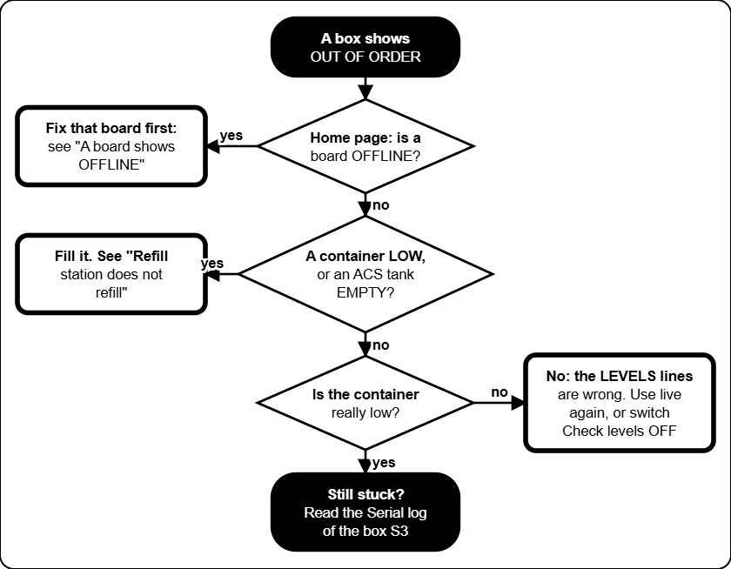
OUT OF ORDER means a container is too low and the refill gave up, or a board is missing.

Tree 2: a board shows OFFLINE
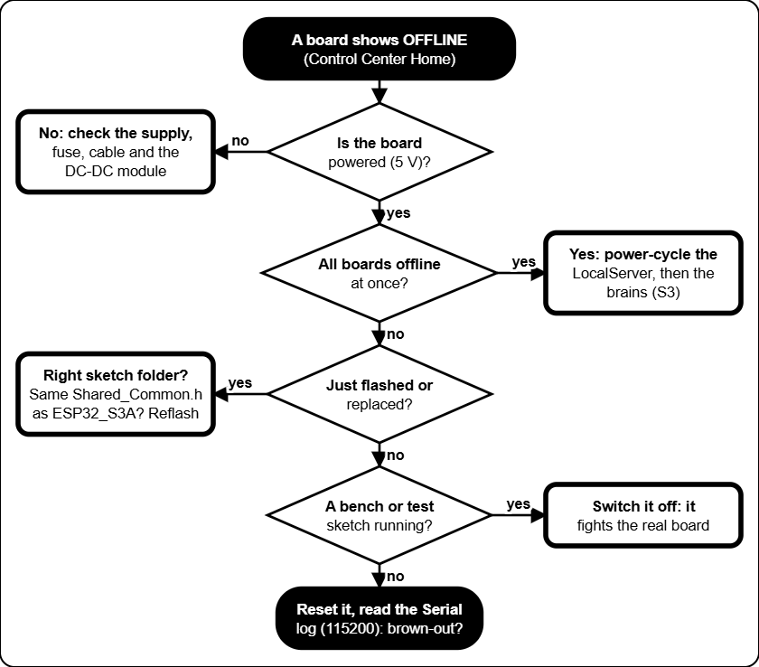
A board is OFFLINE when the LocalServer has heard nothing from it for a while.

Tree 3: coin inserted, nothing counts
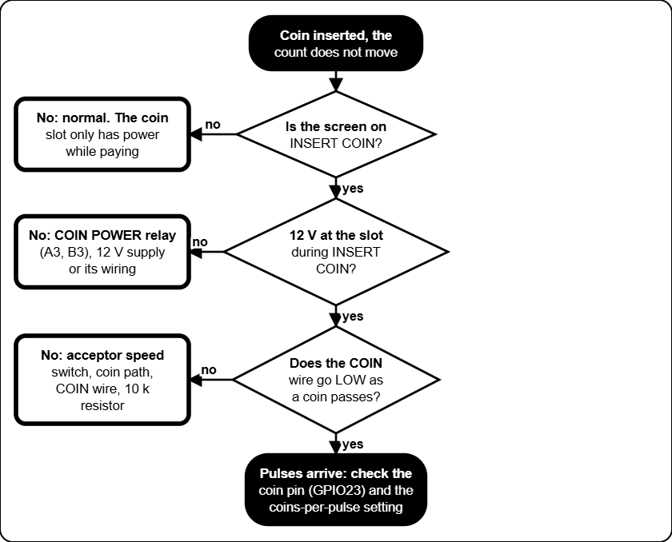
In Box 1 and Box 3 the coin slot has power only while the screen shows INSERT COIN.

Tree 4: the door will not open
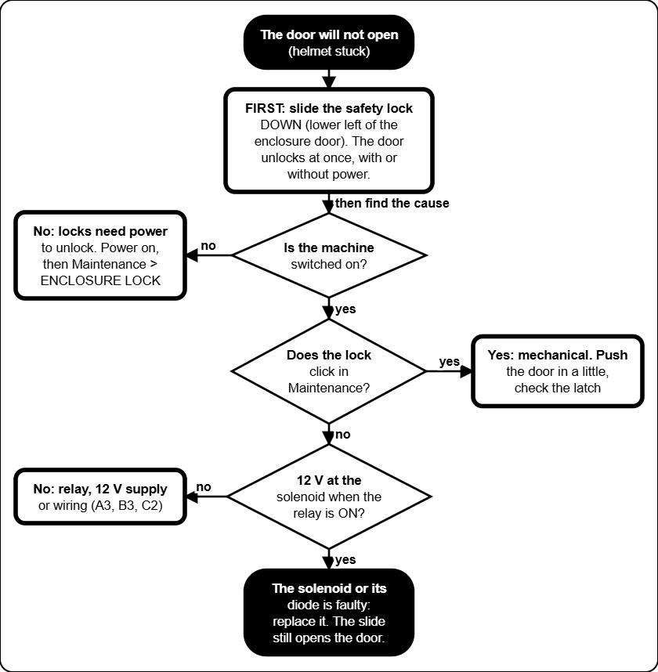
The locks are power-to-unlock: with no power a solenoid door stays shut, but the safety slide (lower left of the enclosure door) opens it by hand. Switch the mains off before reaching in.

Tree 5: the refill station does not fill
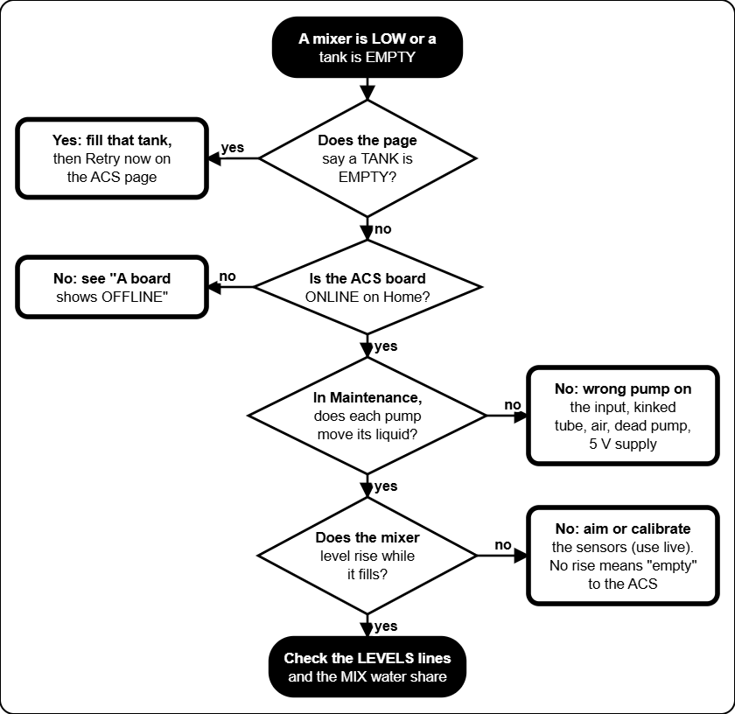
The ACS reads "level did not rise" as "the supply tank is empty".

Tree 6: the web page shows old data
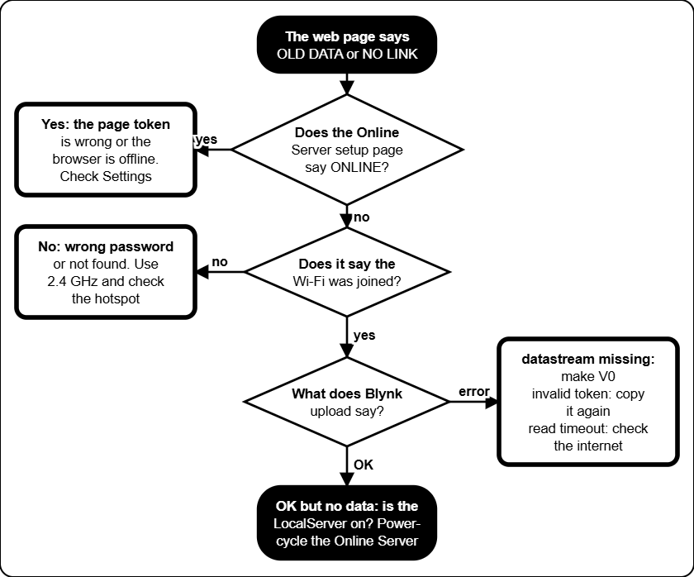
The web page is read only. It shows what the Online Server last sent to Blynk.

Tree 7: the touch screen is white or wrong
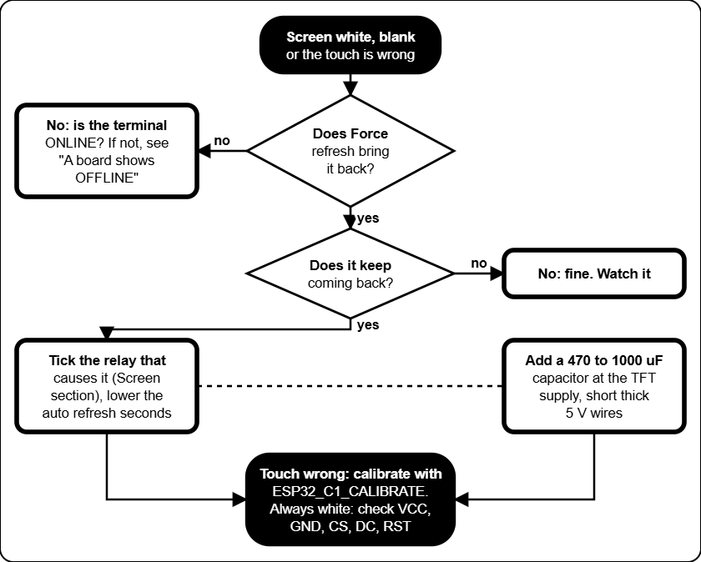
A white screen is almost always a supply dip when a heavy load switches. Force refresh re-initialises the screen.

Settings reference
Every setting you can change, with the value the firmware starts with and the range it accepts (a value outside the range is refused). Write the value you use in the last column. The firmware defaults are what a freshly flashed board starts with; the machine you are looking at may have been changed. Settings are saved inside the boards, so they survive a power cut and a LocalServer swap. Where to change them: Control Center, the box page (or /acs).

Prices and time (Box 1, Box 2 and Box 3)

Setting | What it does | Default | Allowed | Yours
Rating bands (4) | From and to rating, and the minutes suggested for that rating. | Box 1, 3: 1-5 = 5, 6-7 = 10, 8-9 = 15, 10 = 20 min. Box 2: 1-3 = 3, 4-6 = 5, 7-8 = 8, 9-10 = 10 min | Rating 1-10 (from not above to), 1-120 min
Minimum time | Shortest session the customer can buy. | Box 1, 3: 5 min. Box 2: 3 min | 1-120 min
Coin rate | N coins buy X minutes (or seconds). | Box 1, 3: 15 coins = 5 min (20 s a coin). Box 2: 10 coins = 3 min (18 s a coin) | 1-500 coins, 0.1-9999 time
Most coins | Largest number of coins one session can take. | Box 1, 3: 90. Box 2: 100 | 1-999
Free retry | One free run after the final rating. | On | On or off
Free retry from rating | Lowest final rating that gets the free retry (1 = everyone). | 1 | 1-10
Free retry length | How long the free run lasts. | 2 min | 1-60 min
Cool down (Box 2, Box 3) | How long the cool down lasts, also after a cancel. | 60 s | 5-900 s

Containers and sensors (Box 1 and Box 3)
The distances are what the ultrasonic sensor on the main container reads, from the sensor down to the liquid. A bigger number means emptier. The defaults are placeholders: measure your real containers.

Setting | What it does | Default | Allowed | Yours
Check levels | Refuse to run (OUT OF ORDER) when a container is low. | Off | On or off
Alcohol low | At or over this distance the alcohol container is LOW. | 20 cm | 0-400 cm
Alcohol full | At or under this distance it counts as refilled. | 8 cm | 0-400 cm
Scented low | Same for the scented container. | 20 cm | 0-400 cm
Scented full | Same for the scented container. | 8 cm | 0-400 cm
Helmet detect | The helmet counts as inside when its sensor reads under this. | Box 1, 3: 15 cm. Box 2: 30 cm | 1-200 cm
Water sensor WET (alcohol, scented) | Raw reading at which the sensor means wet. | 600 | 0-4095
Water sensor DRY (alcohol, scented) | Raw reading at which it means dry again (the gap stops flicker). | 400 | 0-4095
Reading goes up when wet | Direction of the water sensor. | Yes | Yes or no
Refill tries | Refill attempts before the box gives up. | 10 | 1-99
Refill interval | Seconds between tries. | 10 s | 1-250 s
Ask the ACS to refill | Off: only count the tries. On: really send the refill request. | Off | On or off

Check levels and Ask the ACS to refill are off when a board is flashed, so a box with uncalibrated sensors still serves customers. Measure the four distances, then switch both on.

Cleaning phases (Box 1 and Box 3)
A paid run is cut into a start part, a middle part (all that is left) and an end part. Each relay is on or off in each part. The lengths are in percent, seconds or minutes.

Setting | What it does | Default | Allowed | Yours
Phases in a paid run | Use the start, middle and end parts. | On | On or off
Phases in the free retry | Same, for the free run. | Box 1: off. Box 3: on | On or off
Start part, end part | Length of the first and the last part. | 1 min each | 0-7200 (0-100 if percent)
Humidifiers (3) | Parts in which each mist maker runs. | Middle only (Box 3 free: start only) | Any of start, middle, end
UV-C lamps (2) | Parts in which each lamp is on. | Start and end (Box 3 free: all) | Any of start, middle, end
Heater (Box 3 only) | Parts in which the heater runs while cleaning. | End (also in the free retry) | Any of start, middle, end

Screen refresh (all boxes)

Setting | What it does | Default | Allowed | Yours
Refresh when a relay switches on or off | Which relay changes force a full re-initialisation of the touch screen (the white-screen cure). One tick per relay, for ON and for OFF. | Box 1, 2: when the enclosure lock turns off. Box 3: heater on; lock and heater off | Any relay
Auto refresh | Every N seconds the box re-sends the current page as a full re-init. Screens where the customer types or picks a rating are skipped. | 2 s | 0 (never) to 60 s

Refill station (ACS 1 and ACS 2)
The ACS keeps two mixer containers (alcohol and scented) topped up from three supply tanks (water, alcohol, scented). Name in brackets: the name used on the /acs page and the serial console. A, S = the alcohol and the scented mixer. Distances are from the ultrasonic sensor down to the liquid.

Setting | What it does | Default | Allowed | Yours
Empty (emptyA, emptyS) | Sensor to the bottom of the mixer, for the level percent. | 14 cm | 5-300 cm
Top-up at (topupA, topupS) | Distance at which a top-up starts. | 8 cm | 1-300 cm
Low (lowA, lowS) | At or over this distance the mixer is LOW. | 11 cm | 1-300 cm
Full (fullA, fullS) | At or under this distance the mixer is FULL. | 3.3 cm | 1-300 cm
Water share (waterA, waterS) | Water part of each top-up. | Alcohol 30 %, scented 90 % | 1-99 %
No rise (norise) | A pump runs this long and the level does not rise: that supply is called empty. | 12 s | 3-120 s
Rise (risecm) | How far the distance must shrink to count as a rise. | 0.5 cm | 0.1-5 cm
Water rise (wlrise) | How far the water-sensor reading must move to count as a rise. | 150 | 20-4000
Longest fill (phasemax) | Hard limit for one fill pump run. | 120 s | 10-900 s
Delivery shot (deliver) | One delivery to the box. | 6 s | 1-60 s
Try again after (emptyhold) | An empty supply is tried again after this. | 300 s | 10-3600 s
Request valid for (reqhold) | A request from a box stays valid this long. | 30 s | 5-300 s
Pause after a time limit (holdoff) | Fills pause this long after a pump hit its time limit. | 60 s | 5-900 s
Water WET, DRY (wlenter, wlleave) | Raw readings for wet and dry on the mixer water sensor. | 600, 400 | 0-4095
Reading goes up when wet (wlhigher) | Direction of that sensor. | Yes | Yes or no

LocalServer and Online Server

Setting | What it does | Default | Allowed | Yours
Control Center Wi-Fi | Name and password of the LocalServer Wi-Fi. Open 192.168.4.1. | JollyHelmet-Local, 12345678 | Set in the firmware
Coin value | Pesos one coin pulse adds to the revenue. | 1.00 | Any positive number
Online Server setup Wi-Fi | Wi-Fi to open the setup page on. | JollyHelmet-Online, 12345678 | Set in the firmware
Send to Blynk every | How often the Online Server uploads. | 1 minute | 30 s, 1, 2 or 5 min
Time zone | Hours from UTC, for the daily revenue. | As set in the portal | -12 to 14
Extra datastreams, events, skip TLS check | V1 to V4, the alert event, and the certificate check. | Off, off, off | On or off
Blynk server | Server name. | blynk.cloud | Text
Public status device token | Token of a second Blynk device for the customer page (status.html). Type - to remove it. | Empty (not used) | A token
Reset statistics | Button in More settings: starts the per-box, busiest-hours and busiest-days counts again from zero. | - | Button
Bypass Safety 2 Seconds Relay | Box page, Maintenance. When ticked, relays you switch on by hand stay on until you switch them off. The heater still stops after 5 minutes and the enclosure lock rests after 60 seconds. | Off (relays go off after 2 s) | Tick or untick
OPEN A / OPEN B beep | Box page. Length of the beep and the wait between beeps while OPEN A or OPEN B waits for the door. Kept in the box. | 100 ms beep, 500 ms wait | Beep 20 to 1000 ms, wait 0 to 10000 ms (0 = one beep)
Date and time (clock) | Settings tab. Set by a phone when the Control Center is opened after a power-on, or typed by hand. A power cut loses it. | Phone's time | Any date and time
Restore from backup CSV | Settings tab. Puts back the sessions of an unchanged Download log (CSV) file. The totals are raised to at least the log's tally. | - | A CSV exactly as downloaded
Previous data (history.json) | Settings tab. Customers from before the log existed, drawn lighter in the chart and counted in the Finished and cancelled card. Never a name. | None | Up to 1000 rows, 64 KB
ENTRY board Wi-Fi | The form board for the previous data. Opens by itself, or go to 192.168.5.1. It joins JollyHelmet-Local only to push the file. | JollyHelmet-Entry, 12345678 | Set in the firmware
Crash reports | Settings, This board. The last restarts kept on the board. Delete these reports clears them. | None | The last 3 are kept

Online web page (kept in each browser)

Setting | What it does | Default | Allowed | Yours
Refresh every (Settings window) | How often the page reads Blynk. | 10 s | 5, 10, 30, 60 s
Early warning for containers (Alerts tab) | The dial turns amber and a notice alert starts here. | 30 % | Off, 20-40 %
Play alert sounds, Volume | Master switch and loudness on this device. | On, 80 % | On or off, 0-100 %
Repeat a critical alert every | An unacknowledged critical alert sounds again. | 1 minute | Never, 30 s, 1, 2, 5 min
Sound of each alert | Which sound, or none, each kind of alert plays. | See Alerts and sounds | 9 sounds or silent
Chime when a warning clears | Plays when an alert goes away. | On | On or off
Browser notifications | A notification when the page is in the background. | Off | On or off
publicToken (js/config.js) | Token of the public status device for the customer page. | Empty (the QR address carries it) | A token
prices, contact (js/config.js) | Texts on the customer page. | The firmware prices | Any text
Team password | Opens the encrypted chapters of the Manual tab. | Set when build_web_manual.ps1 is run | 6 or more characters

Fixed values (not settings)

Value | Where it comes from
Radio channel 1 | ESP-NOW and the Wi-Fi of the LocalServer must stay on channel 1.
15 s watchdog | No sign of the brain for 15 s: relays off, a trapped helmet is released.
60 s lock, 5 s rest | A lock never stays on longer than that.
5 min heater, 60 s pumps | Limit of a hand-set heater, and of a hand-set ACS pump, in Maintenance.
One free retry | A session can have only one.
Coin signal on GPIO 23 | On A1, B1 and C1.
Safety slide | Mechanical, lower left of the enclosure door. Not a setting: it always works.

Circuit schematics
The wiring of the machines was drawn in Cirkit Designer. The pictures below are exports of that drawing. Where a picture is missing a dashed box shows the file name to use: save the export in MANUAL\images\cirkit under that name, then rebuild the manual (see the README). The drawings in the Technician guide (power, relay stage, locks, coin slot, Online Server) are a simplified view of the same wiring.

Picture | Shows | File name
Whole installation | All boards and how they are powered | cirkit_overview
Box 1 | A1, A2, A3, S3A | cirkit_box1
Box 2 | C1, C2, S3C | cirkit_box2
Box 3 | B1, B2, B3, S3B | cirkit_box3
Refill station | ACS 1 and ACS 2: pumps, mixers, sensors | cirkit_acs

The Cirkit drawing was checked against what was really built. Where the two differ, the pinout tables in the Technician guide are right (they come from the flashed firmware). Relay input numbers (IN1 ...) come from the drawing.

Whole installation

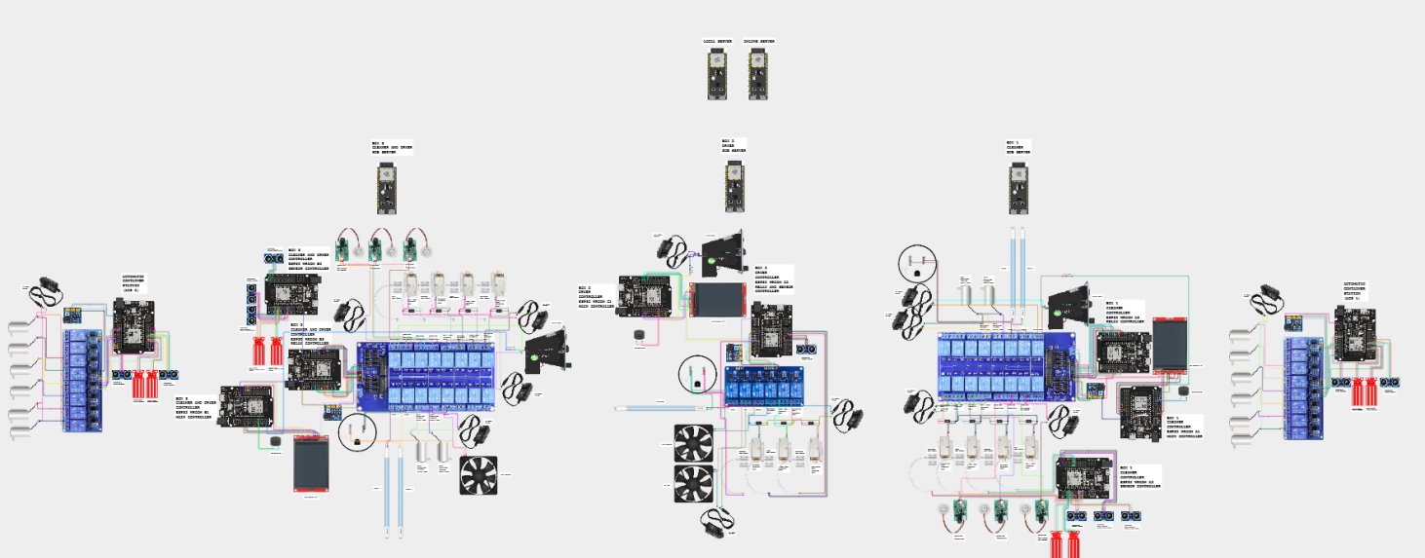
Cirkit Designer picture goes here
Delete this text and use Insert, Pictures. (For the PDF the picture is saved as images\cirkit\cirkit_overview.png.)
Whole installation (Cirkit Designer)

Box 1: A1, A2, A3

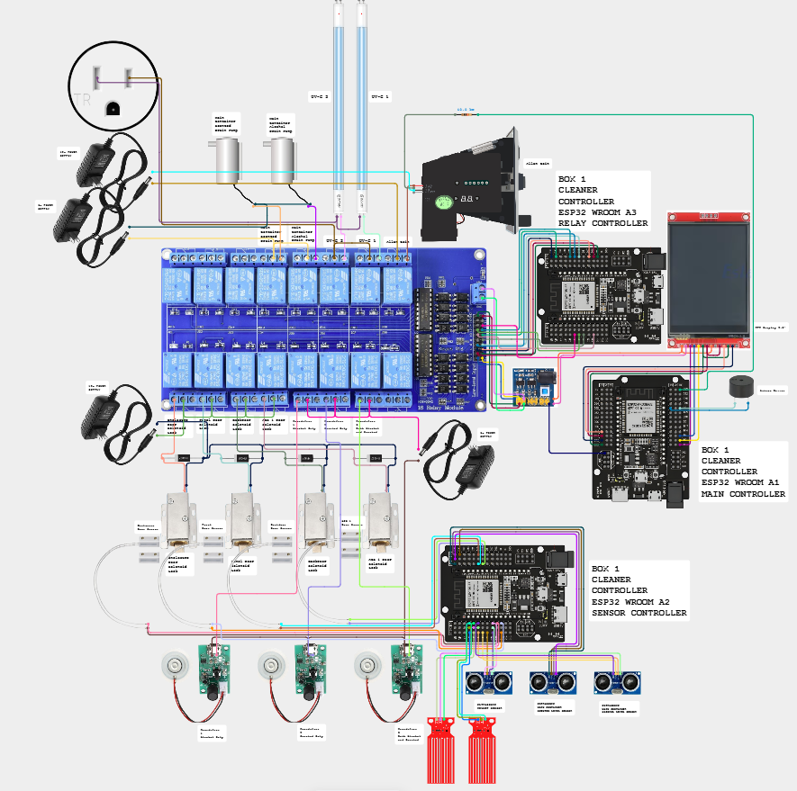

Box 1 (Cirkit Designer)

Box 2: C1, C2

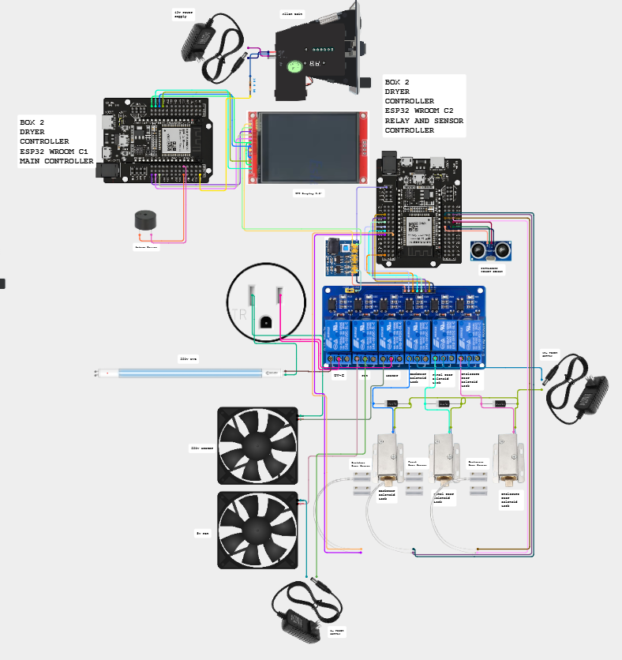

Box 2 (Cirkit Designer)

Box 3: B1, B2, B3

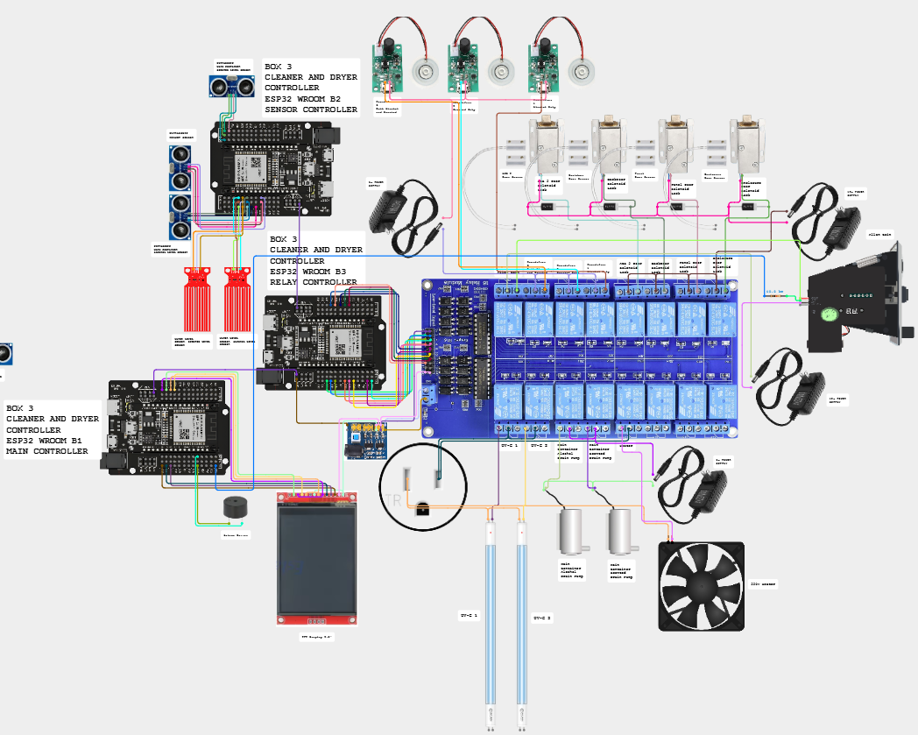

Box 3 (Cirkit Designer)

Refill station: ACS 1 and ACS 2

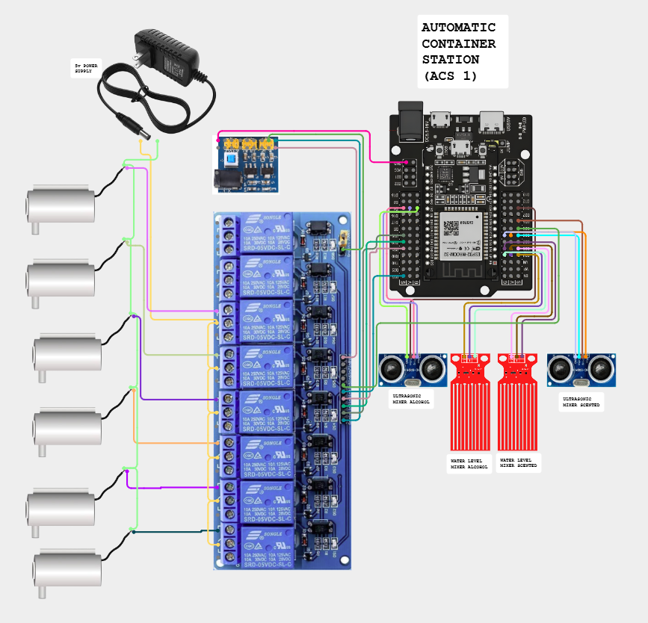

Refill station (Cirkit Designer)

Policies
What the machine does is fixed by the firmware. The rules around it are the owner's decisions. Items marked confirm are proposals: edit them to match what the owner decides, then post the customer rules at the machine.

Coins and refunds

Situation | What the machine does | Policy
Customer cancels a run | Asks CONFIRM or RESUME and warns that coins will not be refunded. The coins are not refunded. | No refund after a run starts.
Customer cancels while inserting coins | Asks YES or NO and warns that coins will not be refunded. The machine does not return coins already inserted. | No refund after inserting the coin
Fault or power cut during a run | The run stops, a trapped helmet is released, coins are not returned by the machine. | Staff offers a free run or a refund.
Machine OUT OF ORDER | It does not take coins. | A sign: use another machine.
Free retry | One free run after the final rating (default 2 minutes, for everyone). Not repeatable. | Set who gets it in Settings (lowest final rating).
Too few or too many coins | The time allot screen asks again. The most that can be bought is 90 coins in Box 1 and Box 3, 100 in Box 2. | Posted on the machine.
No change is given | The slot takes coins only. | Say so on the sign.

Using the machine
- Motorcycle helmets only. Take out gloves, phones, cameras and speakers first.
- Children use the machine with an adult.
- Never block, tape or remove the safety slide of the enclosure door. It is how a trapped helmet is freed when the lock or the power fails.
- The owner is not responsible for items left inside or for damage that comes from a helmet's own condition. Nothing is stored in the machine after a run.
- The machine cleans and dries. It does not guarantee that every smell or every drop of water is gone.
- Rating the helmet before and after is part of the run. The ratings are kept only as numbers.

Data and privacy
- The machines have no camera and no microphone. They record only counts: sessions, coins, minutes, ratings and the state of each board.
- The machines and the LocalServer store no names, no phone numbers and no payment cards. Payment is coins only. The one exception is the optional nickname a customer can type on the customer status page: it is public to everybody who opens the page, it lives only in the public Blynk device while the cycle runs, and it clears when the cycle ends.
- The backup log (CSV) and the previous-data file (history.json) hold only dates, times, boxes, coins, minutes and Finished or Cancelled. Keep them like any other record of the business. The CSV ends with a check line, so a copy that was edited is refused by the LocalServer.
- The Online Server sends only totals and status to Blynk. The Blynk token is a secret: keep it out of the manual, the web page and any file that is shared.
- The customer status page shows only whether each machine is free, in use or out of order. The public Blynk device behind it holds nothing else. The admin, technician and reference chapters of the manual are encrypted on the web and open with the team password.
- The Control Center and the setup Wi-Fi use a password printed in this manual. Change both before the machines are used in public, and give the admin and technician parts of this manual only to the team.

Staff and safety
- Only trained staff refill the containers, open the panels or use Maintenance.
- Mains work is for a qualified electrician (see Safety and emergencies).
- Run the weekly and monthly checks in the Maintenance chapter and write the date down.
- Alcohol and scented liquid: keep the supplier's safety data sheet near the ACS. Decide where the drain water may go.

Operating hours and notices

Item | Decision
Operating hours | 9:00 AM – 5:00 PM
Where to report a fault or a lost item | MEJEZ STUDIO || 0975 791 5832
Price list posted at the machine | Prices and time chapter, or the printable panel cards.

Glossary
Words used in this manual, in plain language.

Term | Meaning
2-second safety | In Maintenance a relay you switch on by hand switches itself off after 2 seconds, done by the box itself. Drain pumps and coin power are exempt. See Bypass Safety 2 Seconds Relay.
Acknowledge | The button on the online page that stops a repeating alarm. A new alert still sounds.
ACS | Auto Container System. The refill station: pumps and two mixer containers that top up a box's alcohol and scented containers.
Alert sound | The beep pattern of one kind of alert (siren, alarm, three beeps, two tones, chime...). Each can be changed in the Alerts tab.
Allan coin acceptor | The coin slot. It sends one pulse for each coin value it accepts.
Backup log (CSV) | The file that Download log (CSV) gives you: every session the machines recorded, with date, time, box, coins and minutes. Keep copies: Restore from backup CSV reads it.
Blynk | The online service the Online Server sends its snapshot to. The web page reads it from there.
Brain | The ESP32-S3 board of a box (S3A, S3B, S3C). It runs every step and keeps the settings. A box has one brain and several terminals.
Bypass Safety 2 Seconds Relay | The Maintenance tick box that turns the 2-second safety off, so hand-set relays stay on until you switch them off.
Captive portal | The page that opens by itself when a phone joins the setup Wi-Fi of the Online Server.
Channel 1 | The radio channel all the boards use for ESP-NOW. The LocalServer Wi-Fi stays on it too.
Control Center | The pages of the LocalServer (Dashboard, Settings, Box 1, Box 2, Box 3, ACS) where settings, calibration and Maintenance are done.
Cool down | The time after heating when nothing heats and the helmet can cool. Box 2 runs the fan; Box 3 lets everything rest.
Crash report | A note the LocalServer keeps in its own flash after a restart it did not plan (the last three are kept). Read it in Settings, This board, and send a screenshot to the developer.
Customer status page | status.html: the public page that shows which machine is free, in use or out of order.
Dashboard | The first tab of the Control Center (called Home in older pages): the three boxes, the refill stations, the statistics and the Devices line.
Datastream | A named value in Blynk. This project uses V0 (a text) and, if you switch them on, V1 to V4.
Day viewer | The card that opens when you tap a bar of the Daily chart or pick a date: the customers of that day, with a Machine tab and a JSON tab.
DC-DC module | The power module that turns 12 V into 5 V and 3.3 V for the boards, sensors and small loads.
Devices line | The line on the Dashboard that says how many boards answer (for example 13 of 13 online). Tap it for the badge of every board.
Early warning | The level (30 % by default) where a container dial turns amber and a notice appears, before the box runs out.
Enclosure lock | The solenoid lock of the main door of a box. It is the one released for a trapped helmet.
ENTRY board | The spare ESP32 with a form (Wi-Fi JollyHelmet-Entry, address 192.168.5.1) for typing the previous customers and sending them to the LocalServer.
ESP-NOW | The radio link the boards talk over. No router is needed.
ESP32 and ESP32-S3 | The two kinds of board. The plain ESP32 boards are terminals. The S3 boards are brains and servers.
Free retry | One free run after the final rating (2 minutes by default).
GPIO | A numbered pin of an ESP32 board.
history.json (previous data) | The file of customers the team collected from its own records before the log existed. The chart draws it lighter and the Finished and cancelled card counts it, but it never changes the machine log, the totals or the CSV.
Humidifier | The ultrasonic mist maker that makes the alcohol and scented mist (5 V).
Hysteresis | The gap between the WET and the DRY reading of a water sensor, so it does not flicker.
Integrity line | The last line of the backup CSV. It lets the LocalServer refuse a file that was edited or saved again. It protects against mistakes; it is not a lock.
JD-VCC | The separate power input of a relay module's coils, with a jumper to the logic supply.
Level dial | The half-circle gauge of a container on the Monitor tab. 0 is the refill line.
LocalServer | The board that makes the JollyHelmet-Local Wi-Fi and the Control Center, and counts the revenue.
Maintenance mode | A page where a technician switches relays or pumps by hand. The machine shows MAINTENANCE. Hand-set relays go off after 2 seconds unless the safety is bypassed.
Mixer | One of the two containers of an ACS (alcohol, scented) where the recipe is made before it goes to a box.
Mist | The alcohol or scented vapour used in cleaning. Mist method: balanced, more alcohol, more scented.
Navigation bar | The row at the top of every Control Center page: Dashboard, Settings, Box 1, Box 2, Box 3, ACS 1 / 2.
Nickname | The optional name of up to 12 characters a customer can type on the status page while the cycle runs. It is public and clears when the cycle ends.
NVS | The memory inside a board where settings are saved (they survive a power cut).
Online Server | The ESP32-S3 that listens to the machines and sends a snapshot to Blynk. It never controls anything.
OUT OF ORDER | The screen shown when a box cannot serve customers.
Phase | A part of a cleaning run: start, middle or end. Each relay is on or off per part.
Power-to-unlock | A lock that opens only while it has power. With no power the door stays locked.
Public status device | The second Blynk device whose token may be public. It holds only the step and time left of each box.
QR code | The square code on the sign at each machine. A phone camera opens the customer status page with it.
Rating | The 1 to 10 score the customer gives the helmet before and after: odor (Box 1 and cleaning in Box 3) or dryness (Box 2 and drying).
Relay | An electrically operated switch. The boards use relays to switch locks, pumps, mist makers, lamps and the heater.
SAFETY PAUSE | The screen shown when a door opens during a run. The loads switch off until the door is closed.
Safety slide | The mechanical slide at the lower left of the enclosure door. Slide it down and the door unlocks by hand, with no power and no help from the boards.
Serial Monitor | The Arduino IDE window that shows what a board prints over USB (115200 baud).
SoftAP | A Wi-Fi network made by a board itself (JollyHelmet-Local, JollyHelmet-Online).
Team password | The password that opens the encrypted admin, technician and reference chapters of the Manual tab.
Terminal | A plain ESP32 board that holds a box's sensors, relays and display. It follows its brain.
TFT | The 2.8 inch colour touch screen of a box.
Time allot | The screen where the customer types the minutes to buy.
Token | The secret key that lets the Online Server write to your Blynk template. Keep it private.
Ultrasonic sensor | The HC-SR04. It measures the distance to the helmet or to the liquid in a container.
UV-C lamp | The 220 V germicidal lamp. Never look at it when it is lit.
Watchdog | A safety check: if a board stops hearing its brain for 15 seconds it switches its loads off.

Version and revisions

Item | Value
Manual | Jolly Helmet User Manual, revision 9, 2026-10-16
Made by | MEJEZ STUDIO
Covers | Box 1, Box 2, Box 3, ACS 1, ACS 2, LocalServer, Online Server
Protocol file | Shared_Common.h, identical in every sketch folder (checksum b9da9bfb)

Revision history

Rev | Date | What changed
1 | 2026-10-07 | First manual: customer guide and admin guide for Box 1, 2 and 3, prices, Control Center, ACS. PDF and Word, new logo, Arial.
2 | 2026-10-07 | Technician guide: components, pinouts, circuit and wiring, firmware and flashing, maintenance, hardware troubleshooting. Corrected from the Cirkit Designer document to what was really built.
3 | 2026-10-10 | Online Server, Blynk setup and the web page. Real parts: UV-C 220 V lamps, HC-SR04, 5 V mist makers and pumps, DC-DC module. Team names on the cover.
4 | 2026-10-10 | Reference section: safety and emergencies, box flowcharts, troubleshooting decision trees, settings reference, schematic pages, policies, glossary, this page and the index.
5 | 2026-10-11 | Online page: level dials with early warning, Alerts with a sound for every kind of alert, Reports (busiest hours and days, what each box earns), Checklist, Fix it, customer status page and QR sign, Manual tab with a team password. New Online Server firmware (per-box statistics, public status device).
6 | 2026-10-11 | The safety slide of the enclosure door (lower left, slide down to unlock by hand when the solenoid lock is broken or there is no power): customer guide, admin guide, technician guide, safety and emergencies, decision tree 4, settings reference, glossary and policies.
7 | 2026-10-11 | Box flowcharts and troubleshooting decision trees redrawn in black and white (no colours): thick border = the machine is running or "do this", double border = a fault, black box = start or end.
8 | 2026-10-16 | The LocalServer Wi-Fi is now called JollyHelmet-Local (it was ESP32_LOCAL; the password and the address 192.168.4.1 are unchanged). Updated in the join steps, the settings reference, the glossary and the index. Phones that saved the old name must join the new one; the spare ENTRY board must be flashed with the matching name.
9 | 2026-10-16 | One navigation bar and a Devices line instead of the menu button; the Dashboard, the day viewer (Machine and JSON tabs), the combined Finished and cancelled tally, the Settings tab with the backup restore, the previous-data label and the crash reports kept on the board. Maintenance 2-second safety with its bypass and the drain pump warning; the OPEN A / OPEN B beep settings. The ENTRY board (coins and minutes both ways, captive portal). C1 coin signal moved to GPIO 32. Optional customer names on the status page. Firmware dates and all Control Center screenshots renewed.

Firmware in this manual
The date is when the sketch file was last saved. The board in the machine may carry an older build: compare with what it prints when it starts (Serial Monitor, 115200).

Sketch folder | Board | Role | File date
ESP32_S3A | S3A | Box 1 brain | 2026-10-15
ESP32_A1 | A1 | Box 1 screen, coin, buzzer | 2026-10-13
ESP32_A2 | A2 | Box 1 sensors | 2026-10-13
ESP32_A3 | A3 | Box 1 relays | 2026-10-13
ESP32_S3C | S3C | Box 2 brain | 2026-10-15
ESP32_C1 | C1 | Box 2 screen, coin, buzzer | 2026-10-15
ESP32_C2 | C2 | Box 2 sensors and relays | 2026-10-13
ESP32_S3B | S3B | Box 3 brain | 2026-10-15
ESP32_B1 | B1 | Box 3 screen, coin, buzzer | 2026-10-13
ESP32_B2 | B2 | Box 3 sensors | 2026-10-13
ESP32_B3 | B3 | Box 3 relays | 2026-10-13
ESP32_ACS1 | ACS 1 | Box 1 refill station | 2026-10-13
ESP32_ACS2 | ACS 2 | Box 3 refill station | 2026-10-13
ESP32_LOCALSRV | LocalServer | Control Center, revenue | 2026-10-16
ESP32_ONLINESRV | Online Server | Blynk monitor | 2026-10-14
ESP32_ENTRY | ENTRY | Spare board: form for the previous data | 2026-10-16

Tools and libraries

Item | Version
Arduino IDE board package: esp32 by Espressif | 3.3.7
TFT_eSPI | 2.5.43
ArduinoJson | 7.4.3
ESP_Async_WebServer | 3.12.0
Async_TCP | 3.5.0
Blynk | Blynk Cloud HTTPS API (no library on the board)

Check before you hand over
- Measure the real containers, enter the LEVELS distances and the ACS lines, then switch Check levels and Ask the ACS to refill on.
- Run every relay and every pump by hand in Maintenance before the first automatic run.
- Calibrate the touch screen of B1 (it still has the A1 numbers) with ESP32_C1_CALIBRATE.
- Online Server: after its first upload, the Control Center must still hear every board (13 of 13). If it does not, check the radio channel.
- Online page: flash the Online Server firmware of 2026-10-10, create the public status Blynk device, print the QR sign for every machine, and run build_web_manual.ps1 after every change to this manual.

Index
Page numbers refer to this manual. In the Word file, right-click the index and choose Update field to refresh it after editing.
1N4007 diode
12 V power supply
220 V mains
A1 (Box 1 screen board)
A2 (Box 1 sensor board)
A3 (Box 1 relay board)
ACS 1 and ACS 2 (refill station)
Allan coin acceptor (coin slot)
Arduino IDE
B1 (Box 3 screen board)
B2 (Box 3 sensor board)
B3 (Box 3 relay board)
Blynk
Board settings (flashing)
Buzzer
C1 (Box 2 screen board)
C2 (Box 2 relay and sensor board)
Calibration
Captive portal
Cirkit Designer
Cleaning phases
Coin value and revenue
Control Center
Cool down
DC-DC module
Door lock (solenoid)
Door sensor (MC-38)
Drain pump
Emergency
ESP-NOW and channel 1
Fan
Flowcharts
Free retry
Fuse
Heater
Humidifier (mist maker)
Level checks (containers)
LocalServer
Maintenance mode
Mixer container
Online Server
OUT OF ORDER
Pinouts
Policies and refunds
Power cut (power-to-unlock)
Prices
Rating (odor and dryness)
Refill pump
Relay
S3A (Box 1 brain)
S3B (Box 3 brain)
S3C (Box 2 brain)
SAFETY PAUSE
Screen refresh (white screen)
Serial Monitor
Time allot
Token (Blynk)
Touch screen (TFT)
Trapped helmet
Ultrasonic sensor (HC-SR04)
UV-C lamp
V0 datastream
Watchdog (15 seconds)
Water-level sensor
Web page (monitor)
Wi-Fi JollyHelmet-Local

Thank you for using
Jolly Helmet
We hope to see you again!
Make your Helmet Happy Again.
MEJES, JERAHMEEL ALZEL M.
CRUZ, DEAN RYAN P.
MENDOZA, RICAH S.
MARTOS, KRISTINA E.
DEVELOPERS AND DESIGNERS
USER MANUAL

